COASTAL Charlotte Harbor

MONITORING NETWORK

Standard Operating Procedures

2023 Updates

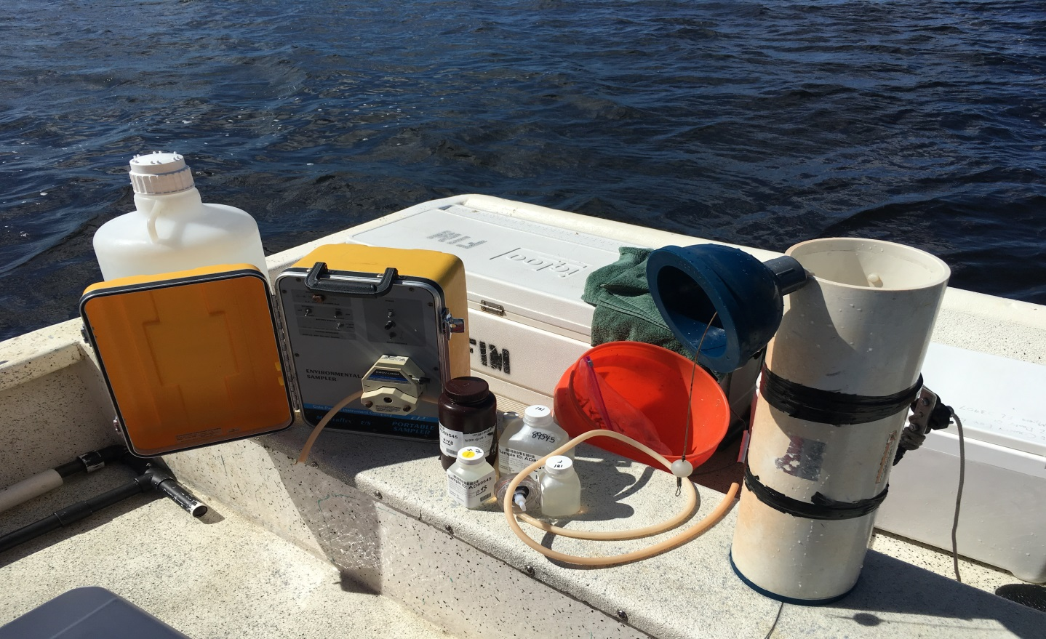

Coastal & Heartland National Estuary Partnership

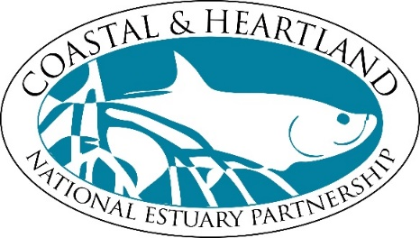

1050 Loveland Blvd.

Port Charlotte, FL 33980

941-833- 6580

[*www.CHNEP.org*](http://www.CharlotteHarborNEP.org)

Coastal & Heartland National Estuary Partnership

The Coastal & Heartland National Estuary Partnership (CHNEP, formerly the Charlotte Harbor National Estuary Program) is a partnership of citizens, elected officials, resource managers and commercial and recreational resource users working to improve the water quality and ecological integrity of the eight watersheds that comprise the CHNEP area including; Charlotte Harbor, Dona and Roberts Bays, Lemon Bay, San Carlos Bay, Estero Bay as well as the Peace, Myakka, and Caloosahatchee River basins. A cooperative decision-making process is used within the program to address diverse resource management concerns in the 5,400-square-mile study area.

Acknowledgements

This document updates the original Coastal Charlotte Harbor Monitoring Network (CCHMN) Standard Operating Procedures (SOPs) approved by the Coastal & Heartland National Estuary Partnership (CHNEP) Management Conference in March 2014 (CHNEP Technical Report 02-03). Many organizations and individuals contributed to the development of the original CCHMN SOPs, as well as these updates. The original CCHMN SOPs were built on the Southwest Florida Water Management District (SWFWMD) *A Long-Term Water Quality Monitoring Design for Charlotte Harbor, Florida* (1995) and theCoastal & Heartland National Estuary Partnership (CHNEP) *Long Term Monitoring Strategy and Gap Analysis* (2000). The assistance from all those who contribute their field, laboratory and data management expertise toward making the CCHMN a reliable, on-going source of technically sound region-wide estuarine water quality data is greatly appreciated by many. Thank you to each contributor.

**COASTAL & HEARTLAND NATIONAL ESTUARY PARTNERSHIP**

**Policy Committee**

**Mr. Brian Smith**, Co-Chair **Mr. Jennifer Carpenter**, Co-Chair

US EPA, Region 4 Florida Department of Environmental Protection

**Hon. Sandy Meeks**

Hardee County

**Hon. Ramon Iglesias**

Hendry County

**Hon. Scott Kirouac**

Highlands County

**Hon. Frank Mann**

Lee County

**Hon. James Satcher**

Manatee County

**Mr. Bill Braswell**

Polk County

**Hon. Ron Cutsinger**

Sarasota County

**Hon. Ken Doherty**

Charlotte County

**Hon. Steve Hickox**

Desoto County

**Hon. Tony Whidden**

Glades County

**Hon. Robert Heine, Jr.**

City of Arcadia

**Hon. Steve Githins**

City of Bartow

**Hon. Jessica Cosden**

City of Cape Coral

**Hon. Fred Burson**

City of Fort Myers

**Hon. Bill Veach**

Town of Fort Myers Beach

**Hon. Bill Read**

City of Lakeland

**Hon. Alice White**

City of North Port

**Hon. Donna Peterman**

City of Punta Gorda

**Hon. Mike Miller**

City of Sanibel

**Hon. Nicholas Pachota**

City of Venice

**Mr. M. J. Carnevale**

City of Winter Haven

**Hon. Katy Errington**

Village of Estero

**Hon. Barbara Arnold**

City of Fort Meade

**Ms. Allie McCue**

Florida Fish & Wildlife Conservation Commission

**Mr. Chauncey Goss**

South Florida Water Management District

**Ms. Margaret Wuerstle**

Southwest Florida Regional Planning Council

**Mr. Jack Bispham**

Southwest Florida Water Management District

**Mr. Don McCormick**

Southwest Florida Regional Planning Council

**Ms. Jennifer Codo-Salisbury**

Central Florida Regional Planning Council

# Table of Contents

Purpose 6

Background 12

Coastal Charlotte Harbor Monitoring Network Study Design 18

Coastal Charlotte Harbor Monitoring Network Field Sampling Procedures 25

Budget 30

Appendix A: Example CCHMN Field Equipment Check List 32

Appendix B: Example CCHMN Data Sheet 33

Appendix B: Example CCHMN Chain of Custody Form 34

# Figures

Figure 1: CHNEP Study Area 8

Figure 2: Uses of CCHMN Data 9

Figure 3: CHNEP Estuary Strata 11

Figure 4: CCHMN Strata and Partners 19

Figure 5: CCHMN Strata and Grid Numbers 20

# Tables

Table 1: Depths for light attenuation data collection 30

Table 2: CCHMN Estimated Annual Budget (2019) 31

# Purpose

This purpose of this document is to incorporate updated staff, dates, field, laboratory, and data management information into the Coastal Charlotte Harbor Monitoring Network (CCHMN) Standard Operating Procedures (SOPs). The original *Coastal Charlotte Harbor Monitoring Network Description and Standard Operating Procedures* (CHNEP Technical Report 02-03) were approved by the Coastal & Heartland National Estuary Partnership (CHNEP) Management Conference on March 19, 2004 (CHNEP, 2004; available at [www.chnep.org](http://www.chnep.org)).

The CCHMN is a regional partnership of agencies (managed under the CHNEP) initiated in 2001 that collects monthly water quality data using consistent, technically sound sampling design. Long-term random sampling of strategically located stations allows scientific assessment of status and trends. CCHMN field and laboratory partners collect and analyze water samples from 60 randomly selected field sites throughout 10 waterbodies each month, including Lemon Bay, Cape Haze/Gasparilla Sound, Charlotte Harbor, Pine Island Sound, Matlacha Pass, San Carlos Bay, Estero Bay and the Tidal Myakka, Peace, and Caloosahatchee Rivers (Figure 3). Fifteen water quality parameters are measured and analyzed using consistent field and laboratory methods (CHNEP 2015 and CHNEP 2016).

Data are uploaded biannually by partners to WIN (Watershed Information Network), previously called STORET (Storage and Retrieval), a standard, common public database maintained by the Florida Department of Environmental Protection (FDEP). In addition, all contributing CCHMN laboratories and field monitoring agencies participate in Southwest Florida Regional Ambient Monitoring Program (SWF RAMP) quarterly meetings to help ensure region-wide data and methodology comparability. The SWF RAMP serves as a quality assurance forum for comparing split-sample laboratory results, resolving inconsistencies in results, and discussing pertinent water quality monitoring issues throughout the region.

Identifying waterbody impairments, establishing pollutant limits, and monitoring progress of corrective management actions all depend on the availability of accurate, high quality data. Protocols and procedures must be employed to ensure that data are properly collected, handled, processed, used, and maintained at all stages of the data lifecycle. CCHMN supplements other ongoing water quality monitoring programs implemented by partners, including ongoing fixed station monitoring by counties, cities, agencies, and citizen scientists.

CHNEP management activities for CCHMN include developing and updating Standard Operating Procedures and field Quality Assurance (QA) Plans, conducting annual field audits, contracting and assisting with field water quality sampling and equipment repair, hosting annual meetings, and participating in quarterly RAMP quality assurance meetings. These activities are developed to be consistent with FDEP QA Rules (62-160, F.A.C.).

Activities in the CHNEP are guided by the *Comprehensive Conservation and Management Plan 2019* (CCMP) and identified as a priority in the *CHNEP Monitoring Strategy* (2020) (CHNEP, 2019; available at [www.chnep.org](http://www.chnep.org)).

The CCMP identifies four Priority Actions throughout the CHNEP area relating to:

* Water Quality Improvement
* Hydrological Restoration
* Fish, Wildlife, and Habitat Protection
* Public Engagement

The CCHMN implements the CCMP Priority Actions relating to Water Quality Improvement including:

* **Water Quality Improvement Action 1: Support a comprehensive and coordinated water quality monitoring and assessment strategy.**
* **Activity 1.1:** Assist with the consistent and efficient collection of technically-sound long-term water quality data throughout the CHNEP area, including supporting key programs like the Coastal Charlotte Harbor Water Quality Monitoring Network, partners’ long-term fixed stations, and volunteer monitoring programs like the Charlotte Harbor Estuaries Volunteer Monitoring Network, Lee County Pond Watch, and the Cape Coral Canal Watch programs. Work with partners to obtain additional resources, increase efficiencies, and identify and fill sampling gaps.
* **Activity 1.2:** Support uploading and archiving of data in standard, common public databases, including FDEP’s database and the CHNEP Water Atlas.

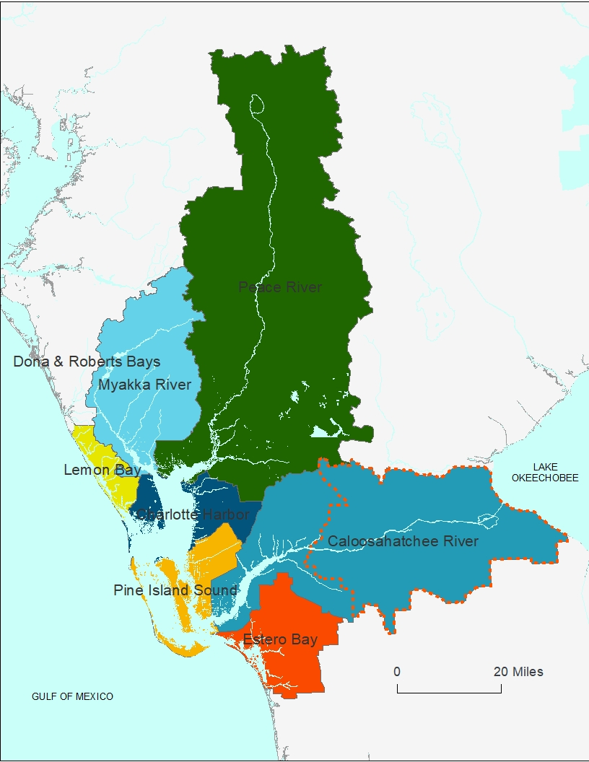

**Figure 1:** The basins within the CHNEP area.

The original CCHMN SOPs were developed by the CHNEP with assistance from many partners from throughout the study area. CCHMN SOP Updates are made to incorporate changes to the program, field monitoring, lab sampling, or data collection/entry protocols that have occurred since the monitoring program was initiated in 2004 and updated in 2015, 2017, 2019, and 2023. This document also reflects feedback from partners that is received at the CCHMN annual meetings. The CCHMN SOPs ensure continued reliable, consistent, technically sound water quality data collection throughout the estuarine regions of the CHNEP study area. The basins within the CHNEP area are shown in Figure 1.

The water quality data provided by the CCHMN is an essential component of many water quality assessments and resource management decisions throughout the CHNEP estuarine and tidal waters. The data is critical for linking development of water quality criteria with evaluation and assessment of waterbodies to determine if they are meeting regulatory requirements (Figure 2).



Figure 2: Uses of CCHMN Data

Specific uses of the CHNEP water quality data include:

* CHNEP Water Quality Status and Trends (Janicki Environmental, 2007),
* CHNEP Water Atlas Water Quality Trends, Water Quality Dashboard and Preliminary Numeric Nutrient Criteria Calculator (Updated Annually),
* CHNEP Water Quality Targets (CHNEP, 2006),
* CHNEP Numeric Nutrient Criteria (Janicki Environmental, 2011),
* CHNEP Optical Model development (Dixon et al, 2014).
* State Impaired Waters and TMDL determinations,
* State BMAP processes, and
* Water Management District Minimum Flows and Levels (MFLs).

The CCHMN is currently funded by a partnership of Southwest Florida Water Management District (SWFWMD), Charlotte County, Lee County, the City of Cape Coral, Florida Department of Environmental Protection (FDEP), and CHNEP. Field sampling is conducted by Florida Fish and Wildlife Conservation Commission (FWC) Charlotte Harbor Field Laboratory, City of Cape Coral, FDEP Environmental Assessment and Restoration South Regional Operations, and Lee County Environmental Laboratory. Laboratory analyses are conducted by a partnership with Charlotte County (Benchmark Laboratory), City of Cape Coral Laboratory and Lee County Environmental Laboratory.

The CCHMN data is entered into the federal, state and water management district water quality databases (including Legacy USEPA STORET (Storage and Retrieval) and the replacement database FDEP WIN (Watershed Information Network) and SWFWMD WMIS (Water Management Information System) and its replacement WISKI and is available to the public and agency staff through the CHNEP Water Atlas (<http://www.chnep.wateratlas.usf.edu/>).

The CCHMN background information, study design and field methods are described briefly in the following sections. For additional detail, please refer to the *Coastal Charlotte Harbor Monitoring Network Description and Standard Operating Procedures* (CHNEP, 2004).

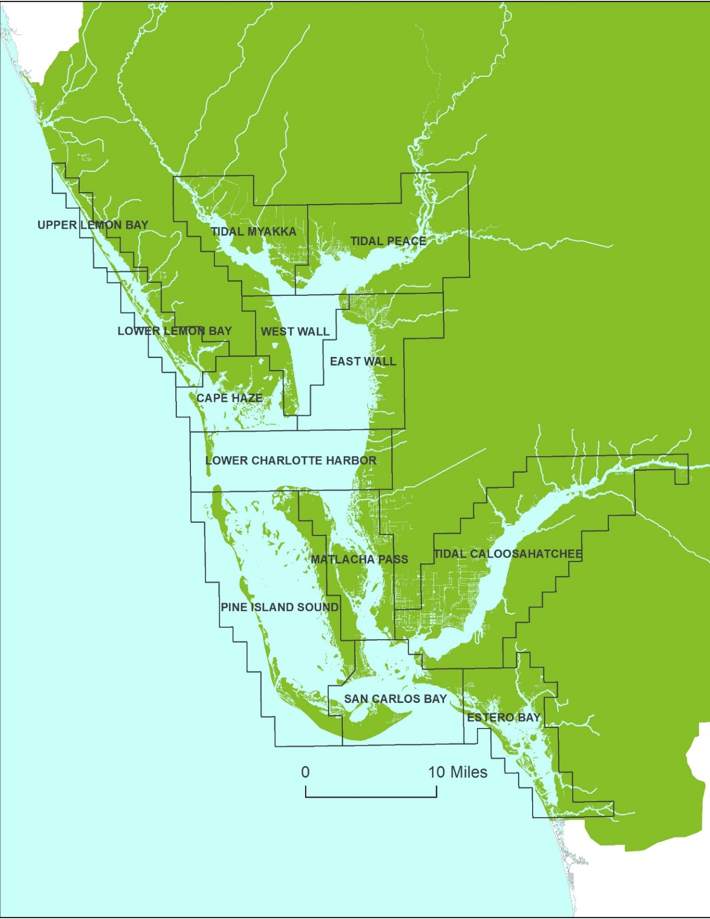 **Figure 3: CCHMN water quality sampling strata**. CCHMN field and laboratory partners collect and analyze water samples from 60 randomly selected field sites throughout 10 waterbodies each month.

# Background

The original CCHMN SOPs were built on the SWFWMD *A Long-Term Water Quality Monitoring Design for Charlotte Harbor, Florida* (1995) and theCHNEP *Long Term Monitoring Strategy and Gap Analysis* (2000).

The purpose of the CHNEP Long-Term Monitoring Strategy was to track status and trends of fish and wildlife habitat, hydrologic and water quality conditions for the greater Charlotte Harbor watershed. The strategy recommended a stratified, random sampling design based on the U.S. Environmental Protection Agency’s (EPA) Environmental Monitoring and Assessment Program (EMAP) for the region’s coastal water quality programs. The objectives of long term monitoring strategy were to provide unbiased data that answer the following water quality questions:

1. Is water quality changing through time for a specific water body?
2. Did water quality change as the result of implementing some management practice?
3. Did water quality change by some specific target level?

The CHNEP Long Term Monitoring Strategy was developed based on a consensus approach and review of existing guidance, including EPA’s Environmental Monitoring and Assessment Program (EMAP) approach. EMAP used a stratified-random sampling protocol to provide statistically unbiased results for the coastal areas.

The CCHMN was created to fill gaps in coastal water monitoring and initiate a unified approach throughout the study area. Based on extensive scientific input, the estuaries and tidal rivers of the CHNEP were divided into 13 regions of relatively homogeneous water quality and habitat conditions and overlaid with the square mile sampling grids utilized by the FWC Fisheries Independent Monitoring (FIM) sampling protocols. Within each stratum, five grids are randomly selected each month and sampling locations (latitude and longitude) within each grid are randomly selected. This allows each stratum to be monitored at 60 locations each year. The details of how and why the strata, grids, sampling frequency, sampling protocols, metadata, data analysis methods and core analytes were determined are included in the CHNEP Coastal Charlotte Harbor Monitoring Network Description and Operating Procedures (CHNEP, 2004).

One of the major goals of the CHNEP is to help facilitate inter-agency cooperation and coordination to utilize the region’s assets for more collaborative natural resources management and research, including the area’s monitoring programs. Charlotte Harbor covers 270 square miles and the CHNEP area extends over an area of 5,400 square miles. The study area includes all or part of ten counties, two water management districts, two FDEP districts, and many cities and towns. This large service area and the interconnected jurisdictions of the public and private institutions have created both management opportunities as well as critical gaps in the complex legal and organizational framework.

Water quality monitoring programs throughout the region generally consist of fixed stations that are designed to sample for analytes and in areas that are of interest to the various monitoring agencies. It can be difficult statistically to make assumptions about the condition of larger waterbodies based on limited fixed station data, though the data can be useful for regulatory purposes. In addition, between the various monitoring agencies, the number of individual monitoring sites, the frequency of the collection and the sampled analytes at each site are highly variable. Monitoring agencies also often use different protocols for lab analysis and sample collection. These inconsistencies can result in data gaps and incomparable data across basins. Inter-governmental coordination of field sampling methodologies, monitoring sites and laboratory methods throughout the southwest Florida region benefited by the creation of the Southwest Florida Regional Ambient Monitoring Program (SWF RAMP). The SWF RAMP meets quarterly to conduct split sampling for comparisons, compare split sampling laboratory results, resolve inconsistencies in results and discuss relevant emerging issues.

The CCHMN began implementation in 2001 as a cooperative monitoring network to fill gaps in water quality data in the CHNEP estuaries using a stratified, random sampling design. Initially, five strata were sampled (Tidal Peace and Myakka Rivers, Lemon Bay and Charlotte Harbor East Wall and West Wall) by five partners (SWFWMD, FWC Florida Wildlife Research Institute, FDEP Charlotte Harbor Aquatic Preserves, and Charlotte and Sarasota Counties). In 2002, seven additional stratum were added (Lower Lemon Bay, Lower Charlotte Harbor, Pine Island Sound, Matlacha Pass, Tidal Caloosahatchee River, San Carlos Bay and Estero Bay) by four additional partners (Lee County, Cape Coral, Sanibel, and SFWMD). Since the time the CCHMN was implemented, field and laboratory partners and funding sources have changes, but partners continue to work together to ensure collection of technically sound water quality using consistent methods throughout the CHNEP estuaries.

The CCHMN stratified, random sampling design includes monthly sampling within 13 estuary strata, with five randomly selected grids and sites sampled in each stratum each month. This allows for data to be collected at 60 sites per stratum per year as suggested by the CHNEP Long Term Monitoring Strategy. The sampling design results in approximately normal data distributions allowing for parametric statistical analyses to be conducted for robust comparisons of means between strata, between seasons (wet and dry), and between years.

**Existing Ambient Water Quality Monitoring Programs in CHNEP Area**

The CCHMN supplements other ongoing ambient water quality monitoring programs within CHNEP, including, but not limited to:

**Canalwatch**

The Canalwatch program is a fixed station, canal, monthly water quality monitoring program managed by the City of Cape Coral Environmental Resources Division in Cape Coral, Florida. There are approximately 45 sites in the Cape Coral canals. Monitoring is conducted on the first Wednesday of each month by over 50 trained volunteers. The program began in 1995 and more information is available at: <http://www.capecoral.net/department/public_works/canalwatch.php#.VYxqYWfbKEU>.

**Charlotte County**

Charlotte County Utilities conducts fixed station bi-monthly groundwater quality monitoring at approximately 85 sites, which are tidally influenced, within the County’s jurisdiction. Sampling at some sites began in 2012. In addition, Charlotte County Public Works conducts quarterly surface water fixed station monitoring at 5 sites in South Gulf Cove. More information is available at: <http://www.charlottecountyfl.com/CCU/WaterQuality/index.asp>.

Charlotte County also conducts fixed station watershed water quality monitoring at 62 stations throughout Charlotte County through the Charlotte County Project Plan for Ambient Surface Water Monitoring Program. The data is collected monthly, this program began in 2022.

**Charlotte Harbor Estuaries Volunteer Water Quality Monitoring Network** **(CHEVWQMN)**

The CHEVWQMN is a fixed station, estuarine, monthly water quality monitoring program managed by the FDEP Charlotte Harbor Aquatic Preserves in Punta Gorda, Florida. There are approximately 45 sites from Lemon Bay through Estero Bay. Monitoring is conducted synoptically, on the first Monday of each month within 1 hour of sunrise, by over 100 trained volunteers. The program started in 1996 and more information is available at: <http://www.chnep.wateratlas.usf.edu/chevwqmn/>.

**City of Cape Coral**

The City of Cape Coral Environmental Resources Division conducts monthly water quality monitoring at approximately 35 fixed stations within the City’s jurisdiction. The program began in 1989 and more information is available at: <http://www.capecoral.net/department/public_works/environmental_resources_division.php#.VYxpemfbKEU>.

**City of North Port**

The City of North Port conducts monthly water quality monitoring at 10 fixed stations as part of their SWFWMD water use permit (WUP) Hydrobiological (HB) monitoring program and the National Pollutant Discharge Elimination System (NPDES) program. The HB monitoring includes 2 freshwater sites (Cocoplum Canal and Myakkahatchee Creek upstream of the City’s main dam) and 8 brackish water sites in the tidal portions of the Myakkahatchee Creek downstream of the City’s main dam and the Myakka River.  Data is collected for 22 parameters including nutrients. The monitoring program began in 2006 and more information is available at by contacting the City’s Stormwater Manager via <http://www.cityofnorthport.com/contact-us> .

**City of Punta Gorda**

The City of Punta Gorda Utilities Department conducts monthly water quality monitoring at fixed, freshwater sites as required for the City’s Water Treatment Facility consumptive use permit with the SWFWMD. The program monitors 6 fixed sites in Shell Creek and the Peace River. The program began in 1991 and is coordinated with monitoring conducted by the Peace River Manasota Regional Water Supply Authority (PRMRWSA) on a monthly frequency.

**FDEP Aquatic Preserves Continuous Water Quality Datasondes**

The FDEP Charlotte Harbor and Estero Bay Aquatic Preserves collect continuous water quality data using datasondes deployed in-situ at 6 fixed stations in Matlacha Pass and Estero Bay. The datasondes are fixed to pilings 0.5 m off the bottom and data is recorded every 15 minutes for 7 parameters, including temperature, turbidity, depth, pH, conductivity, salinity and dissolved oxygen. The datasondes are calibrated before deployment and remain on site for two to four weeks before being retrieved and replaced, and the data downloaded. The continuous data provides additional temporal detail to augment other existing monthly water quality monitoring programs. The FDEP continuous water quality datasonde program began in 2005 and additional information is available at: <https://floridadep.gov/fco/aquatic-preserve>.

**FDEP Watershed Monitoring Program**

The FDEP formed the Integrated Water Resources Monitoring Network Committee in 1996 to develop strategies and techniques for implementing an integrated monitoring plan that would combine surface water, groundwater, and biological monitoring. The EPA, FDEP, Water Management Districts, and local governments were all asked to participate. The program subsequently established a three-tiered assessment approach. Tier 1 Status Network uses a stratified, random sampling design to characterize the overall health of Florida’s water resources and observe possible trends. Tier 2 monitoring programs consist of strategically placed fixed sampling stations with the goal of further characterizing water body segments on the 303(d) list. Tier 3 monitoring programs function mainly as ongoing compliance monitoring programs and will determine if permitted facilities are in compliance with their permits. This monitoring tier provides in-depth information on individual water body segments and yields the basis for evaluating the effectiveness of the management choices relating to facilities. The program was initiated in 1996 and more information is available at: <https://floridadep.gov/dear/watershed-monitoring-section>  (main page).

**Lee County**

The Lee County Environmental Laboratory conducts fixed station, monthly water quality monitoring at approximately 28 estuarine sites in Pine Island Sound, Matlacha Pass and Estero Bay, and 48 freshwater sites within the County’s jurisdiction. Sampling at some sites began in 2002 and more information is available at: <https://www.leegov.com/naturalresources/EnvLab>.

**Manatee County**

The Manatee County Air and Watershed Management program conducts fixed station, freshwater, monthly water quality monitoring at two permanent sites within the County’s jurisdiction. Temporary sites were added as needs indicated. Monitoring records from the oldest site extends back to 1997. More information is available at: <http://www.manatee.wateratlas.usf.edu/river/?wbodyatlas=river&wbodyid=14609>.

**Polk County**

Polk County Parks and Natural Resource Division conducts fixed station, freshwater, quarterly water quality monitoring and laboratory analysis for eight sites on the Peace River and its tributaries, and in 84 public access lakes in the Peace River watershed within the County’s jurisdiction. The ambient monitoring program began in 1985.  Although the County program is not coordinated with monitoring conducted by the Florida LakeWatch Program, water quality data from a variety of sources can be downloaded from the Polk County Water Atlas. These data and additional information are available at:

<http://www.polk.wateratlas.usf.edu/>.

**Pond Watch**

Pond Watch is a fixed station, stormwater pond, monthly water quality monitoring program managed by the Lee County Hyacinth Control District in Lehigh Acres, Florida. There are approximately 65 sites in Lee County stormwater ponds. Monitoring is conducted on the second Monday of each month by over 75 trained volunteers. The program began in 1995 and more information is available at: <http://www.chnep.wateratlas.usf.edu/pond-watch-program/>.

**Peace River Manasota Regional Water Supply Authority (PRMRWSA)**

The PRMRWSA’s Hydrobiological Monitoring Program (HBMP) was initiated in 1976 and was developed by the SWFWMD and General Development Utilities, Inc. (GDU) for GDU’s Peace River Regional Water Supply Facilities original consumptive use permit (1975). The PRMRWSA obtained ownership and operation of the facility in 1991. The HBMP was designed to evaluate the impacts and significance of natural salinity changes on the aquatic fauna and flora in the lower Peace River and upper Charlotte Harbor and to determine if freshwater withdrawals by the Peace River Facility could be shown to alter these patterns. The program currently includes 3 U.S. Geological Survey (USGS) water level recorders (Harbour Heights, Peace River Heights and Peace River Facility Intake) which provide surface and bottom conductivity at 15 minute intervals. The PRMRWSA also has 8 continuous recorders along the river which provide subsurface conductivity at 15 minute intervals. Monthly chemical and physical water quality measurements are conducted at four “moving” salinity-based isohaline locations (0, 6, 12 and 20 ppt) along a river kilometer center-line, running from the mouth of the Peace River upstream to Horse Creek and downstream to Boca Grande Pass. Monthly water column profiles are conducted at 16 locations along a transect running from the river mouth to the Peace River Facility. Chemical water quality samples are collected at five of these locations. Both the “moving” and fixed stations include physical *in situ* water column profile measurements (temperature, dissolved oxygen, pH, conductivity and salinity) at 0.5 meter intervals from the surface to the bottom, plus light attenuation. More information is available in the HBMP Annual Data Reports or 5 year HBMP Summary Report found in the southwest Florida Water Atlas system and also as a public document at SWFWMD or PRMRWSA.

**Sarasota County**

The Sarasota County Stormwater Environmental Utility conducts monthly ambient water quality monitoring of bays, creeks and the Myakka River. County bays are divided into eight segments. Each segment has one sample taken from each of five polygons and has data going back to 1995. Sixteen coastal creeks have been monitored since 2007. More information is available at: <http://www.sarasota.wateratlas.usf.edu/>.

**South Florida Water Management District (SFWMD)**

The SFWMD established a water quality monitoring program in the Caloosahatchee River in April 1999. Four fixed sites are sampled on a monthly frequency through a contract with Lee County Environmental Lab (the SFWMD has sampled eight sites off and on since the late 1980s; the four chosen for this program were part of the original eight sites). Water quality data are used to produce annual technical reports on the current status and trends of several nutrients and physical attributes of the system, provide supporting data for water supply modeling, and contribute to a growing body of regional data made available to all interested parties. More information is available at: <http://www.sfwmd.gov/caloosahatchee> .

**Southwest Florida Water management District (SWFWMD)**

This program was initiated in 1997 and currently monitors 11 fixed stations in the Peace River basin and five fixed stations in the Myakka River, either monthly or every other month. The District also collects field data for six fixed sites on a quarterly basis in Flatford Swamp in the upper Myakka watershed. SWFWMD also had numerous monthly sampled, fixed sites within the harbor itself that were revamped into the program described herein. More information is available at: <http://www.swfwmd.state.fl.us/data/water-quality/>.

**U.S. Environmental Protection Agency (EPA)**

The EPA initiated a monitoring effort in the Southwest Florida area, formerly called Coastal 2000. The objectives of the Coastal 2000 National Coastal Survey are: (1) to create an integrated comprehensive coastal monitoring program across the Nation’s coastlines to assess the condition of the estuarine and coastal waters at the National, State, and Tribal scales; (2) to estimate the condition of estuarine resources for the United States, the 24 coastal states, Puerto Rico, and appropriate coastal Tribal Nations; and (3) to complete this objective with as little modification to existing State programs as possible. In 2000-2001, all 24 coastal states in the United States, and Puerto Rico were sampled to estimate the condition of their estuarine resources. The minimum number of sampling locations in each state and Puerto Rico was 50 sites located through a probabilistic design. The EPA, through an agreement with FWC Florida Fish and Wildlife Research Institute (FMRI) collected biotic condition indicator, exposure indicator, habitat indicator and stressor indicatorinformation for Charlotte Harbor. Depending on resources, the Harbor will be re-sampled for the Coastal Assessment in future years. More information is available at: <http://www.epa.gov/emap/index.html>.

# Coastal Charlotte Harbor Monitoring Network Study Design

**Sampling Design**

The CHNEP estuaries are divided into 13 strata based on those used by the FWC Fish and Wildlife Research Institute (FWRI) Fisheries Independent Monitoring program (FIM) and extensive review by the CHNEP technical community. Each stratum has relatively homogeneous water quality conditions and is divided into square mile grids, as used by FWRI FIM. Within 12 of the strata five grids are randomly selected and then sampling sites within each of the selected grids are randomly selected each month. This allows the CCHMN to collect data within each stratum at five sites per month, adding up to 60 samples per stratum per year. Throughout the CHNEP estuaries, CCHMN partners provide consistent water quality data at 60 sites per month and 720 sites per year. Sarasota County conducts water quality monitoring in the final stratum (Upper Lemon Bay) monthly through an ambient monitoring program, however site selection is not in conformance with the CCHMN SOPs.

The 12 strata sampled monthly in accordance with the CCHMN SOPs are shown in Figure 4 and include:

* Lower Lemon Bay
* Cape Haze/Gasparilla Sound
* Tidal Myakka River
* Tidal Peace River
* Charlotte Harbor West Wall
* Charlotte Harbor East Wall
* Lower Charlotte Harbor
* Pine Island Sound
* Matlacha Pass
* Tidal Caloosahatchee River
* San Carlos Bay
* Estero Bay

The square mile grids and numbers for each stratum are shown in Figure 5.

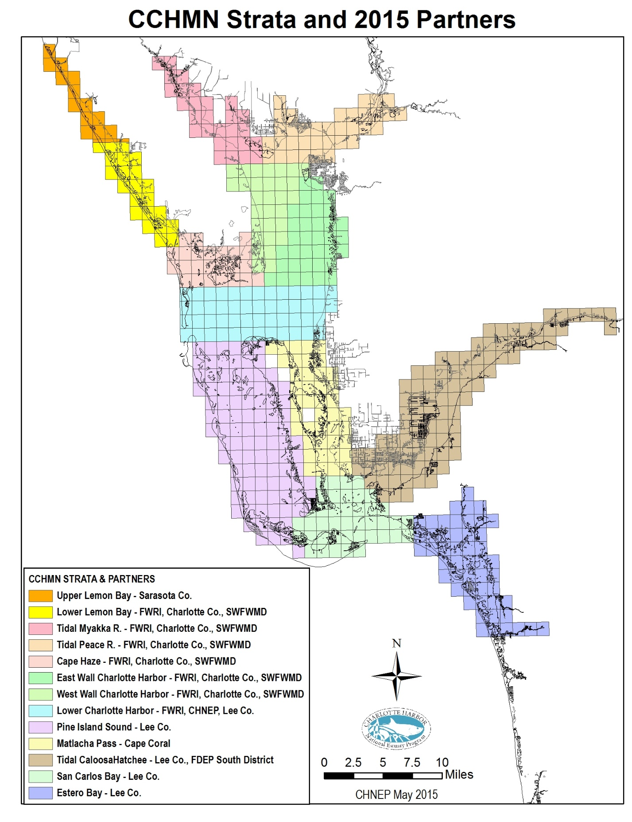

Figure 4: CCHMN Strata and Partners

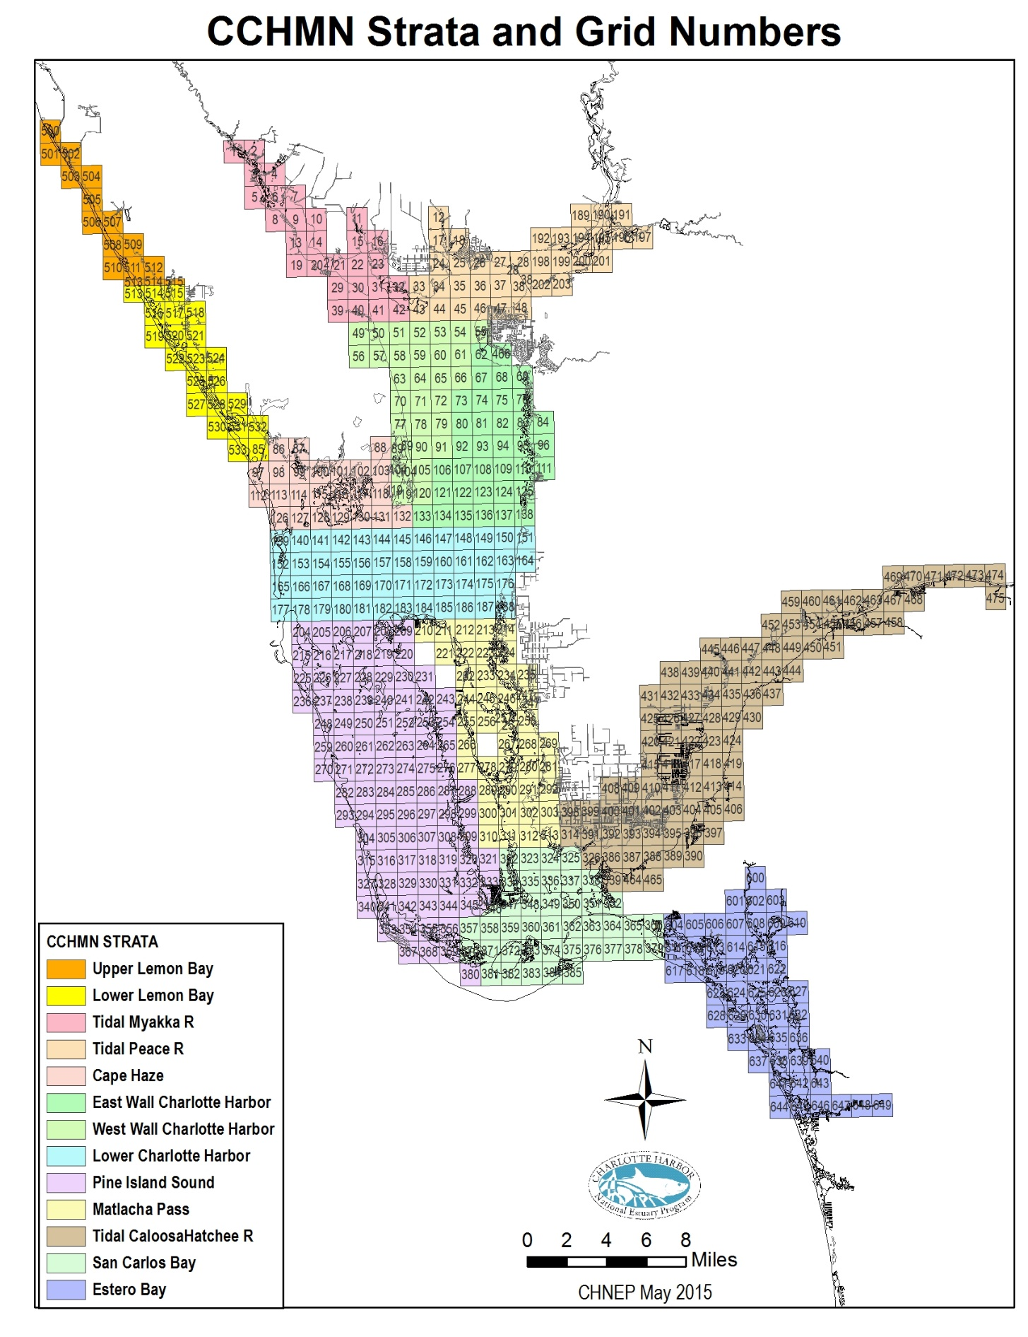

Figure 5: CCHMN Strata and Grid Numbers

**CCHMN Core Water Quality Analytes for Estuaries and Tidal Rivers**

The CCHMN core water quality analytes measured and collected in estuaries and tidal rivers collected according to FDEP 2017 SOPs (Effective 4/16/2018) Field testing overall – FT 1000

include:

**Measured In-Situ:**

* Depth (m)
* Secchi disc (m)
* Light attenuation (PAR; k)
* Temperature (oC) (FT 1400)
* Salinity (ppt) (FT 1300)
* Specific conductance (µS) (FT 1200)
* Dissolved oxygen (DO) (mg/L) (FT 1500)
* pH (pH units) (FT 1100)

**Water Samples Collected for Laboratory Analyses:**

.

* Color (PCU) (Standard Method (SM) 2120B, SM2120C 2011)
* Specific Conductance (µS) (not done in lab unless field QC fails, SM 2150B 2011)
* Turbidity (NTU) (SM 2130B, EPA180.1)
* Total suspended solids (TSS) (mg/L) (SM 2540D 2015, SM 2540D, SM 2540D, EPA160.2)
* Total organic carbon (TOC) (mg/L) (SM 5210B, SM 5310B 2011)
* Chlorophyll a (mg/L) (corrected for phaeophytin) (SM 1200H, SM 1200M, EPA445.0, Strickland & Parsons, SM10200H 2011)
* Total nitrogen (TN) (mg/L) (calculated from TKN + NOX)
* Total Kjeldahl nitrogen (TKN-N) (mg/L) (SM 4500NH3F, EPA351.2)
* Total ammonia nitrogen (mg/L) (SM 4500NH3F, SM4500NH3G, SM4500NH3H, SM184500NH3C, EPA350.1)
* Total nitrite plus nitrate nitrogen (mg/L) (SM4500NO3F, SM184500N3, EPA353.2)
* Dissolved orthophosphate (OP) (mg/L) (SM4500PE, SM184500PF, EPA365.1, EPA365.3)
* Total phosphorus (TP) (mg/L) (SM184500PF, SM4500PE, EPA365.1, EPA365.3, EPA365.4)

For water quality samples, a single sample will be collected at 0.5 meters below the surface for those locations where the bottom depth is less than 3.0 meters. For locations where the bottom depth is greater than 3.0 meters, two samples will be collected (0.5 meters below the surface and 0.5 meters above the bottom). Light attenuation will be taken for sites greater than 1.3 meters deep.

## Field Sampling and Laboratory Analysis Responsibilities

Currently (2019) the CCHMN field and laboratory partners are shown in Figure 4 and include:

* Lower Lemon Bay - field sampling by FWRI and laboratory analyses by Charlotte County contract laboratory (Benchmark Laboratory).
* Cape Haze/Gasparilla Sound - field sampling by FWRI and laboratory analyses by Charlotte County contract laboratory (Benchmark Laboratory).
* Tidal Myakka River - field sampling by FWRI and laboratory analyses by Charlotte County contract laboratory (Benchmark Laboratory).
* Tidal Peace River - field sampling by FWRI and laboratory analyses by Charlotte County contract laboratory (Benchmark Laboratory).
* Charlotte Harbor West Wall - field sampling by FWRI and laboratory analyses by Charlotte County contract laboratory (Benchmark Laboratory).
* Charlotte Harbor East Wall - field sampling by FWRI and laboratory analyses by Charlotte County contract laboratory (Benchmark Laboratory).
* Lower Charlotte Harbor - field sampling by FWRI and laboratory analyses by Lee County Environmental Laboratory.
* Pine Island Sound – field sampling and laboratory analyses by Lee County Environmental Laboratory.
* Matlacha Pass – field sampling and laboratory analyses by the City of Cape Coral.
* Tidal Caloosahatchee River – field sampling by FDEP Division of Environmental Assessment and Restoration, South Regional Operations and laboratory analyses by Lee County Environmental Laboratory.
* San Carlos Bay – field sampling and laboratory analyses by Lee County Environmental Laboratory.
* Estero Bay – field sampling and laboratory analyses by Lee County Environmental Laboratory.

Field sampling will be conducted according to the CCHMN Field Sampling Procedures described in the following sections. All laboratories involved in the CCHMN will follow all applicable federal and state guidelines for quality assurance and quality control of water quality analyses, including the use of appropriate duplicate samples and equipment blanks. It is strongly recommended that these laboratories be certified by The NELAC Institute (TNI) and meet FDEP laboratory certification requirements, pursuant to Chapter 62-160, FAC (DEP QA Rule).

It is also strongly recommended that all field sampling be conducted according to FDEP 2017 SOPs (Effective 4/16/2018). Water Samples Collected for Laboratory Analyses – FS 1000, FS 2000, FS 2100. (<https://floridadep.gov/dear/quality-assurance/content/dep-sops>)

Project Roles

CHNEP serves as coordinator for the Network. CHNEP houses and updates Standard Operating Procedures and Quality Assurance Project Plan Documents and works with CHNEP TAC and CCHMN partner agencies to make agreed upon changes to SOPs and QAPP Items to keep documents and practices current. CHNEP also directly funds sampling efforts to fill data gaps, hosts Annual CCHMN partners meeting, conducts field sampling audits, attends Southwest FL RAMP meetings, uploads data into CHNEP Water Atlas and funds maintenance and trend analysis features on CHNEP Water Atlas pages on behalf of partners.

Each month, CCHMN partners will be responsible for selecting random sampling grids and sites, conducting field measurements and recording results on field data sheets, collecting water quality samples, transporting samples to the laboratories for analysis, communicating field collection issues and quality assurance items to lab for continued refinement, communicating lab analyses issues and quality assurance items to field samplers for continued refinement, downloading data and providing copies of the field data sheets and data bases to appropriate data managers. To ensure data comparability, CCHMN quality assurance activities include: annual field audits conducted with each sampling partner; field and laboratory partner participation in the Southwest FL RAMP quarterly meetings and split-sample analyses; and CHNEP Management Conference review of data and statistical methods during regular water quality status and trends reporting. It is anticipated that further quality assurance measures will be implemented in the future as needed.

## Field Audits

CHNEP will be responsible for performing annual field audits for sample collection for each sampling agency. The results of these audits will be presented at an annual CCHMN meeting for this express purpose as well as resolve outstanding issues.

## Data Ownership

The data owner for each stratum will be responsible for data handling and uploading their respective data into the federal and state water quality data bases. The current data owners for each of the CCHMN Strata are:

* Upper Lemon Bay – Sarasota County
* Lower Lemon Bay – SWFWMD and Charlotte County
* Cape Haze – SWFWMD and Charlotte County
* Tidal Myakka River – SWFWMD and Charlotte County
* Tidal Peace River – SWFWMD and Charlotte County
* Lower Charlotte Harbor – Lee County Environmental Laboratory
* Pine Island Sound – Lee County Environmental Laboratory
* Matlacha Pass – Cape Coral Environmental Resources
* Tidal Caloosahatchee River – Lee County Environmental Laboratory
* San Carlos Bay – Lee County Environmental Laboratory
* Estero Bay – Lee County Environmental Laboratory

Data owners may assign the uploading of data to federal, state and water management district water quality databases to the certified lab undertaking the laboratory analysis of their field samples as part of a contract, but the data owner is ultimately responsible for ensuring this process is fulfilled. Data owners will also collaborate to the best of their ability to standardize data formatting.

Links to the CCHMN data on agency websites include:

* SWFWMD: <http://www.swfwmd.state.fl.us/data/water-quality/>.
* Lee County Environmental Laboratory: <http://leegis.leegov.com/surfwater/>
* LEGACY replaced with Florida WIN (Florida STORET: <http://storet.dep.state.fl.us/DearSpa/public/welcome>);(CCHMN OrgID numbers begin with CHNEP); and
* Florida WIN (Watershed Information Network): <http://prodenv.dep.state.fl.us/DearWin/public/welcomeGeneralPublic?calledBy=GENERALPUBLIC> (CCHMN OrgID numbers begin with CHNEP).

**Data Management**

The CCHMN data will be maintained and uploaded to federal, state and water management district water quality databases by data owners. The data will be available to public and partnering agencies at all times. The University of South Florida staff will upload CCHMN data to the CHNEP Water Atlas website (<http://www.chnep.wateratlas.usf.edu/> ) to facilitate public access to the data.

**Data Analysis**

The CHNEP will regularly analyze the CCHMN and make the results publicly available through the CHNEP Website Water Atlas website **(**<http://www.chnep.wateratlas.usf.edu/>). In addition, 10-year time series analyses of all collected parameters, are available on the CHNEP Water Atlas (<http://www.chnep.wateratlas.usf.edu/water-quality-trends/>).

Water quality status and trends reports incorporating the CCHMN data include:

* CHNEP Water Quality Status and Trends (Janicki Environmental, 2007)
* CHNEP Water Quality Targets (CHNEP, 2006)
* CHNEP Numeric Nutrient Criteria (Janicki Environmental, 2011)
* CHNEP Optical Model development (Dixon et al, 2014)
* CHNEP Water Atlas Water Quality Trends, Water Quality Dashboard and Preliminary Numeric Nutrient Criteria Calculator (Updated Annually),

## Participation in the Regional Ambient Monitoring Program (RAMP)

All participating CCHMN laboratories and field monitoring agencies will participate in Southwest Florida Regional Ambient Monitoring Program (Southwest FL RAMP) quarterly meetings and inter-laboratory split-sample exercises to help ensure data comparability region-wide. The SWF RAMP serves as a quality assurance forum for comparing split-sample laboratory results, resolving inconsistencies in results and discussing pertinent water quality monitoring issues throughout the region.

# Coastal Charlotte Harbor Monitoring Network Field Sampling Procedures

**Sample Collection**

1. **Site Selection:**

* Five sites per stratum will be sampled each month.
* Five grids per stratum will be randomly selected and sampling locations within each selected grids will be randomly selected.
* Sampling sites will be chosen and mapped prior to field sampling (see below for procedure).
* Alternate sites can be chosen if the water depth at the site is too shallow or it is not possible to access the site.

**B. Sample Acquisition:**

* Water samples shall be collected by using a horizontal sampling device, such as an Alpha or Niskin bottle
* All appropriate sample bottles shall be filled in the order listed below and labeled properly.

**C. Blank, Duplicate and Split Samples:**

* An equipment blank will be taken every sampling trip.
* Optionally (preferred) one duplicate every 10 sites or one every sampling trip will be taken.
* Split samples for the testing the precision of lab analysis is optional.

**D. Use of Protective Gloves:** FDEP recommends wearing protective gloves when conducting all sampling, but, their use is not mandatory. Use gloves if sampler has come in contact with potential contaminants (i.e., sun tan lotion, outboard motor oil):

**E. Container and Equipment Rinsing:** When collecting aqueous samples the sample collection equipment and non-preserved containers shall be rinsed three times with sample water before the actual sample is taken. This protocol shall not be followed for sample containers with pre-measured preservatives in the container (acidified bottles).

**F. Dedicated Equipment Storage:** All dedicated equipment shall be stored in a clean environment, protected from dirt and other sources of TN, TP, and TSS contaminants.

**G. Fuel-powered Equipment and Related Activities:** All sampling is done away from fuel-powered equipment activities. Samplers will make every effort to observe winds, currents and other parameters to ensure no contamination.

# H. Preservation - All certified labs participating in the CCHMN shall provide pre-preserved sample bottles to the sampling entity, ready for use. Samplers use an intermediate device to transfer the samples into the bottles, and don’t need to add acid preservative. Samplers should check the pH of the acid preserved samples (except for the TOC bottle with no air space) to make sure the pH <2. According to DEP SOP FS 2001, section 3.5

Decontamination

1. **Equipment Preparation:** All equipment shall be cleaned in a controlled environment and transported to the field pre-cleaned and ready to use.

* All equipment must be immediately rinsed with water after use, as specified below. Field cleaned equipment (pump tubing and re-usable filters) shall be cleaned between samples.
* Alpha bottles shall be cleaned with ambient sample water, while the pump tubing and re-usable filters shall be cleaned with deionized water (between samples).
* Proper cleaning protocol, upon return to the field lab, is followed.
* Detergents used shall be Liquinox (or equivalent) or Alconox (or equivalent).
* Deionized water is used as the final rinse for all cleaning (suitable for only inorganic analyses (metals, nutrients, etc.).

Aqueous Sampling Procedures

1. **General:** There are several requirements that are common to all types of surface water sampling events and are independent of technique. Several of these requirements are concerned with sample parameters that are inherently difficult to sample. In addition to the below procedures, overall care must be taken in regards to equipment handling, container handling/storage, decontamination, and record keeping.

* Sample collection equipment and non-preserved sample containers must be rinsed with sample water before the actual sample is taken.
* If protective gloves are used they shall be clean, new and disposable. These should be changed prior to the next sampling site.
* If possible, one member of the field team should take all the notes, fill out tags, etc., while the other member does all of the sampling. To ensure sampling precision, each member should continue to assume the same duties for the entire sampling trip, especially secchi disk readings.

1. Sampling Site Access: Access will be left up to the sampling group. Ease of access should not be the main criteria for sampling site choice. If sampling by boat, there are certain precautions that must be considered:

* If sampling with a boat, samples should be taken from the bow, away and upwind from any gasoline outboard engine.
* Every effort will be taken to prevent contamination. (Charlotte Harbor –FWC-FWRI—has mid-hull engines and does sampling behind the outboard and fuel tank. Winds, currents and boat position shall be taken into account when sampling, in order to meet these criteria.)
* Care should be taken not to disturb sediments when motoring to the sampling sites (especially shallow water sites).

1. **Site Selection:** Five sites per stratum per month will be sampled. Samples shall be randomly selected for every month and every stratum.

* Each month, five random grids (1 X 1 nautical mile) within each stratum will selected
* Each grid within each stratum is numbered and a GIS layer of the grid coordinates and numbers for each of the 13 strata is available from the CHNEP office (Figure 5).
* Using the randomly selected grids for each stratum, the latitude and longitude coordinates for the sampling locations within that grid will be randomly selected using a GIS or other program.
* The sampling site latitude and longitude coordinates will be recorded in decimal degrees (i.e.: 26.625801; -81.897886).
* Every attempt to collect samples from the pre-selected sites should be made.
* Both selected and actual sample locations should be recorded on the datasheets. Any alteration from the pre-selected site will be noted.
* Site changes will be done in this order:
* If site is too shallow or on land, then movement from the selected site toward the Intracoastal Waterway or center of grid until appropriate depths are achieved (1.0 m in Charlotte Harbor, tidal Peace and Myakka rivers; 0.7 m in Lemon, San Carlos and Estero Bays; 0.7 m in Bokeelia section of Charlotte Harbor, Pine Island Sound, Matlacha Pass and tidal Caloosahatchee River).
* If the grid has a deeper area, and no channel nearby, movement will be made toward that area until depths are achieved.
* If the area is shallow and the knowledge of the grid dictates that water level (or other factors) will not allow for sampling, then an alternate grid can be chosen.
* Priority of the grid selection should include (region/stratum is first, Grid is next, sample area is last.
* If alternate sites are sampled,
  + sampling must not be done more than once per grid,
  + the grid must remain in the same region or strata,
  + the closest grid to the original grid should be chosen unless conditions in surrounding grids are similar

1. Sample Acquisition: Water samples will be collected according to FDEP 2017 SOPs (Effective 4/16/2018) Water Samples Collected for Laboratory Analyses – FS 1000, FS 2000, FS 2100. Samples are taken using a horizontal sampling device, such as an Alpha or Niskin bottle, with depths taken from the center of the container. Sample acquisition will follow these procedures:

* The initial grab is taken at 0.5 m below the surface.
* If the sample site > 3m, then an additional sample is taken at 0.5 m above the bottom.
* Once the sampling device is triggered and sample is trapped, the sample is brought on board.
* The proper order for filling sample bottles is as follows: non-preserved, preserved and finally filtered samples.
* Filtered samples (Orthophosphate) shall be collected by a peristaltic pump or syringe-filter combination. All filters will be 0.45 microns.
* The tubing for the peristaltic pump is rinsed with the sample water (through the spigot). Non-preserved bottles will be rinsed with sample water prior to filling.
* Total Organic Carbon (TOC) sample bottles when filled to include a convex meniscus shall not contain head space. Small bubbles smaller than pea-size are permissible. The most effective way to accomplish this is to collect the sample with the sample bottle tilted toward the spigot of the Alpha or Niskin bottle, not straight up and down.
* Ensure all caps are tightened prior to placing sample bottles in ice chests.
* Once filled, all bottles shall be put in ice in sampling coolers according to FDEP protocols

1. Data Measurements and Recording – Each member of the field sampling team will conduct the same tasks throughout the sampling event. One field sampler will record environmental parameters, light attenuation measurements, multi-parameter sampling meter (Hydrolab or YSI) readings, Secchi disks values and any other pertinent information needed. Measurements will be taken and recorded as following:

* Secchi disk depths shall be taken on shady side of boat without the use of sunglasses, and light meter readings will be taken on sunny side of boat.
* Multi-parameter sampling meter values (pH, DO, salinity, pH, and temperature) shall be recorded to the nearest 0.01 values, except conductivity, which is recorded to the nearest unit.
* Values shall be measured and recorded at 0.5 m below the surface at all sites.
* Values shall be measured and recorded at 0.5 m above the bottom for sites deeper than >1m depths, and optionally for all sites >1.5 m.
* Values may also optionally (preferred) be measured and recorded at 1 m depth profiles throughout the water column at sites >3 m.
* Depths shall be recorded from the probes, not the bottom of the instrument.
* Bottom composition information (mucky, sandy, submerged aquatic vegetation, hard bottom or unknown) will be recorded.
* Additional information is recorded as per the datasheet (see attachment).
* An example CCHMN field data sheet is shown in Appendix A.

1. **Light Measurements**: Light attenuation readings will be taken and recorded using a Licor according to the below procedure. This information will be used to update/calibrate the Optical Model for CHNEP and Charlotte Harbor region.

* Underwater sensors may be 2 pi (flat) or 4 pi (round). It is preferable to use similar sensors throughout the CCHMN, but 2 pi sensors may be used in the SWFWMD strata and 4 pi sensors may be used in the SFWMD strata.
* Underwater light meters will be mounted 0.5 m apart on a PVC pole frame with depths accurately and clearly marked.
* Before each sampling event, the light meter underwater sensor readings will be validated by taking simultaneous readings in the air and recording the values for each sensor on the data sheet, so that the readings may be used as correction factors during data analysis as needed. The most effective way to accomplish this is to hold the PVC frame out of the water, pointed directly towards the sun away from your body or any other objects. If both sensors’ reading are within 5% of one another while performing this validation, there is no need to send meters for manufacturer calibration.
* The light meter data logger will be set to average readings every 5 seconds and the data will be recorded after the readings stabilize (about 30 seconds).
* A data qualifier will be used to record bottom composition information (mucky, sandy, submerged aquatic vegetation, hard bottom or unknown), especially when using a 4 pi sensor over white, sandy sediments.
* During field sampling at each site, underwater light meter measurements will be recorded simultaneously with the PVC pole frame held vertically in the water without shading the sensors by the boat, equipment, submerged aquatic vegetation or algae. Air sensor measurement(s) will be recorded simultaneously with corresponding underwater readings while placed on a level surface on the boat.
* In rough waves, the PVC pole frame with the underwater sensors will be held with the appropriate depth mark held as stable as possible at the water surface. The most effective way to accomplish this is to have the person holding the PVC pole frame lean over the water, ensuring all safety precautions have been met, and act as a “gimbal” as the boat moves under them.
* **For sites < 2.0 m**, light meter measurements will utilize one air measurement and two underwater light measurements taken simultaneously at depths of 0.5 m and 1.0 m below the surface.
* **For sites > 2 m**, light meter measurements will utilize one air measurement and two underwater measurements collected simultaneously. Underwater light measurements will be taken at depths of 0.5 m and 1.0 m below the surface and 0.5 m and 1.0 m above the bottom.
* **For sites > 3 m** (Optional), light meter measurements will utilize one air measurement and two underwater measurements collected simultaneously. Underwater light measurements will be taken at depths of 0.5 m and 1.0 m below the surface, 0.5 m and 1.0 m above the bottom or the lowest depth the light measurement pole can reach. **and at 1.0 m increments between the surface and bottom.**

Table 1. Depths for light attenuation data collection.

| **Water Depth (m)** | **Light Meter Measurement Depths (m)** | | | |
| --- | --- | --- | --- | --- |
| **1** | **2** | **3** | **Air** |
| **1.3 - 2.0** | 0.5/1.0 | - | - | Optional |
| **2.1** | 0.5/1.0 | 1.1/1.6 | - | Required |
| **2.2** | 0.5/1.0 | 1.2/1.7 | - | Required |
| **2.3** | 0.5/1.0 | 1.3/1.8 | - | Required |
| **2.4** | 0.5/1.0 | 1.4/1.9 | - | Required |
| **2.5** | 0.5/1.0 | 1.5/2.0 | - | Required |
| **2.6** | 0.5/1.0 | 1.6/2.1 | - | Required |
| **2.7** | 0.5/1.0 | 1.7/2.2 | - | Required |
| **2.8** | 0.5/1.0 | 1.8/2.3 | - | Required |
| **2.9** | 0.5/1.0 | 1.9/2.4 | - | Required |
| **3.0** | 0.5/1.0 | 1.5/2.0 | 2.0/2.5 | Required |
| **>3.0** | 0.5/1.0 | 1.5/2.0 | 2.0/2.5 | Required |

**Sample Transport**

Each laboratory will provide sampling field staff with pre-labeled bottles and equipment as needed. Field sampling staff will arrange for water samples to be delivered to the laboratory within that allotted sample holding time. Sample transport will follow appropriate Chain of Custody procedures between field and laboratory partners, including proper sample preservation and temperature requirements. Chain of Custody forms will be kept on file with the laboratories, available on request.

# Budget

Table 1: Example CCHMN estimated budget.

|  |  |  |  |  |  |
| --- | --- | --- | --- | --- | --- |
| **Agency** | **Strata** | **Field Sampling** | **Laboratory Analyses** | **Funding Mechanism** | **Agency Total** |
| **Southwest FL Water Management District/ CHNEP** | Lower Lemon Bay; Cape Haze; Tidal Myakka, Tidal Peace, Charlotte Harbor East & West Walls | Conducted by FWRI. | Conducted by Charlotte Co. Contract Lab. | Cooperative Agreement with CHNEP & contract with FWRI. |  |
|  |  | $74,000 | $0 |  | $74,000 |
| **FWC FL Fish & Wildlife Research Institute** | Lower Lemon Bay; Cape Haze; Tidal Myakka, Tidal Peace, Charlotte Harbor East & West Walls | Conducted by FWRI. 7 strata X 5 samples/strata X 12 months | Conducted by Charlotte Co. Contract Lab. & Lee County Environ. Lab. | Cooperative Agreement with CHNEP & contract with FWRI. |  |
|  |  | $0 | $0 |  | $0 |
| **Charlotte County** | Lower Lemon Bay; Cape Haze; Tidal Myakka, Tidal Peace, Charlotte Harbor East & West Walls | Conducted by FWRI. | Conducted by Charlotte Co. Contract Lab. 6 Strata X 5 samples/strata X 12 months. | Charlotte Co. budget & contract with lab. |  |
|  |  | $0 | $42,000 |  | $42,000 |
| **FDEP Environmental Assessment & Restoration** | Tidal Caloosahatchee | Conducted by FDEP EAR. 1 stratum X 5 samples/strata X 12 months | Conducted by Lee Co. Environ. Lab. | FDEP budget. |  |
|  |  | $7,500 | $0 |  | $7,500 |
| **Lee County** | Charlotte Harbor Lower, Pine Island Sound, Tidal Caloosahatchee, San Carlos Bay, Estero Bay | Conducted by Lee Co. Environ. Lab. 3 strata X 5 samples/strata X 12 months | Conducted by Lee Co. Environ. Lab. 5 strata X 5 samples/strata X 12 months | Lee Co. budget. |  |
|  |  | $22,500 | $121,000 |  | $143,500 |
| **CHNEP** | Charlotte Harbor Lower | Conducted by FWRI. 1 strata X 5 samples/month X 12 months | Conducted by Lee Co. Environ. Lab. | CHNEP budget & contract with FWRI. |  |
|  |  | $13,000 | $3,420 |  | $16,240 |
| **City of Cape Coral** | Matlacha Pass | Conducted by Cape Coral Environ. Resources. 1 strata X 5 samples/month X 12 months | Conducted by Cape Coral Water Plant. 1 strata X 5 samples/strata X 12 months | Cape Coral budget. | $16,000 |
|  |  | $5,500 | $10,500 |  | $16,000 |
| **TOTAL** |  | **$100,500** | **$173,500** |  | **$274,000** |

**References**

Charlotte Harbor National Estuary Program. 2014. *Comprehensive Conservation and Management Plan Update 2013,* Charlotte Harbor National Estuary Program, Punta Gorda, FL. [www.chnep.org](http://www.chnep.org)

Charlotte Harbor National Estuary Program. 2008. *Comprehensive Conservation and Management Plan Update 2008,* Charlotte Harbor National Estuary Program, Punta Gorda, FL. [www.chnep.org](http://www.chnep.org)

Charlotte Harbor National Estuary Program. 2008. *Environmental Indicators Update 2008.* Charlotte Harbor National Estuary Program, Punta Gorda, FL. [www.chnep.org](http://www.chnep.org)

Charlotte Harbor National Estuary Program. 2006. Numeric Water Quality Targets for Lemon Bay, Charlotte Harbor and Estero Bay, Florida. CHNEP Technical Report 06-03. Charlotte Harbor National Estuary Program, Punta Gorda, FL. [www.chnep.org](http://www.chnep.org)

Charlotte Harbor National Estuary Program. 2004. *Coastal Charlotte Harbor Monitoring Network Description and Standard Operating Procedures.* CHNEP Technical Report 02-03. Charlotte Harbor National Estuary Program, Punta Gorda, FL. [www.chnep.org](http://www.chnep.org)

Charlotte Harbor National Estuary Program. 2000. *Comprehensive Conservation and Management Plan,* Charlotte Harbor National Estuary Program, Punta Gorda, FL. [www.chnep.org](http://www.chnep.org)

Charlotte Harbor National Estuary Program. 2000. *Long Term Monitoring Strategy and Gaps Analysis*, Charlotte Harbor National Estuary Program, Punta Gorda, FL. [www.chnep.org](http://www.chnep.org)

Dixon, L.K. and M. R. Wessel. 2014. *The optical Model Spectral Validation and Annual Water Clarity Reporting Tool Final Report*. Mote Marine Laboratory Technical Report No. 1748. Charlotte Harbor National Estuary Program, Punta Gorda, FL. [www.chnep.org](http://www.chnep.org)

Florida Department of Environmental Protection 2017 SOPs (Effective 4/16/2018): <https://floridadep.gov/dear/quality-assurance/content/dep-sops>.

Janicki Environmental, Inc. 2011. *Charlotte Harbor Numeric Nutrient Criteria: Task 8 – TN and TP Loading and Concentration Based Criteria.* Charlotte Harbor National Estuary Program, Punta Gorda, FL. [www.chnep.org](http://www.chnep.org)

Janicki Environmental, Inc. 2007. *Water Quality Data Analysis and Report for the Charlotte Harbor National Estuary Program.* Charlotte Harbor National Estuary Program, Punta Gorda, FL. [www.chnep.org](http://www.chnep.org)

Southwest Florida Water Management District. 1995. *A Long-Term Water Quality Monitoring Design for Charlotte Harbor, Florida*, Southwest Florida Water Management District, SWIM Department, Tampa, FL.

St. Johns River Water Management District.2000. *Florida’s Integrated Water Resource Monitoring Network*, St. Johns River Water Management District.

# Appendix A: Example CCHMN Field Equipment Check List

|  |  |
| --- | --- |
| **CCHMN Field Equipment Check List** | |
| **Date:________________ Strata: __________________________________** | |
| **Agency:______________ Samplers:_______________________________** | |
|  |  |
|  | **Equipment & Supplies** |
|  | CCHMN SOPs |
|  | Sampling Site Locations |
|  | Sampling Site Maps |
|  | Data Sheets |
|  | Pens, Pencils, Sharpies |
|  | Chain of Custody Forms |
|  | GPS |
|  | Depth Finder |
|  | DI Water |
|  | Secchi |
|  | YSI or Hydrolab & Extra Weight (Sonde #________________) |
|  | Alpha Bottle |
|  | Licor |
|  | Pump or Syringes |
|  | Filter Holders, Filters, Forceps |
|  | Sample Bottle Kits |
|  | Coolers |
|  | Ice |
|  | If Acidify Sample in Field, Acid Vials (SO4 & NO3) & Waste Container |
|  | Equipment Spare Parts & Tool Box |
|  | Truck Notebook |
|  | Boat Notebook |
|  | PFDs |
|  | Sunscreen & Bug Repellant |
|  | Cellphone & Handheld Radio |
|  | Paddle |
|  | Throwable PFD |
|  | Horn or Whistle |
|  | First Aid Kit |
|  | Flares |
|  | Other: |
|  | Other: |
|  | Other: |

# 

# Appendix B: Example CCHMN Data Sheet

# Appendix C: Example CCHMN Chain of Custody Form

**Appendix D: Example CCHMN Annual Audit Form**



