Coastal Charlotte Harbor Monitoring Network
Field Sampling
Quality Assurance Project Plan

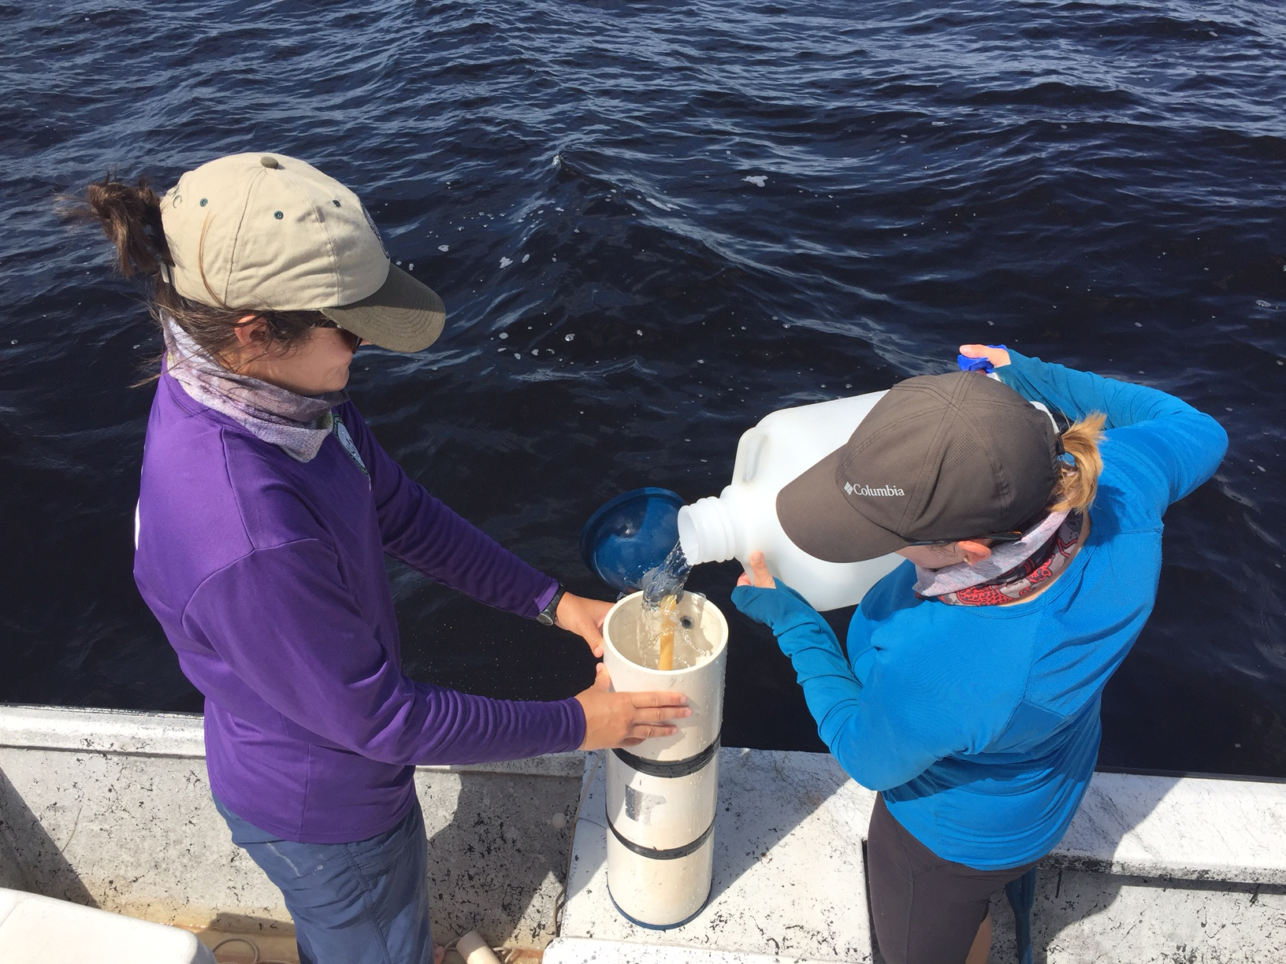

Coastal & Heartland National Estuary Partnership
Edited 2023

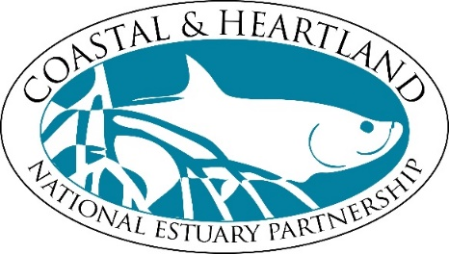

1050 Loveland Blvd.
Port Charlotte, FL 33980
941-833- 6580

www.CHNEP.org

Section A - Project Management

A.1 Title and Approval Sheet

Coastal Charlotte Harbor Monitoring Network Field Sampling Quality Assurance Project Plan

Prepared by
Coastal & Heartland National Estuary Partnership
326 W. Marion Ave, Punta Gorda, FL 33950
Prepared for
US Environmental Protection Agency
Sam Nunn Atlanta Federal Center
61 Forsyth St., SW
Atlanta, GA 30303
This Quality Assurance Project Plan (QAPP) has been prepared according to guidance provided in the USEPA Guidance for Quality Assurance Project Plans (EPA QA/G-5. EPA/240/R-02/009, U.S. Environmental Protection Agency, Office of Environmental Information, Washington, DC, December 2002) to ensure that environmental and related data collected, compiled and/or generated for the project are complete, accurate, and of the type, quantity and quality required for their intended use. The Coastal and Heartland National Estuary Partnership (CHNEP), with the City of Punta Gorda, Florida, as its fiscal host, will conduct work in conformance with the quality assurance program.
Concurrences and Approvals:

_______________________________________________ __________________
Jennifer Hecker (Project Manager) Date
Executive Director, Coastal & Heartland National Estuary Partnership

_______________________________________________ __________________
Rachel Hart (Quality Assurance Officer) Date
United State Environmental Protection Agency

_______________________________________________ __________________
Jennifer DiMaio (QAPP Approving Official) Date
United State Environmental Protection Agency

A.2 Table of Contents
Section A - Project Management i
A.1 Title and Approval Sheet i
A.2 Table of Contents ii
A.3 Distribution List 1
A.4 Project and Task Organization 2
A.5 Location, Background, Study Area and Problem Definition 4
A.6 Project and Task Descriptions 10
A.7 Objectives and Criteria for Measurement Data 13
A.8 Special Training and Certification 15
A.9 Documentation and Records 16
Section B - Project Design 17
B.1 Sampling Design 17
B.2 Sampling Methods 18
B.3 Sample Handling and Custody 23
B.5 Quality Control 25
B.6 Instrument/Equipment Testing, Inspection and Maintenance 26
B.7 Instrument Calibration and Frequency 26
B.9 Non-Direct Measurements 27
B.10 Data Management 28
Section C - Project Assessment and Oversight 29
C.1 Assessments and Response Actions 29
C.2 Reports to Management 30
Section D – Data Validation and Usability 31
D.1 Data Review, Validation and Verification 31
D.2 Validation and Usability 31
Section E – References 32
Section F – Appendices 33
Appendix F.1: CCHMN Lower Charlotte Harbor Field Sampling Equipment List 33
Appendix F.2: CCHMN Lower Charlotte Harbor Field Sampling Data Sheet 34
Appendix F.3: Coastal Charlotte Harbor Monitoring Network Standard Operating Procedures 2015 Updates 35

List of Figures
Figure 1: CCHMN Lower Charlotte Harbor Field Sampling Organizational Chart. 3
Figure 2: CHNEP Study Area. 5
Figure 3: CHNEP Strata 6
Figure 4: CCHMN Estuary Strata and Partners (2015). 7
Figure 5: CCHMN Lower Charlotte Harbor Estuary Stratum. 9
Figure 6: YSI Meter Calibration Report Form 21
Figure 7: LCEL Chain of Custody Record Form. 23

List of Tables
Table 1: List of Commonly Used Acronyms iv
Table 2: CCHMN Lower Charlotte Harbor Field Sampling Distribution List. 1
Table 3: CCHMN Lower Charlotte Harbor Field Sampling Personnel and Responsibilities. 2
Table 4: CCHMN Lower Charlotte Harbor Field Sampling Tasks and Schedule. 12
Table 5: CCHMN Lower Charlotte Harbor Field Sampling Parameters and Water Quality Standards. 14
Table 6: CCHMN Lower Charlotte Harbor Field Sampling Measurement and Sample Collection Methods. 18
Table 7: CCHMN Lower Charlotte Harbor Field Sampling Equipment and Supply Needs. 19
Table 8: CCHMN Lower Charlotte Harbor Field Sampling Containers, Preservation Methods and Holding Times. 22
Table 9: CCHMN Lower Charlotte Harbor Field Sampling Analytical Methods Used by LCEL. 24

Table 1: List of Commonly Used Acronyms
Acronym | Definition
BMAP | Basin Management Action Plan
CCHMN | Coastal Charlotte Harbor Monitoring Network
CCMP | Comprehensive Conservation Management Plan
CHNEP | Charlotte Harbor National Estuary Program
CWA | Clean Water Act
DO | Dissolved Oxygen
DQO | Data Quality Objective
FDEP | Florida Department of Environmental Protection
FFWCC | Florida Fish and Wildlife Conservation Commission
FIM | FWRI Fisheries Independent Monitoring Program
FWRI | FFWCC Fish and Wildlife Research Institute
LCEL | Lee County Environmental Laboratory
MFLs | Minimum Flows and Levels
NELAC | National Environmental Laboratory Accreditation Certification
PAR | Photosynthetically Active Radiation
QA | Quality Assurance
QAPP | Quality Assurance Project Plan
QC | Quality Control
RAMP | (Southwest Florida) Regional Ambient Monitoring Program
SOPs | Standard Operating Procedures
TAC | Technical Advisory Committee
TMDL | Total Maximum Daily Loads
TN | Total Nitrogen
TNI | The NELAC Institute
TOC | Total Organic Carbon
TP | Total Phosphorus
TSS | Total Suspended Solids
USEPA | United States Environmental Protection Agency
YSI | Yellow Springs Instrument multi-parameter water sampling meter

A.3 Distribution List

Distribution List

This original quality assurance project plan, and any subsequent revisions or modifications, shall be distributed to the below listed individuals who are identified by organizational affiliations and project specific roles. If additional individuals become involved with this project, the quality assurance project plan shall be distributed to those individuals as well.

Table 2: CCHMN Lower Charlotte Harbor Field Sampling Distribution List.
QAPP Recipient | Organization | Project Role
Jennifer  Hecker | Coastal & Heartland National Estuary Partnership (CHNEP)  1050 Loveland Blvd.  Port Charlotte, FL 33980 | Project Contact: Principal Investigator; All Aspects
Nicole Iadevaia | Coastal & Heartland National Estuary Partnership (CHNEP)  1050 Loveland Blvd.  Port Charlotte, FL 33980 | Project Contact: Project Field Investigator, Quality Assurance, Data Management; All Aspects of Project
Rachel Hart | U.S. Environmental Protection Agency (USEPA) – Region 4  61 Forsyth Street SW  Atlanta, GA 30303 | EPA Liaison: Quality Assurance Officer
Jennifer DiMaio | U.S. Environmental Protection Agency (USEPA) – Region 4  61 Forsyth Street SW  Atlanta, GA 30303 | EPA Liaison: QAPP Approving Official

A.4 Project and Task Organization

Project Organization

The purpose of this document is to present the Quality Assurance Project Plan (QAPP) for the Coastal Charlotte Harbor Monitoring Network (CCHMN).. The CCHMN is a monthly, stratified random water quality monitoring program conducted throughout the Coastal & Heartland National Estuary Partnership (CHNEP) (Figure 2) estuaries by multiple field and laboratory partners. CHNEP coordinates with the CCHMN and partners conduct the water quality monitoring throughout the 13 CHNEP estuary regions (stratum) (Figure 3) using consistent Standard Operating Procedures (CHNEP, 2023). CHNEP provides funding support to the Florida Fish and Wildlife Commission (FFWCC) Fish and Wildlife Research Institute (FWRI) to conduct CCHMN field sampling in the six upper Charlotte Harbor strata (Figure 5). CHNEP also provides funding support for Lee County Environmental Laboratory (LCEL) to conduct CCHMN field sampling in the Lower Charlotte Harbor strata. CHNEP serves as coordinator for the Network. CHNEP houses and updates Standard Operating Procedures and Quality Assurance Project Plan Documents and works with CHNEP TAC and CCHMN partner agencies to make agreed upon changes to SOPs and QAPP Items to keep documents and practices current. CHNEP also directly funds sampling efforts to fill data gaps, hosts Annual CCHMN partners meeting, conducts field sampling audits, attends Southwest FL RAMP meetings, uploads data into CHNEP Water Atlas and funds maintenance and trend analysis features on CHNEP Water Atlas pages on behalf of the partners. Additional support for CCHMN field and laboratory activities is provided by funding and in-kind match from the partners.

This QAPP provides general descriptions of: 1) the organizational hierarchy of the project with roles and responsibilities; 2) project goals, objectives, and tasks to be completed for this project;
3) data quality objectives and quality control quality assurance steps used in the collection of additional data; and 4) assessment and oversight protocols including validation and verification procedures for ensuring data usability.

The CCHMN Partner Roles are outlined in the CCHMN Standard Operating Procedures (Attachment 1)This project structure provides the framework for accomplishing the project tasks, facilitating project performance, and adhering to quality control (QC) procedures and quality assurance (QA) requirements.

Project Contact
Jennifer Hecker (CHNEP)
Project Contact
Nicole Iadevaia (CHNEP)
Field Sampling
CCHMN Partners as Outlined in CCHMN SOPs
Laboratory Support
CCHMN Partners as Outlined in CCHMN SOPs
Data Management
CCHMN Partners as Outlined in CCHMN SOPs

Figure 1: CCHMN Lower Charlotte Harbor Field Sampling Organizational Chart.

Jennifer Hecker is the Executive Director of the Coastal and Heartland National Estuary Partnership (CHNEP), serving as Project Manager for all project management functions including questions regarding finance and grant management related to the CCHMN Field Sampling Project.

Nicole Iadevaia is the Director or Research & Restoration for the CHNEP, serving as Contact for quality assurance regarding all aspects of data management for the CCHMN Field Sampling Project.

A.5 Location, Background, Study Area and Problem Definition

This purpose of this document is to incorporate updated staff, dates, field, laboratory, and data management information into the Coastal Charlotte Harbor Monitoring Network (CCHMN) Standard Operating Procedures (SOPs). The original Coastal Charlotte Harbor Monitoring Network Description and Standard Operating Procedures (CHNEP Technical Report 02-03) were approved by the Coastal & Heartland National Estuary Partnership (CHNEP) Management Conference on March 19, 2004 (CHNEP, 2004; available at www.chnep.org).

The CCHMN is a regional partnership of agencies (managed under the CHNEP) initiated in 2001 that collects monthly water quality data using consistent, technically sound sampling design. Long-term random sampling of strategically located stations allows scientific assessment of status and trends. CCHMN field and laboratory partners collect and analyze water samples from 60 randomly selected field sites throughout 10 waterbodies each month, including Lemon Bay, Cape Haze/Gasparilla Sound, Charlotte Harbor, Pine Island Sound, Matlacha Pass, San Carlos Bay, Estero Bay and the Tidal Myakka, Peace, and Caloosahatchee Rivers (Figure 3). Fifteen water quality parameters are measured and analyzed using consistent field and laboratory methods (CHNEP 2015 and CHNEP 2016).

Data are uploaded biannually by partners to WIN (Watershed Information Network), previously called STORET (Storage and Retrieval), a standard, common public database maintained by the Florida Department of Environmental Protection (FDEP). In addition, all contributing CCHMN laboratories and field monitoring agencies participate in Southwest Florida Regional Ambient Monitoring Program (SWF RAMP) quarterly meetings to help ensure region-wide data and methodology comparability. The SWF RAMP serves as a quality assurance forum for comparing split-sample laboratory results, resolving inconsistencies in results, and discussing pertinent water quality monitoring issues throughout the region.

Identifying waterbody impairments, establishing pollutant limits, and monitoring progress of corrective management actions all depend on the availability of accurate, high-quality data. Protocols and procedures must be employed to ensure that data are properly collected, handled, processed, used, and maintained at all stages of the data lifecycle. CCHMN supplements other ongoing water quality monitoring programs implemented by partners, including ongoing fixed station monitoring by counties, cities, agencies, and citizen scientists.

CHNEP management activities for CCHMN include developing and updating Standard Operating Procedures and field Quality Assurance (QA) Plans, conducting annual field audits, contracting and assisting with field water quality sampling and equipment repair, hosting annual meetings, and participating in quarterly RAMP quality assurance meetings. These activities are developed to be consistent with FDEP QA Rules (62-160, F.A.C.).

Activities in the CHNEP are guided by the Comprehensive Conservation and Management Plan 2019 (CCMP) and identified as a priority in the CHNEP Monitoring Strategy (2020) (CHNEP, 2019; available at www.chnep.org).
The CCMP identifies four Priority Actions throughout the CHNEP area relating to:
• Water Quality Improvement
• Hydrological Restoration
• Fish, Wildlife, and Habitat Protection
• Public Engagement

The CCHMN implements the CCMP Priority Actions relating to Water Quality Improvement including:
• Water Quality Improvement Action 1: Support a comprehensive and coordinated water quality monitoring and assessment strategy.

• Activity 1.1: Assist with the consistent and efficient collection of technically-sound long-term water quality data throughout the CHNEP area, including supporting key programs like the Coastal Charlotte Harbor Water Quality Monitoring Network, partners’ long-term fixed stations, and volunteer monitoring programs like the Charlotte Harbor Estuaries Volunteer Monitoring Network, Lee County Pond Watch, and the Cape Coral Canal Watch programs. Work with partners to obtain additional resources, increase efficiencies, and identify and fill sampling gaps.
• Activity 1.2: Support uploading and archiving of data in standard, common public databases, including FDEP’s database and the CHNEP Water Atlas.

This data is also used for scientific assessment of water quality trends and is an essential component of water quality assessments and resource management decisions throughout the CHNEP watersheds and waterbodies. The CCHMN data is an essential component of many water quality assessments and resource management decisions throughout the CHNEP estuarine and tidal waters. The data is critical for linking development of water quality criteria with evaluation and assessment of waterbodies to determine if they are meeting regulatory requirements.

Sampling Design
The CHNEP estuaries are divided into 13 strata based on those used by the FWC Fish and Wildlife Research Institute (FWRI) Fisheries Independent Monitoring program (FIM) and extensive review by the CHNEP technical community. Each stratum has relatively homogeneous water quality conditions and is divided into square mile grids, as used by FWRI FIM. Within 12 of the strata five grids are randomly selected and then sampling sites within each of the selected grids are randomly selected each month. This allows the CCHMN to collect data within each stratum at five sites per month, adding up to 60 samples per stratum per year. Throughout the CHNEP estuaries, CCHMN partners provide consistent water quality data at 60 sites per month and 720 sites per year. Sarasota County conducts water quality monitoring in the final stratum (Upper Lemon Bay) monthly through an ambient monitoring program, however site selection is not in conformance with the CCHMN SOPs.

The 12 strata sampled monthly in accordance with the CCHMN SOPs are shown in Figure 4 and include:
- Lower Lemon Bay
- Cape Haze/Gasparilla Sound
- Tidal Myakka River
- Tidal Peace River
- Charlotte Harbor West Wall
- Charlotte Harbor East Wall
- Lower Charlotte Harbor
- Pine Island Sound
- Matlacha Pass
- Tidal Caloosahatchee River
- San Carlos Bay
- Estero Bay

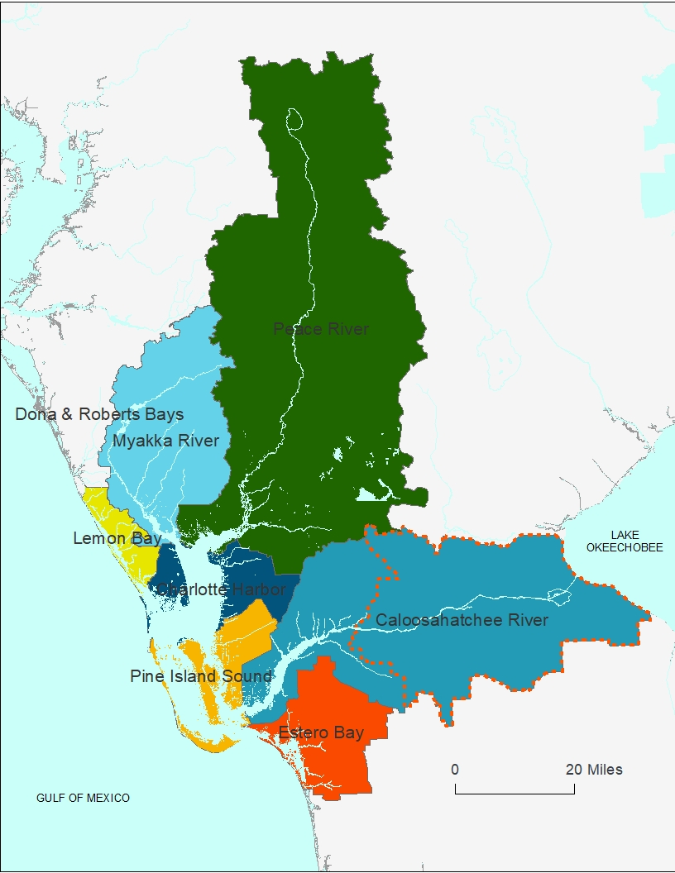
Figure 2: The basins within the CHNEP area.

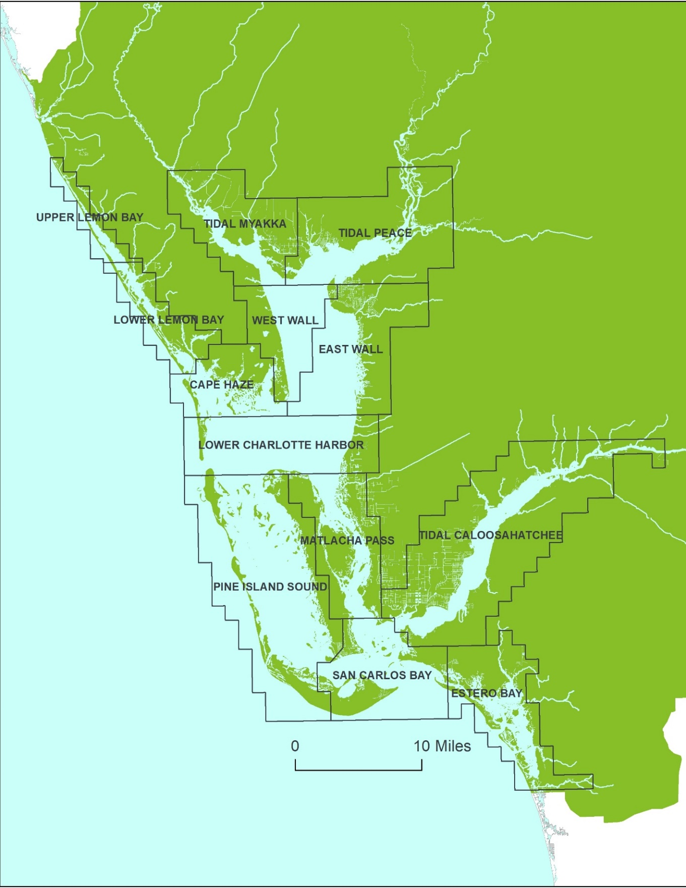
Figure 3: CCHMN water quality sampling strata. CCHMN field and laboratory partners collect and analyze water samples from 60 randomly selected field sites throughout 10 waterbodies each month.
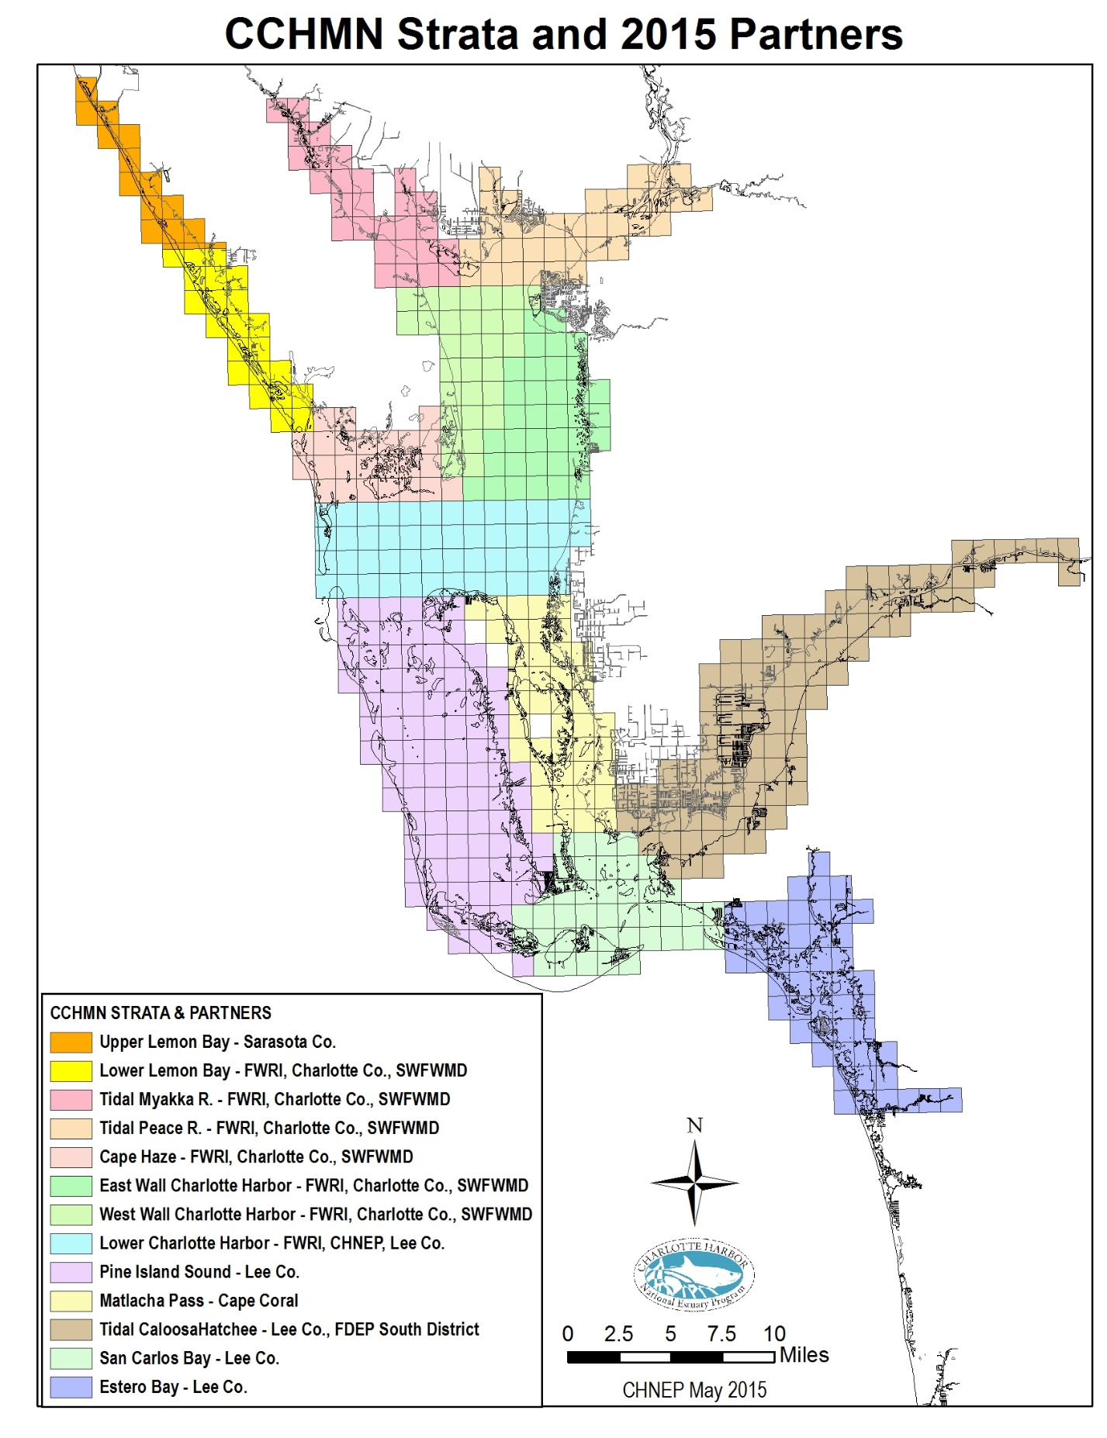
Figure 2: CCHMN Strata and Partners

Specific uses of the CHNEP water quality data include:
- CHNEP Water Quality Status and Trends (Janicki Environmental, 2007),
- CHNEP Water Atlas Water Quality Trends, Water Quality Dashboard and Preliminary Numeric Nutrient Criteria Calculator (Updated Annually),
- CHNEP Water Quality Targets (CHNEP, 2006),
- CHNEP Numeric Nutrient Criteria (Janicki Environmental, 2011),
- CHNEP Optical Model development (Dixon et al, 2014).
- State Impaired Waters and TMDL determinations,
- State BMAP processes, and
- Water Management District Minimum Flows and Levels (MFLs).

The CCHMN is currently funded by a partnership of Southwest Florida Water Management District (SWFWMD), Charlotte County, Lee County, the City of Cape Coral, Florida Department of Environmental Protection (FDEP), and CHNEP. Field sampling is conducted by Florida Fish and Wildlife Conservation Commission (FWC) Charlotte Harbor Field Laboratory, City of Cape Coral, FDEP Environmental Assessment and Restoration South Regional Operations, and Lee County Environmental Laboratory. Laboratory analyses are conducted by a partnership with Charlotte County (Benchmark Laboratory), City of Cape Coral Laboratory and Lee County Environmental Laboratory.

The CCHMN data is entered into the federal, state and water management district water quality data bases (including Legacy USEPA STORET (Storage and Retrieval) and the replacement database, FDEP WIN (Watershed Information Network) and SWFWMD WMIS (Water Management Information System) and its replacement WISKI and is available to the public and agency staff through the CHNEP Water Atlas (http://www.chnep.wateratlas.usf.edu/).

The CCHMN background information, study design and field methods are described briefly in the following sections. For additional detail, please refer to the Coastal Charlotte Harbor Monitoring Network Description and Standard Operating Procedures (CHNEP, 2004).

Study Area
The CCHMN Field Sampling Project study area consists of the 13 CCHMN strata. The project stratum (Figure 5) Sampling Design. Monthly sampling is conducted throughout the study area.

Problem Definition
Continued technically sound, consistent water quality monitoring in the CCHMN stratum is critical for the spatial and temporal integrity of the data collected by the CCHMN. CHNEP Estuaries, including Charlotte Harbor between the Tidal Peace and Myakka Rivers, Boca Grande Pass and northern Pine Island Sound are tidal mixing zones. Within the stratum, water quality conditions vary greatly daily, monthly, seasonally, annually and inter-annually.. The CCHMN stratum have been monitoring continuously using the CCHMN SOPs since 2002. Continuity in the availability of the data is essential to evaluate status and trends of water quality conditions throughout the CHNEP estuaries for regulatory assessments and evaluations of the effects of resource management activities.

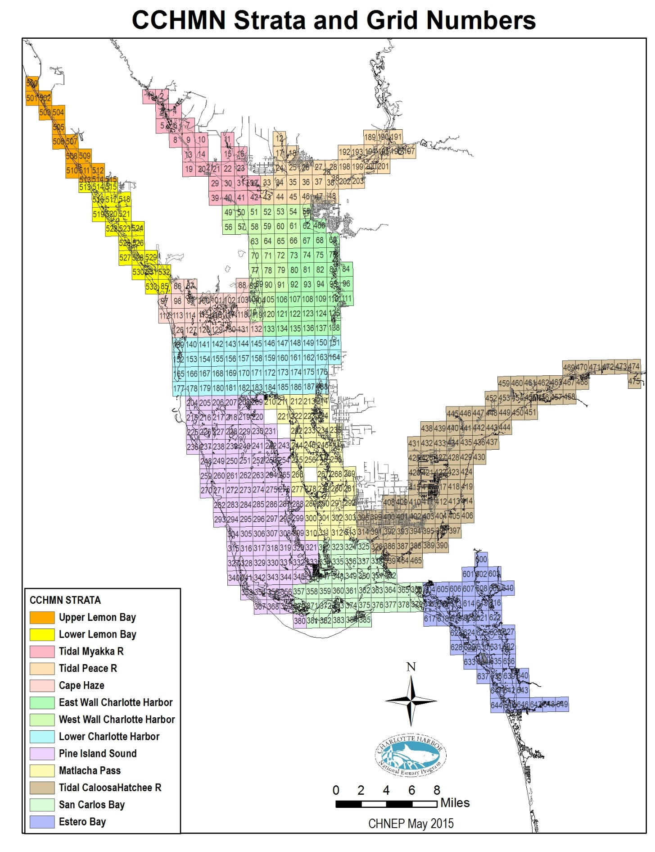
Figure 3: CCHMN Strata and Grid Numbers

A.6 Project and Task Descriptions

Project Goals
The goals of the CCHMN Field Sampling Project are to collect monthly water quality data and samples throughout the CCHMN strata consistent with the CCHMN stratified random sampling design and SOPs, transport the samples to laboratories according to approved chain-of-custody procedures, and upload the data to the

Project Tasks, Responsibilities, Deliverables and Schedule

CCHMN Core Water Quality Analytes for Estuaries and Tidal Rivers
The CCHMN core water quality analytes measured and collected in estuaries and tidal rivers collected according to FDEP 2017 SOPs (Effective 4/16/2018) Field testing overall – FT 1000
include:
Measured In-Situ:
- Depth (m)
- Secchi disc (m)
- Light attenuation (PAR; k)
- Temperature (ºC) (FT 1400)
- Salinity (ppt) (FT 1300)
- Specific conductance (µS) (FT 1200)
- Dissolved oxygen (DO) (mg/L) (FT 1500)
- pH (pH units) (FT 1100)

Water Samples Collected for Laboratory Analyses:
.
- Color (PCU) (Standard Method (SM) 2120B, SM2120C 2011)
- Specific Conductance (µS) (not done in lab unless field QC fails, SM 2150B 2011)
- Turbidity (NTU) (SM 2130B, EPA180.1)
- Total suspended solids (TSS) (mg/L) (SM 2540D 2015, SM 2540D, SM 2540D, EPA160.2)
- Total organic carbon (TOC) (mg/L) (SM 5210B, SM 5310B 2011)
- Chlorophyll a (mg/L) (corrected for phaeophytin) (SM 1200H, SM 1200M, EPA445.0, Strickland & Parsons, SM10200H 2011)
- Total nitrogen (TN) (mg/L) (calculated from TKN + NOX)
- Total Kjeldahl nitrogen (TKN-N) (mg/L) (SM 4500NH3F, EPA351.2)
- Total ammonia nitrogen (mg/L) (SM 4500NH3F, SM4500NH3G, SM4500NH3H, SM184500NH3C, EPA350.1)
- Total nitrite plus nitrate nitrogen (mg/L) (SM4500NO3F, SM184500N3, EPA353.2)
- Dissolved orthophosphate (OP) (mg/L) (SM4500PE, SM184500PF, EPA365.1, EPA365.3)
- Total phosphorus (TP) (mg/L) (SM184500PF, SM4500PE, EPA365.1, EPA365.3, EPA365.4)

For water quality samples, a single sample will be collected at 0.5 meters below the surface for those locations where the bottom depth is less than 3.0 meters. For locations where the bottom depth is greater than 3.0 meters, two samples will be collected (0.5 meters below the surface and 0.5 meters above the bottom). Light attenuation will be taken for sites greater than 1.3 meters deep.

Field Sampling and Laboratory Analysis Responsibilities
Currently (2019) the CCHMN field and laboratory partners are shown in Figure 4 and include:
- Lower Lemon Bay - field sampling by FWRI and laboratory analyses by Charlotte County contract laboratory (Benchmark Laboratory).
- Cape Haze/Gasparilla Sound - field sampling by FWRI and laboratory analyses by Charlotte County contract laboratory (Benchmark Laboratory).
- Tidal Myakka River - field sampling by FWRI and laboratory analyses by Charlotte County contract laboratory (Benchmark Laboratory).
- Tidal Peace River - field sampling by FWRI and laboratory analyses by Charlotte County contract laboratory (Benchmark Laboratory).
- Charlotte Harbor West Wall - field sampling by FWRI and laboratory analyses by Charlotte County contract laboratory (Benchmark Laboratory).
- Charlotte Harbor East Wall - field sampling by FWRI and laboratory analyses by Charlotte County contract laboratory (Benchmark Laboratory).
- Lower Charlotte Harbor - field sampling by FWRI and laboratory analyses by Lee County Environmental Laboratory.
- Pine Island Sound – field sampling and laboratory analyses by Lee County Environmental Laboratory.
- Matlacha Pass – field sampling and laboratory analyses by the City of Cape Coral.
- Tidal Caloosahatchee River – field sampling by FDEP Division of Environmental Assessment and Restoration, South Regional Operations and laboratory analyses by Lee County Environmental Laboratory.
- San Carlos Bay – field sampling and laboratory analyses by Lee County Environmental Laboratory.
- Estero Bay – field sampling and laboratory analyses by Lee County Environmental Laboratory.

Field sampling will be conducted according to the CCHMN Field Sampling Procedures described in the following sections. All laboratories involved in the CCHMN will follow all applicable federal and state guidelines for quality assurance and quality control of water quality analyses, including the use of appropriate duplicate samples and equipment blanks. It is strongly recommended that these laboratories be certified by The NELAC Institute (TNI) and meet FDEP laboratory certification requirements, pursuant to Chapter 62-160, FAC (DEP QA Rule).
It is also strongly recommended that all field sampling be conducted according to FDEP 2017 SOPs (Effective 4/16/2018). Water Samples Collected for Laboratory Analyses – FS 1000, FS 2000, FS 2100. (https://floridadep.gov/dear/quality-assurance/content/dep-sops)

Project Roles
CHNEP serves as coordinator for the Network. CHNEP houses and updates Standard Operating Procedures and Quality Assurance Project Plan Documents and works with CHNEP TAC and CCHMN partner agencies to make agreed upon changes to SOPs and QAPP Items to keep documents and practices current. CHNEP also directly funds sampling efforts to fill data gaps, hosts Annual CCHMN partners meeting, conducts field sampling audits, attends Southwest FL RAMP meetings, uploads data into CHNEP Water Atlas and funds maintenance and trend analysis features on CHNEP Water Atlas pages on behalf of partners.
Each month, CCHMN partners will be responsible for selecting random sampling grids and sites, conducting field measurements and recording results on field data sheets, collecting water quality samples, transporting samples to the laboratories for analysis, communicating field collection issues and quality assurance items to lab for continued refinement, communicating lab analyses issues and quality assurance items to field samplers for continued refinement, downloading data and providing copies of the field data sheets and data bases to appropriate data managers. To ensure data comparability, CCHMN quality assurance activities include: annual field audits conducted with each sampling partner; field and laboratory partner participation in the SWF Southwest FL RAMP quarterly meetings and split-sample analyses; and CHNEP Management Conference review of data and statistical methods during regular water quality status and trends reporting. It is anticipated that further quality assurance measures will be implemented in the future as needed.

Field Audits
CHNEP will be responsible for performing annual field audits for sample collection for each sampling agency. The results of these audits will be presented at an annual CCHMN meeting for this express purpose as well as resolve outstanding issues.

Data Ownership
The data owner for each stratum will be responsible for data handling and uploading their respective data into the federal and state water quality data bases. The current data owners for each of the CCHMN Strata are:
- Upper Lemon Bay – Sarasota County
- Lower Lemon Bay – SWFWMD and Charlotte County
- Cape Haze – SWFWMD and Charlotte County
- Tidal Myakka River – SWFWMD and Charlotte County
- Tidal Peace River – SWFWMD and Charlotte County
- Lower Charlotte Harbor – Lee County Environmental Laboratory
- Pine Island Sound – Lee County Environmental Laboratory
- Matlacha Pass – Cape Coral Environmental Resources
- Tidal Caloosahatchee River – Lee County Environmental Laboratory
- San Carlos Bay – Lee County Environmental Laboratory
- Estero Bay – Lee County Environmental Laboratory

Data owners may assign the uploading of data to federal, state and water management district water quality databases to the certified lab undertaking the laboratory analysis of their field samples as part of a contract, but the data owner is ultimately responsible for ensuring this process is fulfilled. Data owners will also collaborate to the best of their ability to standardize data formatting.

Links to the CCHMN data on agency websites include:
- SWFWMD: http://www.swfwmd.state.fl.us/data/water-quality/.
- Lee County Environmental Laboratory: http://leegis.leegov.com/surfwater/
- LEGACY replaced with Florida WIN (Florida STORET: http://storet.dep.state.fl.us/DearSpa/public/welcome);(CCHMN OrgID numbers begin with CHNEP); and
- Florida WIN (Watershed Information Network): http://prodenv.dep.state.fl.us/DearWin/public/welcomeGeneralPublic?calledBy=GENERALPUBLIC (CCHMN OrgID numbers begin with CHNEP).

Data Management
The CCHMN data will be maintained and uploaded to federal, state and water management district water quality databases by data owners. The data will be available to public and partnering agencies at all times. The University of South Florida staff will upload CCHMN data to the CHNEP Water Atlas website (http://www.chnep.wateratlas.usf.edu/ ) via to facilitate public access to the data.

Data Analysis
The CHNEP will regularly analyze the CCHMN and make the results publicly available through the CHNEP Website Water Atlas website (http://www.chnep.wateratlas.usf.edu/). In addition, 10-year time series analyses of three parameters, TN, chlorophyll a and DOall collected parameters, are available on the CHNEP Water Atlas, more parameter analysis will be available by the end of 2020. (http://www.chnep.wateratlas.usf.edu/water-quality-trends/).

Water quality status and trends reports incorporating the CCHMN data include:
- CHNEP Water Quality Status and Trends (Janicki Environmental, 2007)
- CHNEP Water Quality Targets (CHNEP, 2006)
- CHNEP Numeric Nutrient Criteria (Janicki Environmental, 2011)
- CHNEP Optical Model development (Dixon et al, 2014)
- CHNEP Water Atlas Water Quality Trends, Water Quality Dashboard and Preliminary Numeric Nutrient Criteria Calculator (Updated Annually),

Participation in the Regional Ambient Monitoring Program (RAMP)
All participating CCHMN laboratories and field monitoring agencies will participate in Southwest Florida Regional Ambient Monitoring Program (SWF Southwest FL RAMP) quarterly meetings and inter-laboratory split-sample exercises to help ensure data comparability region-wide. The SWF RAMP serves as a quality assurance forum for comparing split-sample laboratory results, resolving inconsistencies in results and discussing pertinent water quality monitoring issues throughout the region.

Coastal Charlotte Harbor Monitoring Network Field Sampling Procedures

Sample Collection
- Site Selection:
- Five sites per stratum will be sampled each month.
- Five grids per stratum will be randomly selected and sampling locations within each selected grids will be randomly selected.
- Sampling sites will be chosen and mapped prior to field sampling (see below for procedure).
- Alternate sites can be chosen if the water depth at the site is too shallow or it is not possible to access the site.

B. Sample Acquisition:
- Water samples shall be collected by using a horizontal sampling device, such as an Alpha or Niskin bottle
- All appropriate sample bottles shall be filled in the order listed below and labeled properly.

C. Blank, Duplicate and Split Samples:
- An equipment blank will be taken every sampling trip.
- Optionally (preferred) one duplicate every 10 sites or one every sampling trip will be taken.
- Split samples for the testing the precision of lab analysis is optional.

D. Use of Protective Gloves: FDEP recommends wearing protective gloves when conducting all sampling, but, their use is not mandatory. Use gloves if sampler has come in contact with potential contaminants (i.e., sun tan lotion, outboard motor oil):

E. Container and Equipment Rinsing: When collecting aqueous samples the sample collection equipment and non-preserved containers shall be rinsed three times with sample water before the actual sample is taken. This protocol shall not be followed for sample containers with pre-measured preservatives in the container (acidified bottles).

F. Dedicated Equipment Storage: All dedicated equipment shall be stored in a clean environment, protected from dirt and other sources of TN, TP, and TSS contaminants.

G. Fuel-powered Equipment and Related Activities: All sampling is done away from fuel-powered equipment activities. Samplers will make every effort to observe winds, currents and other parameters to ensure no contamination.

H. Preservation - All certified labs participating in the CCHMN shall provide pre-preserved sample bottles to the sampling entity, ready for use. Samplers use an intermediate device to transfer the samples into the bottles, and don’t need to add acid preservative. Samplers should check the pH of the acid preserved samples (except for the TOC bottle with no air space) to make sure the pH <2. According to DEP SOP FS 2001, section 3.5

Decontamination
- Equipment Preparation: All equipment shall be cleaned in a controlled environment and transported to the field pre-cleaned and ready to use.
- All equipment must be immediately rinsed with water after use, as specified below. Field cleaned equipment (pump tubing and re-usable filters) shall be cleaned between samples.
- Alpha bottles shall be cleaned with ambient sample water, while the pump tubing and re-usable filters shall be cleaned with deionized water (between samples).
- Proper cleaning protocol, upon return to the field lab, is followed.
- Detergents used shall be Liquinox (or equivalent) or Alconox (or equivalent).
- Deionized water is used as the final rinse for all cleaning (suitable for only inorganic analyses (metals, nutrients, etc.).

Aqueous Sampling Procedures
- General: There are several requirements that are common to all types of surface water sampling events and are independent of technique. Several of these requirements are concerned with sample parameters that are inherently difficult to sample. In addition to the below procedures, overall care must be taken in regards to equipment handling, container handling/storage, decontamination, and record keeping.
- Sample collection equipment and non-preserved sample containers must be rinsed with sample water before the actual sample is taken.
- If protective gloves are used they shall be clean, new and disposable. These should be changed prior to the next sampling site.
- If possible, one member of the field team should take all the notes, fill out tags, etc., while the other member does all of the sampling. To ensure sampling precision, each member should continue to assume the same duties for the entire sampling trip, especially secchi disk readings.

Sampling Site Access: Access will be left up to the sampling group. Ease of access should not be the main criteria for sampling site choice. If sampling by boat, there are certain precautions that must be considered:
- If sampling with a boat, samples should be taken from the bow, away and upwind from any gasoline outboard engine.
- Every effort will be taken to prevent contamination. (Charlotte Harbor –FWC-FWRI—has mid-hull engines and does sampling behind the outboard and fuel tank. Winds, currents and boat position shall be taken into account when sampling, in order to meet these criteria.)
- Care should be taken not to disturb sediments when motoring to the sampling sites (especially shallow water sites).
- Site Selection: Five sites per stratum per month will be sampled. Samples shall be randomly selected for every month and every stratum.
- Each month, five random grids (1 X 1 nautical mile) within each stratum will selected
- Each grid within each stratum is numbered and a GIS layer of the grid coordinates and numbers for each of the 13 strata is available from the CHNEP office (Figure 5).
- Using the randomly selected grids for each stratum, the latitude and longitude coordinates for the sampling locations within that grid will be randomly selected using a GIS or other program.
- The sampling site latitude and longitude coordinates will be recorded in decimal degrees (i.e.: 26.625801; -81.897886).
- Every attempt to collect samples from the pre-selected sites should be made.
- Both selected and actual sample locations should be recorded on the datasheets. Any alteration from the pre-selected site will be noted.
- Site changes will be done in this order:
- If site is too shallow or on land, then movement from the selected site toward the Intracoastal Waterway or center of grid until appropriate depths are achieved (1.0 m in Charlotte Harbor, tidal Peace and Myakka rivers; 0.7 m in Lemon, San Carlos and Estero Bays; 0.7 m in Bokeelia section of Charlotte Harbor, Pine Island Sound, Matlacha Pass and tidal Caloosahatchee River).
- If the grid has a deeper area, and no channel nearby, movement will be made toward that area until depths are achieved.
- If the area is shallow and the knowledge of the grid dictates that water level (or other factors) will not allow for sampling, then an alternate grid can be chosen.
- Priority of the grid selection should include (region/stratum is first, Grid is next, sample area is last.
- If alternate sites are sampled,
  - sampling must not be done more than once per grid,
  - the grid must remain in the same region or strata,
  - the closest grid to the original grid should be chosen unless conditions in surrounding grids are similar

Sample Acquisition: Water samples will be collected according to FDEP 2017 SOPs (Effective 4/16/2018) Water Samples Collected for Laboratory Analyses – FS 1000, FS 2000, FS 2100. Samples are taken using a horizontal sampling device, such as an Alpha or Niskin bottle, with depths taken from the center of the container. Sample acquisition will follow these procedures:

The initial grab is taken at 0.5 m below the surface.

If the sample site > 3m, then an additional sample is taken at 0.5 m above the bottom.

Once the sampling device is triggered and sample is trapped, the sample is brought on board.

The proper order for filling sample bottles is as follows: non-preserved, preserved and finally filtered samples.

Filtered samples (Orthophosphate) shall be collected by a peristaltic pump or syringe-filter combination. All filters will be 0.45 microns.

The tubing for the peristaltic pump is rinsed with the sample water (through the spigot). Non-preserved bottles will be rinsed with sample water prior to filling.

Total Organic Carbon (TOC) sample bottles when filled to include a convex meniscus shall not contain head space. Small bubbles smaller than pea-size are permissible. The most effective way to accomplish this is to collect the sample with the sample bottle tilted toward the spigot of the Alpha or Niskin bottle, not straight up and down.

Ensure all caps are tightened prior to placing sample bottles in ice chests.

Once filled, all bottles shall be put in ice in sampling coolers according to FDEP protocols

Data Measurements and Recording – Each member of the field sampling team will conduct the same tasks throughout the sampling event. One field sampler will record environmental parameters, light attenuation measurements, multi-parameter sampling meter (Hydrolab or YSI) readings, Secchi disks values and any other pertinent information needed. Measurements will be taken and recorded as following:
- Secchi disk depths shall be taken on shady side of boat without the use of sunglasses, and light meter readings will be taken on sunny side of boat.
- Multi-parameter sampling meter values (pH, DO, salinity, pH, and temperature) shall be recorded to the nearest 0.01 values, except conductivity, which is recorded to the nearest unit.
- Values shall be measured and recorded at 0.5 m below the surface at all sites.
- Values shall be measured and recorded at 0.5 m above the bottom for sites deeper than >1m depths, and optionally for all sites >1.5 m.
- Values may also optionally (preferred) be measured and recorded at 1 m depth profiles throughout the water column at sites >3 m.
- Depths shall be recorded from the probes, not the bottom of the instrument.
- Bottom composition information (mucky, sandy, submerged aquatic vegetation, hard bottom or unknown) will be recorded.
- Additional information is recorded as per the datasheet (see attachment).
- An example CCHMN field data sheet is shown in Appendix A.
- Light Measurements: Light attenuation readings will be taken and recorded using a Licor according to the below procedure. This information will be used to update/calibrate the Optical Model for CHNEP and Charlotte Harbor region.
- Underwater sensors may be 2 pi (flat) or 4 pi (round). It is preferable to use similar sensors throughout the CCHMN, but 2 pi sensors may be used in the SWFWMD strata and 4 pi sensors may be used in the SFWMD strata.
- Underwater light meters will be mounted 0.5 m apart on a PVC pole frame with depths accurately and clearly marked.
- Before each sampling event, the light meter underwater sensor readings will be validated by taking simultaneous readings in the air and recording the values for each sensor on the data sheet, so that the readings may be used as correction factors during data analysis as needed. The most effective way to accomplish this is to hold the PVC frame out of the water, pointed directly towards the sun away from your body or any other objects. If both sensors’ reading are within 5% of one another while performing this validation, there is no need to send meters for manufacturer calibration.
- The light meter data logger will be set to average readings every 5 seconds and the data will be recorded after the readings stabilize (about 30 seconds).
- A data qualifier will be used to record bottom composition information (mucky, sandy, submerged aquatic vegetation, hard bottom or unknown), especially when using a 4 pi sensor over white, sandy sediments.
- During field sampling at each site, underwater light meter measurements will be recorded simultaneously with the PVC pole frame held vertically in the water without shading the sensors by the boat, equipment, submerged aquatic vegetation or algae. Air sensor measurement(s) will be recorded simultaneously with corresponding underwater readings while placed on a level surface on the boat.
- In rough waves, the PVC pole frame with the underwater sensors will be held with the appropriate depth mark held as stable as possible at the water surface. The most effective way to accomplish this is to have the person holding the PVC pole frame lean over the water, ensuring all safety precautions have been met, and act as a “gimbal” as the boat moves under them.
- For sites < 2.0 m, light meter measurements will utilize one air measurement and two underwater light measurements taken simultaneously at depths of 0.5 m and 1.0 m below the surface.
- For sites > 2 m, light meter measurements will utilize one air measurement and two underwater measurements collected simultaneously. Underwater light measurements will be taken at depths of 0.5 m and 1.0 m below the surface and 0.5 m and 1.0 m above the bottom.
- For sites > 3 m (Optional), light meter measurements will utilize one air measurement and two underwater measurements collected simultaneously. Underwater light measurements will be taken at depths of 0.5 m and 1.0 m below the surface, 0.5 m and 1.0 m above the bottom or the lowest depth the light measurement pole can reach. and at 1.0 m increments between the surface and bottom.

Depths for light attenuation data collection.
Water Depth (m) | Light Meter Measurement Depths (m)
Water Depth (m) | 1 | 2 | 3 | Air
1.3 - 2.0 | 0.5/1.0 | - | - | Optional
2.1 | 0.5/1.0 | 1.1/1.6 | - | Required
2.2 | 0.5/1.0 | 1.2/1.7 | - | Required
2.3 | 0.5/1.0 | 1.3/1.8 | - | Required
2.4 | 0.5/1.0 | 1.4/1.9 | - | Required
2.5 | 0.5/1.0 | 1.5/2.0 | - | Required
2.6 | 0.5/1.0 | 1.6/2.1 | - | Required
2.7 | 0.5/1.0 | 1.7/2.2 | - | Required
2.8 | 0.5/1.0 | 1.8/2.3 | - | Required
2.9 | 0.5/1.0 | 1.9/2.4 | - | Required
3.0 | 0.5/1.0 | 1.5/2.0 | 2.0/2.5 | Required
>3.0 | 0.5/1.0 | 1.5/2.0 | 2.0/2.5 | Required

Sample Transport
Each laboratory will provide sampling field staff with pre-labeled bottles and equipment as needed. Field sampling staff will arrange for water samples to be delivered to the laboratory within that allotted sample holding time. Sample transport will follow appropriate Chain of Custody procedures between field and laboratory partners, including proper sample preservation and temperature requirements. Chain of Custody forms will be kept on file with the laboratories, available on request.

A.7 Objectives and Criteria for Measurement Data

Data Quality Objectives
This QAPP for the CCHMN Field Sampling was developed to meet the data quality objective requirements of the USEPA Guidance for Quality Assurance Project Plan, EPA QA/R-5 (USEPA 2001, 2002, 2006). The field sampling is to be conducted in accordance to the CCHMN Standard Operating Procedures 2023 Updates (SOPs) (CHNEP, 2023). In conjunction with the field sampling, the associated laboratory analyses are to be conducted in accordance with the requirements of their The NELAC Institute (TNI) National Environmental Laboratory Certification (NELAC).

The overall goal of the CCHMN Lower Charlotte Harbor Field Sampling Project it to collect technically sound, consistent water quality data in the CCHMN stratum to continue the critical spatial and temporal integrity of the CCHMN.

The specific data quality objectives of the project are to:
- Collect monthly water quality field measurements and samples at randomly selected sites throughout the CCHMN strata consistent with the CCHMN stratified random sampling design, SOPs and quality assurance requirements;
- Transport the samples according to approved chain-of-custody procedures; and
- Upload the data to federal, state, and local databases using acceptable data management protocols.

A.8 Special Training and Certification

Training Requirements
CCHMN Field Sampling Project staff must have a good understanding of water quality monitoring parameters, the importance of each parameter and expected ranges of values to be found throughout the CHNEP estuaries. Project field staff must be proficient at water quality equipment calibration, field sampling techniques, data recording, sample transport methods, chain-of-custody protocols and quality assurance practices, as defined in the CCHMN SOPs. In addition, project field staff must be capable of safe boat operation.

A.9 Documentation and Records

Information Included in Reports
Annual reports of CCHMN Field Sampling Project data and field audit results will be provided by the data owners to the appropriate federal, state and local databases. Additionally, data will be uploaded by CHNEP in partnership with USF Water Atlas staff to the CHNEP Water Atlas.

Schedule for Laboratory Analyses
The CCHMN Field Sampling laboratory analyses will be conducted within the holding times for each parameter in accordance with the requirements of their The NELAC Institute (TNI) National Environmental Laboratory Certification (NELAC).

Records Retention
The CCHMN Field Sampling data results will be retained by the appropriate federal, state and local databases. Additionally, data will be uploaded by CHNEP in partnership with USF Water Atlas staff to the CHNEP Water Atlas.

Section B - Project Design

B.1 Sampling Design

Sampling Design Rationale
The CHNEP estuaries are divided into 13 strata based on those used by the FWC Fish and Wildlife Research Institute (FWRI) Fisheries Independent Monitoring program (FIM) and extensive review by the CHNEP technical community. Each stratum has relatively homogeneous water quality conditions and is divided into square mile grids, as used by FWRI FIM. Within 12 of the strata five grids are randomly selected and then sampling sites within each of the selected grids are randomly selected each month. This allows the CCHMN to collect data within each stratum at five sites per month, adding up to 60 samples per stratum per year. Throughout the CHNEP estuaries, CCHMN partners provide consistent water quality data at 60 sites per month and 720 sites per year. Sarasota County conducts water quality monitoring in the final stratum (Upper Lemon Bay) monthly through an ambient monitoring program, however site selection is not in conformance with the CCHMN SOPs.

Sampling Locations and Frequency
The 12 strata sampled monthly in accordance with the CCHMN SOPs are shown in Figure 4 and include:
• Lower Lemon Bay
• Cape Haze/Gasparilla Sound
• Tidal Myakka River
• Tidal Peace River
• Charlotte Harbor West Wall
• Charlotte Harbor East Wall
• Lower Charlotte Harbor
• Pine Island Sound
• Matlacha Pass
• Tidal Caloosahatchee River
• San Carlos Bay
• Estero Bay

B.2 Sampling Methods

Water Quality Sampling Methods

CCHMN Core Water Quality Analytes for Estuaries and Tidal Rivers
The CCHMN core water quality analytes measured and collected in estuaries and tidal rivers collected according to FDEP 2017 SOPs (Effective 4/16/2018) Field testing overall – FT 1000
include:
Measured In-Situ:
- Depth (m)
- Secchi disc (m)
- Light attenuation (PAR; k)
- Temperature (ºC) (FT 1400)
- Salinity (ppt) (FT 1300)
- Specific conductance (µS) (FT 1200)
- Dissolved oxygen (DO) (mg/L) (FT 1500)
- pH (pH units) (FT 1100)

Water Samples Collected for Laboratory Analyses:
.
- Color (PCU) (Standard Method (SM) 2120B, SM2120C 2011)
- Specific Conductance (µS) (not done in lab unless field QC fails, SM 2150B 2011)
- Turbidity (NTU) (SM 2130B, EPA180.1)
- Total suspended solids (TSS) (mg/L) (SM 2540D 2015, SM 2540D, SM 2540D, EPA160.2)
- Total organic carbon (TOC) (mg/L) (SM 5210B, SM 5310B 2011)
- Chlorophyll a (mg/L) (corrected for phaeophytin) (SM 1200H, SM 1200M, EPA445.0, Strickland & Parsons, SM10200H 2011)
- Total nitrogen (TN) (mg/L) (calculated from TKN + NOX)
- Total Kjeldahl nitrogen (TKN-N) (mg/L) (SM 4500NH3F, EPA351.2)
- Total ammonia nitrogen (mg/L) (SM 4500NH3F, SM4500NH3G, SM4500NH3H, SM184500NH3C, EPA350.1)
- Total nitrite plus nitrate nitrogen (mg/L) (SM4500NO3F, SM184500N3, EPA353.2)
- Dissolved orthophosphate (OP) (mg/L) (SM4500PE, SM184500PF, EPA365.1, EPA365.3)
- Total phosphorus (TP) (mg/L) (SM184500PF, SM4500PE, EPA365.1, EPA365.3, EPA365.4)

For water quality samples, a single sample will be collected at 0.5 meters below the surface for those locations where the bottom depth is less than 3.0 meters. For locations where the bottom depth is greater than 3.0 meters, two samples will be collected (0.5 meters below the surface and 0.5 meters above the bottom). Light attenuation will be taken for sites greater than 1.3 meters deep.

Equipment Needs
The CCHMN Lower Charlotte Harbor Field Sampling equipment and supply needs are shown in Table 7. The check-list is used when preparing for field sampling to assure all equipment and supplies are available on the boat during sampling events.

Table 3: CCHMN Lower Charlotte Harbor Field Sampling Equipment and Supply Needs.
Equipment & Supplies
CCHMN SOPs
Sampling Site Locations
Sampling Site Maps
Data Sheets
Pens, Pencils, Sharpies
Chain of Custody Forms
GPS
Depth Finder
DI Water
Secchi
YSI & Extra Weight
Alpha Bottle
Licor
Pump or Syringes
Filter Holders, Filters, Forceps
Sample Bottle Kits
Coolers
Ice
If Acidify Sample in Field, Acid Vials (SO₄ & NO₃) & Waste Container
Equipment Spare Parts & Tool Box
Truck Notebook
Boat Notebook
PFDs
Sunscreen & Bug Repellant
Cellphone & Handheld Radio
Paddle
Throwable PFD
Horn or Whistle
First Aid Kit
Flares
Other:

Support Facilities
The CCHMN Field Sampling is conducted The identified sampling agencies. Each facility has dedicated laboratory space for preparing water quality field sampling equipment and calibrating instruments in a clean environment, free from potential contaminants. Samplers maintain a fleet of boats and trucks utilized for the CCHMN Field Sampling project as well as support personnel maintain the boats, trucks and sampling equipment in working order. In addition, the facilities house computers used for downloading, entering and managing the CCHMN data.. Following completion of sampling each month, the coolers containing the iced samples are transported to the lab following approved chain-of-custody procedures (Section B.3), within sample holding times (Table 8). All laboratories are NELAC certified.

Corrective Action Responsibilities
CCHMN Field Sampling problem prevention and resolution are the responsibility of sampling and maintenance staff. Field sampling equipment and boats receive routine maintenance. In addition, spare parts and tool kits for the equipment and boat are taken into the field during sampling days.

Equipment Preparation and Decontamination
Immediately following each sampling event upon return to the laboratory facility, sampling staff clean the CCHMN Field Sampling equipment, including the alpha bottle, pump tubing and filter holders, with an acceptable decontamination solution, followed by a tap water rinse (3 times) and finished with a deionized water rinse (3 times), before air drying and storage in clean, closed containers. Filter holders are loaded with filters prior to field sampling and stored in clean, closed containers. The clean field equipment is transported during sampling events in the clean containers. Prior to sampling each site, the equipment is rinsed with ambient site water 3 times before samples are collected. Following sampling at each site, the equipment is rinsed 3 times with deionized water before storage and transport to the next site. The multi-parameter sonde is calibrated in the laboratory facility within 24 hours before and after each sampling event, according to the manufacturer’s guidelines, and the calibration results are recorded on the Sonde Meter Calibration Record Sheet (Figure 6). The Li-Cor light meter sensors (1 air and 2 underwater sensors) are calibrated immediately before and after each sampling event according to the CCHMN Standard Operating Procedures 2023 Updates (CHNEP, 2023), and the calibration results are recorded on the CCHMN Field Sampling Data Sheet (Appendix F.2).

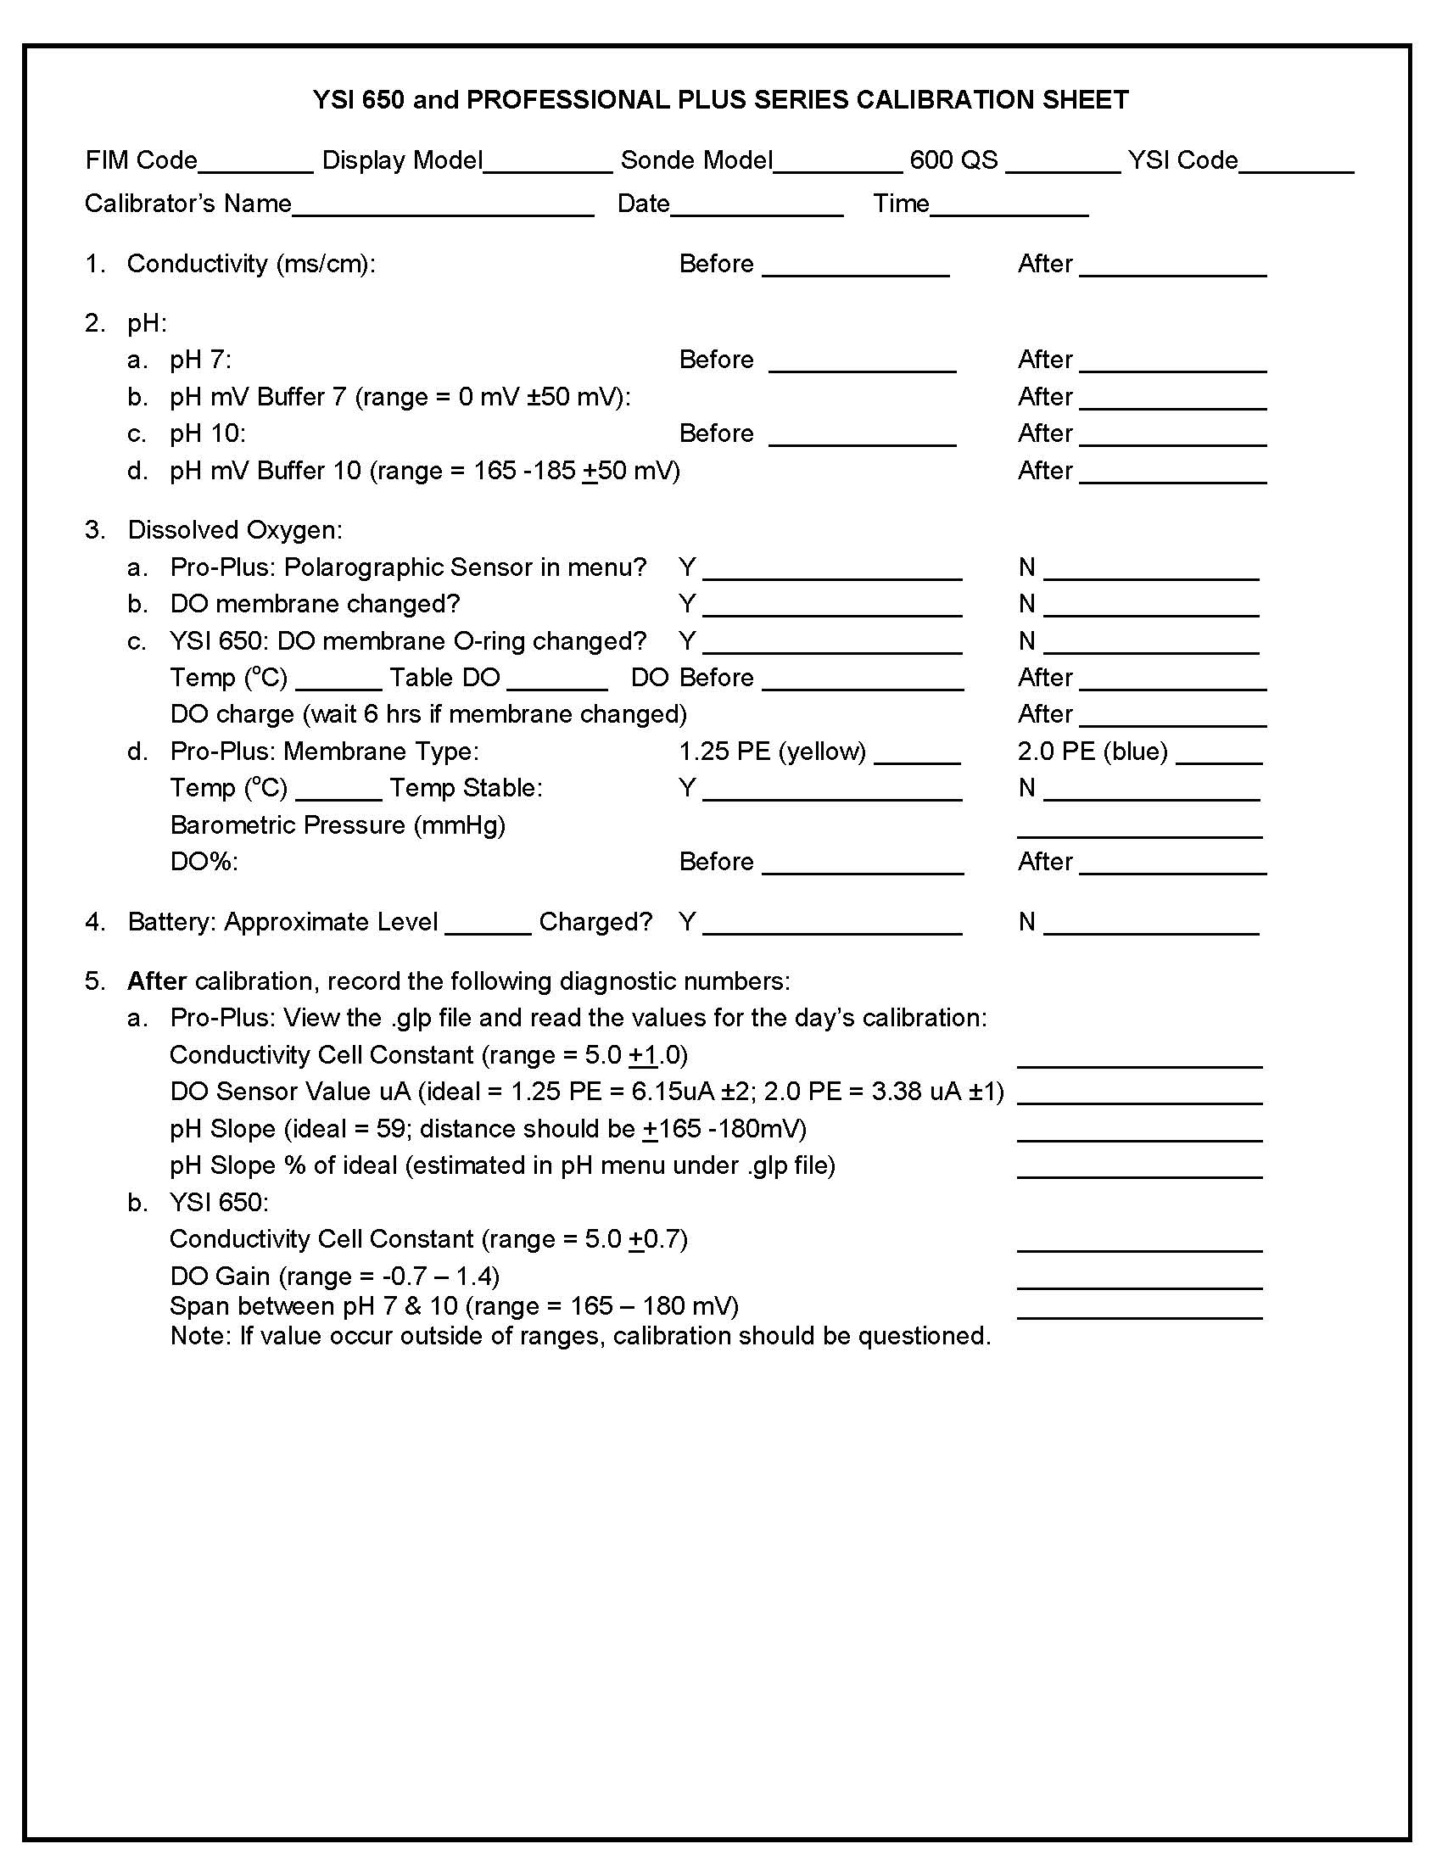
Figure 4: YSI Meter Calibration Report Form

Sample Container Selection and Preparation
The CCHMN Field Sampling sample containers are prepared by the laboratories and provided to sampling staff prior to each sampling event. Laboratories purchase and cleas the sample containers (Table 8) for the selected sites.

Sample Container Volume, Preservation and Holding Times
The CCHMN Field Sampling sample container, preservative and holding time requirements are shown in Table 8. The laboratory analytical methods are shown in Table 9.

Table 4: CCHMN Lower Charlotte Harbor Field Sampling Containers, Preservation Methods and Holding Times.
 | Parameter | Units | Sample Container | Preservation Method | Holding Times
Measured In-Situ:
 | Depth | m | n/a | n/a | n/a
 | Secchi Disc | m | n/a | n/a | n/a
 | Light Attenuation | µmol | n/a | n/a | n/a
 | Temperature | ºC | n/a | n/a | n/a
 | Salinity | ppt | n/a | n/a | n/a
 | Specific Conductance | µS | n/a | n/a | n/a
 | Dissolved Oxygen | mg/L | n/a | n/a | n/a
 | pH | pH units | n/a | n/a | n/a
Water Samples Collected for Laboratory Analyses:
 | Color | PCU | 1 L Polyethylene | Put on ice | 24 hours
 | Specific Conductance | µS | 1 L Polyethylene | Put on ice | 28 days
 | Turbidity | NTU | 1 L Polyethylene | Put on ice | 48 hours
 | Total Suspended Solids | mg/L | 1 L Polyethylene | Put on ice | 7 days
 | Total Organic Carbon | mg/L | 40 ml glass | Sulfuric Acid | 28 days
 | Chlorophyll a (corrected) | mg/L | 1 L Amber Nalgene | Put on ice | Filter within 24 hours; analyze within 3 weeks
 | Total Nitrogen | mg/L | Calculation | Sulfuric Acid | calculated
 | Total Kjeldahl Nitrogen | mg/L | 250-ml polyethylene | Sulfuric Acid | 28 days
 | Total Ammonia Nitrogen | mg/L | 250 ml polyethylene | Sulfuric Acid | 28 days
 | Nitrite plus Nitrate Nitrogen | mg/L | 250 ml polyethylene | Sulfuric Acid | 28 days
 | Dissolved Orthophosphate | mg/L | 250 ml polyethylene | Put on ice | 48 hours
 | Total Phosphorus | mg/L | 250 ml polyethylene | Sulfuric Acid | 28 days

B.3 Sample Handling and Custody

Sample Handling
Water samples are collected according to the CCHMN SOPs, using an alpha bottle that is flushed 3 times with ambient water before being lowered to the proper depth. Sample containers that do not contain preservatives are rinsed 3 times with sample water before filling. Containers are filled in order of non-filtered and non-preserved, filtered and preserved, then non-filtered preserved. Sample containers are put in ice in ice chests immediately after filling, with the exception of chlorophyll a sample, which is placed on top of the ice to avoid rupturing phytoplankton cells. Following completion of the sampling event, the samples are transported on ice in the ice chests directly to the LCEL within 2 hours.

Sample Chain-of-Custody
The CCHMN Field Sampling Project follow the CCHMN SOP (2023) chain-of-custody procedures. The sample Chain of Custody Report form is shown in Figure 7. The form is signed by the field sampler and each relinquishing party until the samples are delivered to the lab. The report form includes the date and time of sampling, site number and depth, number of sample for each analysis to be performed and the corresponding Lab ID number. Once received by the Lab, the holding time and temperature of the samples are verified to assure the laboratory quality assurance requirements.

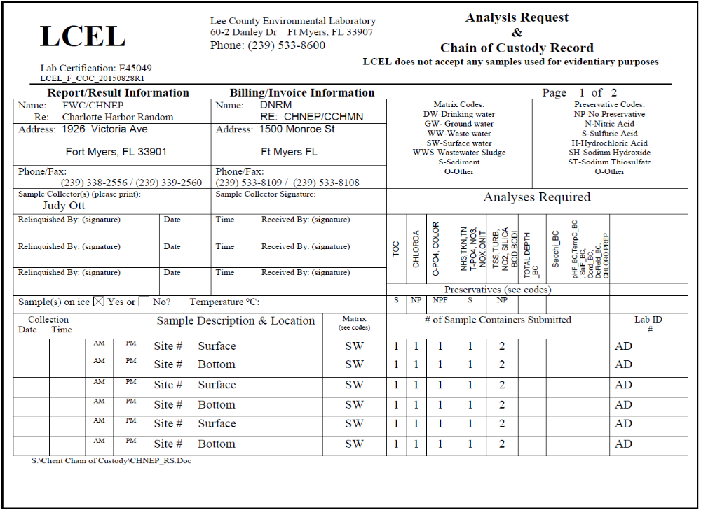
Figure 5: LCEL Chain of Custody Record Form.
B.4 Analytical Methods

Analytical Methods
Analyses of water samples collected by the CCHMN Lower Charlotte Harbor Field Sampling Project are conducted according to their NELAC certification requirements. The analytical methods and minimum detection limits for each parameter utilized for this project are shown in Table 9.

Table 5: CCHMN Lower Charlotte Harbor Field Sampling Analytical Methods Used by LCEL.
 | Parameter | Units | Laboratory Analysis Method | Minimum Detection Level
Measured In-Situ:
 | Depth | m | n/a | 0.1 m
 | Secchi Disc | m | n/a | 0.1 m
 | Light Attenuation | µmol | n/a | 5 µmol
 | Temperature | ºC | n/a | 0.01 ºC
 | Salinity | ppt | n/a | 0.01 ppt
 | Specific Conductance | µS | n/a | 1 µS
 | Dissolved Oxygen | mg/L | n/a | 0.01 mg/L
 | pH | pH units | n/a | 0.01 units
Water Samples Collected for Laboratory Analyses:
 | Color | PCU | SM20 2120 C | 1.0 CU
 | Specific Conductance | µS | SM21 2510B | 2 µS
 | Turbidity | NTU | EPA 180.1 | 0.2 NTU
 | Total Suspended Solids | mg/L | SM21 2540D | 0.6 mg/L
 | Total Organic Carbon | mg/L | SM21 5310 B | 1.0 mg/L
 | Chlorophyll a (corrected) | mg/L | SM21 10200 H | 0.5 mg/M3
 | Total Nitrogen | mg/L | Calculation | 0.06 mg/L
 | Total Kjeldahl Nitrogen | mg/L | EPA 351.2 | 0.05 mg/L
 | Total Ammonia Nitrogen | mg/L | EPA 350.1 | 0.014 mg/L
 | Nitrite plus Nitrate Nitrogen | mg/L | EPA 353.2 | 0.01 mg/L
 | Dissolved Orthophosphate | mg/L | EPA 365.1 | 0.004 mg/L
 | Total Phosphorus | mg/L | EPA 365.1 | 0.006 mg/L

Validation of Non-Standard Analytical Methods
No non-standard analytical methods are used for the CCHMN Field Sampling Project.

Corrective Action Responsibilities
Potential deviations from the field sampling methods for the CCHMN Field Sampling Project are identified during the annual field audits. Options for corrective actions are immediately investigated and the most effective actions are implemented within 1 month of being identified. Corrective actions for laboratory analyses are identified and addressed by the Labaccording to their NELAC quality control/quality assurance procedures.

Time Period for Analyses and Data
CCHMN Field Sampling Project laboratory analyses are completed within the holding times for each parameter shown on Table 8.

B.5 Quality Control

Quality Control Procedures and Frequency
The CCHMN Field Sampling Project is conducted in accordance with the Coastal Charlotte Harbor Monitoring Network Standard Operating Procedures 2023 Updates (CHNEP, 2023). The CCHMN Standard Operating Procedures (SOPs) define how, when and where the Lower Charlotte Harbor field sampling is conducted each month, as well as how samples are transported to the laboratory for analysis.

Immediately before and after each sampling event, field sampling equipment, including the multi-parameter sonde and Licor instrument, are calibrated according to CCHMN SOPs, laboratory protocols and equipment manufacturer guidelines (Section B.7).

During each monthly sampling event, one set of sample bottles is filled with deionized to serve as a field equipment blank for laboratory analyses.

Each year, a field audit of the CCHMN Field Sampling Project is conducted by CHNEP and corrective actions are identified and implemented immediately following the field audit report. Following the annual field audit each year, a CCHMN quality assurance meeting is held for all project partners, to review field audit results and discuss and implement corrective actions throughout the sampling program.

Quarterly, staff participate in the Southwest Florida Regional Ambient Monitoring Network (RAMP) split sample analyses and meetings. RAMP is a region-wide collaboration of water quality field sampling and laboratory organizations from throughout six counties in southwest Florida. The RAMP mission is to “foster cooperative participation to improve comparability of surface water sample collection, in situ measurements and laboratory methods use by surface water quality monitoring programs in southwest Florida marine and freshwater systems”. At each quarterly meeting, Project sampling partners collect samples from the same ambient water source, which are then analyzed by partnership laboratories. The analytical results are compared at the following RAMP meeting and corrective actions are discussed and implemented.

Quality Control Assessment Calculations
The results of the quarterly RAMP split sample field collection and sample analyses are mean, standard deviation, medium, maximum and minimum values for each parameter are compared. Results that exceed +1 and +2 standard deviations are noted and corrective actions are discussed and implemented following the next RAMP meeting. In addition, LCEL conducts quality control assessment calculations according to procedures consistent with their NELAC certification and implements corrective actions, as required by their laboratory certification.

B.6 Instrument/Equipment Testing, Inspection and Maintenance

Supplies and Consumables

CCHMN Lower Charlotte Harbor Field sampling staff purchase and utilize multi-parameter sonde calibration solutions recommended by the manufacturer and replaces them prior to the expiration dates.

Sampling staff and laboratories utilize and replace analytical calibration solutions recommended by the individual instrument manufacturers within guidelines identified in their NELAC certification procedures. They also purchase, replace, clean and acidifys sample bottles within their NELAC certification procedures. Sample bottles used for chlorophyll and total organic carbon (TOC) sample collection and analyses are cleaned after each use according to NELAC requirements. Sample bottles for other analytical parameters are purchased prior to each sampling event and discarded following use.

Performance and System Audits
Annual field audits of the CCHMN Field Sampling Project are conducted by CHNEP for consistency with the CCHMN SOP 2023 Updates (CHNEP, 2023). Results of the field audits are discussed at the CCHMN annual quality assurance meeting and corrective actions are implemented immediately following the meeting. Audits of the laboratory procedures are conducted consistently with the frequency and methods required for their NELAC certification. Corrective actions are also implemented according to NELAC requirements.

B.7 Instrument Calibration and Frequency

Equipment Needing Calibration and Frequency
CCHMN Field Sampling Project staff calibrate the multi-meter sonde immediately before and after each sampling event according to manufacturer’s guidelines. Project staff also calibrate the Licor instrument immediately prior to and following field sampling according to the CCHMN SOP 2023 Updates (CHNEP, 2023)

Calibration Standards

Calibration standards are purchased and replaced according to the equipment manufacturer’s recommendations. No calibration standards are required for dissolved oxygen or salinity or for the Licor water clarity instrument. Calibration standards for the analytical instruments are purchased and replaced according to the instrument manufacturers’ recommendations and NELAC certification.

Calibration Records
Calibration records for the multi-meter sonde and Licor instruments are maintained Field and laboratory staff respectively
.B.8 Inspection/Acceptance Requirements for Supplies and Consumables

Supplies
CCHMN Field Sampling Project calibration supplies for the multi-meter sonde are inspected and accepted annually during the field audit conducted by CHNEP. Lab analytical instrument calibration supply and sample bottle records are inspected and accepted in accordance to NELAC certification requirements.

Criteria for Supplies
The criteria for the multi-meter sonde and analytical instrument calibration solutions are provided by the manufacturers. The solutions are replaced prior to their expiration dates.

Supply Inspection Responsibilities
Supply inspection for the CCHMN Field Sampling Project is the responsibility of the Field Sampling Coordinator and the Laboratory Coordinator.

B.9 Non-Direct Measurements

Non-Measurement Data Types and Acceptance Criteria
No non-measurement data are used for the CCHMN Field Sampling Project.

Limitations of Non-Measurement Data
No non-measurement data are used for the CCHMN Field Sampling Project.

Rational for Non-Measurement Data
No non-measurement data are used for the CCHMN Field Sampling Project.

B.10 Data Management

Record Keeping, Storage and Retrieval
The data owner for each stratum will be responsible for data handling and uploading their respective data into the federal and state water quality data bases. The current data owners for each of the CCHMN Strata are:
- Upper Lemon Bay – Sarasota County
- Lower Lemon Bay – SWFWMD and Charlotte County
- Cape Haze – SWFWMD and Charlotte County
- Tidal Myakka River – SWFWMD and Charlotte County
- Tidal Peace River – SWFWMD and Charlotte County
- Lower Charlotte Harbor – Lee County Environmental Laboratory
- Pine Island Sound – Lee County Environmental Laboratory
- Matlacha Pass – Cape Coral Environmental Resources
- Tidal Caloosahatchee River – Lee County Environmental Laboratory
- San Carlos Bay – Lee County Environmental Laboratory
- Estero Bay – Lee County Environmental Laboratory

Data owners may assign the uploading of data to federal, state and water management district water quality databases to the certified lab undertaking the laboratory analysis of their field samples as part of a contract, but the data owner is ultimately responsible for ensuring this process is fulfilled. Data owners will also collaborate to the best of their ability to standardize data formatting.

Links to the CCHMN data on agency websites include:
- SWFWMD: http://www.swfwmd.state.fl.us/data/water-quality/.
- Lee County Environmental Laboratory: http://leegis.leegov.com/surfwater/
- LEGACY replaced with Florida WIN (Florida STORET: http://storet.dep.state.fl.us/DearSpa/public/welcome);(CCHMN OrgID numbers begin with CHNEP); and
- Florida WIN (Watershed Information Network): http://prodenv.dep.state.fl.us/DearWin/public/welcomeGeneralPublic?calledBy=GENERALPUBLIC (CCHMN OrgID numbers begin with CHNEP).

Data Handling Procedures
The CCHMN data will be maintained and uploaded to federal, state and water management district water quality databases by data owners. The data will be available to public and partnering agencies at all times. The University of South Florida staff will upload CCHMN data to the CHNEP Water Atlas website (http://www.chnep.wateratlas.usf.edu/ ) to facilitate public access to the data.

Attachments to the Quality Assurance Project Plan
F.1 CCHMN Field Sampling Equipment List.
F.2 CCHMN Field Sampling Data Sheet.
F.3 CCHMN Standard Operating Procedures 2023 Updates (CHNEP, 2023).

Office of Information Resource Requirements Process
CCHMN Field Sampling data is made available to scientists, resource managers and the public upon request. Data inquiries are also directed to the CHNEP Water Atlas (www.chnep.wateratlas.org ) for additional options for data retrieval, graphing and mapping.

Section C - Project Assessment and Oversight

C.1 Assessments and Response Actions

Audit Number and Frequency
CCHMN Field Sampling Project field audits are conducted each year by CHNEP for consistency with the CCHMN SOP 2023 Updates (CHNEP, 2023). Results of the field audits are discussed at the CCHMN annual quality assurance meeting and corrective actions are implemented immediately following the meeting. Audits of the laboratory procedures are conducted consistently with the frequency and methods required for their NELAC certification. Corrective actions are also implemented according to NELAC requirements.

Audit Responsibilities
CHNEP will conduct the annual CCHMN field audits and quality assurance meeting to ensure that all CCHMN field and laboratory partners are conducting the monitoring according to the CCHMN SOP 2023 Updates (CHNEP, 2023) and to assure that identified corrective actions are implemented immediately following the meeting.

Auditor’s Independence, Authority and Competence
The CHNEP has the responsibility, authority, skills and independence to conduct the CCHMN annual field audits in a technically sound, unbiased manner to assure the validity of the monitoring results and data.

Audit Results Documentation, Verification and Communication
The results of the annual CCHMN field audits are provided to the field sampling and laboratory partners. The field audit results are discussed at the annual CCHMN quality assurance meeting within 2 months of completion of the audits. Corrective actions are discussed at the annual meeting. The CCHMN Annual Field Audit Reports are available on request from the CHNEP office (www.chnep.org).

Corrective Action Implementation Responsibilities
Corrective actions identified in the CCHMN annual field audits and quality assurance meeting are implemented immediately following the meeting by CCHMN Field Sampling staff.

C.2 Reports to Management

Frequency and Distribution of Reports
The annual CCHMN Field Audit Reports are prepared by CHNEP. The reports are provided to the CCHMN field sampling partners immediately following the annual quality assurance annual meeting. The CCHMN Annual Field Audit Reports are available on request from the CHNEP office (www.chnep.org).

Section D – Data Validation and Usability

D.1 Data Review, Validation and Verification

Data Acceptance Criteria
The CCHMN Lower Charlotte Harbor Field Sampling Project data acceptance criteria are met if: a) the field sampling is conducted in accordance with the CCHMN SOP 2023 Updates (CHNEP, 2023); b) any corrective actions identified in the annual field audit are implemented; and c) the field sampling results fall within the maximum and minimum ranges of values +15% for each parameter observed in Lower Charlotte Harbor during the CCHMN sampling period (2002 to present).

Data Qualifier Flags
Data values that fall outside of the maximum and minimum ranges of values +15% for each parameter observed in CCHMN strata from 2002 to present are reviewed and corrected on a site by site, data by date basis and accepted or rejected/deleted based on review by the data owners. Data outliers observed during status and trends analysis by CHNEP staff and contractors are resolved on a case by case basis.

Project-Specific Statistics, Calculations and Algorithms
No specific statistics, calculations or algorithms are utilized for the CCHMN Field Sampling Project.

D.2 Validation and Usability

Data Validation, Resolution and Usability
The CHNEP will regularly analyze the CCHMN and make the results publicly available through the CHNEP Website Water Atlas website (http://www.chnep.wateratlas.usf.edu/). In addition, 10-year time series analyses of three parameters, TN, chlorophyll a and DOall collected parameters, are available on the CHNEP Water Atlas, more parameter analysis will be available by the end of 2020. (http://www.chnep.wateratlas.usf.edu/water-quality-trends/).

Water quality status and trends reports incorporating the CCHMN data include:
• CHNEP Water Quality Status and Trends (Janicki Environmental, 2007)
• CHNEP Water Quality Targets (CHNEP, 2006)
• CHNEP Numeric Nutrient Criteria (Janicki Environmental, 2011)
• CHNEP Optical Model development (Dixon et al, 2014)
• CHNEP Water Atlas Water Quality Trends, Water Quality Dashboard and Preliminary Numeric Nutrient Criteria Calculator (Updated Annually),

Section E – References
Charlotte Harbor National Estuary Program. 2015. Coastal Charlotte Harbor Monitoring Network Standard Operating Procedures 2015 Updates. CHNEP Technical Report 02-03. Charlotte Harbor National Estuary Program, Punta Gorda, FL. www.chnep.org
Charlotte Harbor National Estuary Program. 2004. Coastal Charlotte Harbor Monitoring Network Description and Standard Operating Procedures. CHNEP Technical Report 02-03. Charlotte Harbor National Estuary Program, Punta Gorda, FL. www.chnep.org
Charlotte Harbor National Estuary Program. 2014. Comprehensive Conservation and Management Plan Update 2013, Charlotte Harbor National Estuary Program, Punta Gorda, FL. www.chnep.org
Charlotte Harbor National Estuary Program. 2008. Comprehensive Conservation and Management Plan Update 2008, Charlotte Harbor National Estuary Program, Punta Gorda, FL. www.chnep.org
Charlotte Harbor National Estuary Program. 2008. Environmental Indicators Update 2008. Charlotte Harbor National Estuary Program, Punta Gorda, FL. www.chnep.org
Charlotte Harbor National Estuary Program. 2006. Numeric Water Quality Targets for Lemon Bay, Charlotte Harbor and Estero Bay, Florida. CHNEP Technical Report 06-03. Charlotte Harbor National Estuary Program, Punta Gorda, FL. www.chnep.org
Charlotte Harbor National Estuary Program. 2004. Coastal Charlotte Harbor Monitoring Network Description and Standard Operating Procedures. CHNEP Technical Report 02-03. Charlotte Harbor National Estuary Program, Punta Gorda, FL. www.chnep.org
Charlotte Harbor National Estuary Program. 2000. Comprehensive Conservation and Management Plan, Charlotte Harbor National Estuary Program, Punta Gorda, FL. www.chnep.org
Charlotte Harbor National Estuary Program. 2000. Long Term Monitoring Strategy and Gaps Analysis, Charlotte Harbor National Estuary Program, Punta Gorda, FL. www.chnep.org
Dixon, L.K. and M. R. Wessel. 2014. The optical Model Spectral Validation and Annual Water Clarity Reporting Tool Final Report. Mote Marine Laboratory Technical Report No. 1748. Charlotte Harbor National Estuary Program, Punta Gorda, FL. www.chnep.org
Florida Department of Environmental Protection: http://www.dep.state.fl.us/water/watersheds/assessment/ as of September 2015.
Janicki Environmental, Inc. 2011. Charlotte Harbor Numeric Nutrient Criteria: Task 8 – TN and TP Loading and Concentration Based Criteria. Charlotte Harbor National Estuary Program, Punta Gorda, FL. www.chnep.org
Janicki Environmental, Inc. 2007. Water Quality Data Analysis and Report for the Charlotte Harbor National Estuary Program. Charlotte Harbor National Estuary Program, Punta Gorda, FL. www.chnep.org
Southwest Florida Water Management District. 1995. A Long-Term Water Quality Monitoring Design for Charlotte Harbor, Florida, Southwest Florida Water Management District, SWIM Department, Tampa, FL.
St. Johns River Water Management District.2000. Florida’s Integrated Water Resource Monitoring Network, St. Johns River Water Management District.
USEPA. 2001. Requirements for Quality Assurance Project Plans. EPA QA/R-5, EPA/240 B-01/0002.
USEPA. 2002. Guidance for Quality Assurance Project Plans. EPA QA/G-5. U.S. Environmental Protection Agency. Office of Environmental Information.
USEPA. 2006. Guidance on Systematic Planning Using the Data Quality Objective Process. EPA QA/G-4, EPA/240 B-06/001.

Section F – Appendices

Appendix F.1: CCHMN Lower Charlotte Harbor Field Sampling Equipment List

CCHMN Field Equipment Check List
Date:________________ Strata: __________________________________
Agency:______________ Samplers:_______________________________
Equipment and Supplies
CCHMN SOPs
Sampling Site Locations
Sampling Site Maps
Data Sheets
Pens, Pencils, Sharpies
Chain of Custody Forms
GPS
Depth Finder
DI Water
Secchi
YSI or Hydrolab and Extra Weight (Sonde #________________)
Alpha Bottle
Licor
Pump or Syringes
Filter Holders, Filters, Forceps
Sample Bottle Kits
Coolers and Ice
Equipment Spare Parts and Tool Box
Truck Notebook
Boat Notebook
PFDs
Sunscreen and Bug Repellant
Cellphone and Handheld Radio
Paddle
Throwable PFD
Horn or Whistle
First Aid Kit
Flares
Other:
Other:

Appendix F.2: CCHMN Lower Charlotte Harbor Field Sampling Data Sheet

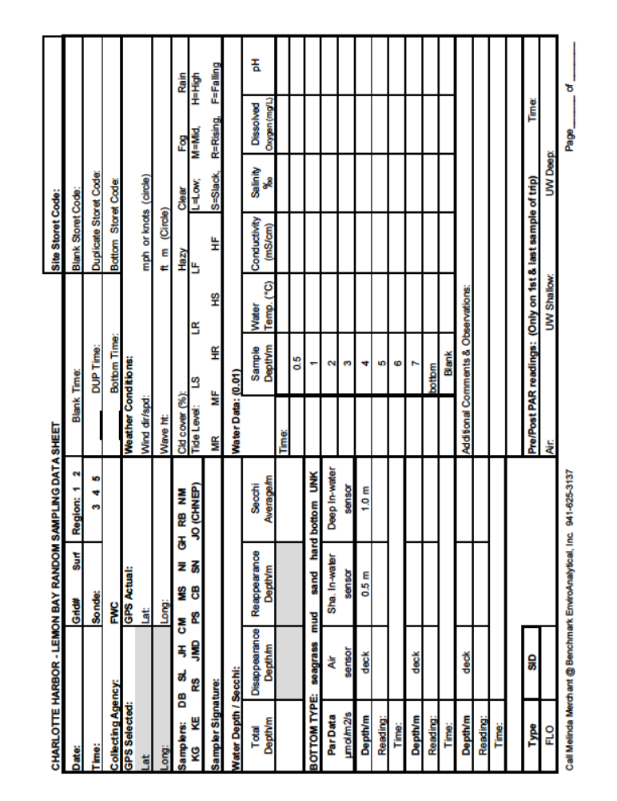

Appendix F.3: Coastal Charlotte Harbor Monitoring Network Standard Operating Procedures 2023 Updates

