CHARLOTTE COUNTY COMPREHENSIVE VULNERABILITY ASSESSMENT
Client:
Charlotte County, FL
Funded By:
COASTAL & HEARTLAND NATIONAL ESTUARY PARTNERSHIP (CHNEP)
APPENDIX D: Hazard and Asset Data

DATE: June 2026
WSP USA

Table of contents
Project Background 4
Purpose and Objectives 4
Topographic Data 4
Flood Scenarios 5
Precipitation 5
Sea Level Projections 6
Tidal Flooding 7
Storm Surge 12
Critical/regionally significant assets inventory 22
Available Data Sources 22
Asset Inventory 23
Data Gaps 25
Precipitation-induced Flooding Data 25
Sea Level Scenarios 25
Asset Inventory 25

List of Figures

Figure 1: Mean high higher water flood depths - 2040 Intermediate-Low Scenario SLR 8
Figure 2: Mean high higher water flood depths - 2040 Intermediate-High Scenario SLR 9
Figure 3: Mean high higher water flood depths - 2070 Intermediate-Low Scenario SLR 10
Figure 4: Mean high higher water flood depths - 2070 Intermediate-High Scenario SLR 11
Figure 5: Storm surge flood depths for 100-year storm, Current Conditions (2022) 13
Figure 6: Storm surge flood depths for 100-year storm, 2040 Intermediate-Low Scenario 14
Figure 7: Storm surge flood depths for 100-year storm, 2040 Intermediate-High Scenario 15
Figure 8: Storm surge flood depths for 100-year storm, 2070 Intermediate-Low Scenario 16
Figure 9: Storm surge flood depths for 100-year storm, 2070 Intermediate-High Scenario 17
Figure 10: Depth to groundwater in feet for mean higher high water, 2040 Intermediate-Low Scenario 19
Figure 11 Depth to groundwater in feet for mean higher high water 2040 intermediate-high or 2070 intermediate-low scenario 20
Figure 12: Depth to groundwater in feet for mean higher high water, 2070 Intermediate-High Scenario 21

List of Tables
Table 1: Detailed sea level change estimates (feet) for selected policy scenarios to meet requirements (FDEP) 7
Table 2: Critical assets within the study area, number of facilities, built area, and their proportional representation 23
Table 3: Roadway linear mileage by functional class and evacuation route 24
Table 4: Transportation infrastructure asset inventory 25
Table 5: Natural, cultural, and historical resources, total acres of land 25

Project Background
Charlotte County, located along the southwest coast of Florida, is bordered by the Gulf of America to the west and is bisected by Charlotte Harbor, the Peace River and the Myakka River which form the center of the county. Its expansive shoreline, low-lying topography, and interconnected waterways make the County particularly vulnerable to a variety of coastal and climate-related hazards. Major population centers such as Port Charlotte and Punta Gorda are situated near critical water bodies, increasing the community’s exposure to increases in coastal flooding, storm surge, extreme precipitation, and compound flooding. These risks are exemplified by recent and recurring hurricane impacts, including Hurricane Ian (2022), Hurricane Idalia (2023), Hurricane Helene and Hurricane Milton (2024); all which caused widespread damage across the region. As these climate-driven events become more frequent and intense, it is increasingly critical for Charlotte County to evaluate and enhance its resilience to current and future environmental threats.
In recognition of this need, Charlotte County has undertaken efforts to assess its vulnerability of critical county assets to flooding and related hazards. This Vulnerability Assessment is being funded by the Coastal & Heartland National Estuary Partnership (CHNEP) in support of regional climate resilience efforts. Although CHNEP is the primary funder, the County is following the Florida Department of Environmental Protection (FDEP)’s standardized set of work tasks and deliverables as outlined in the Resilient Florida Program. Aligning with FDEP’s framework ensures consistency and eligibility for future state funding and state agency project acceptance and makes the county eligible for future funding opportunities. The goal of the Vulnerability Assessment is to develop a comprehensive understanding of the potential hazards facing Charlotte County and to produce an Adaptation Plan that addresses climate risks in support of the long-term resilience of Charlotte County communities.

Purpose and Objectives
This report focuses on the data collection tasks that encompassed the compilation of data in three primary categories:
- Topographic data
- Flood scenario-related data
- Critical and regionally significant asset inventory
WSP USA Inc. is responsible for compiling and organizing these datasets to support the Vulnerability Assessment. The data collected serves as the foundation for identifying areas and assets at risk from current and future flooding hazards. The Critical and Regionally Significant Asset Inventory includes key infrastructure in a range of sectors including transportation; utilities; emergency services; community facilities; and natural, cultural, and historical resources. All data have been compiled into a GIS geodatabase that complies with the FDEP’s Resilient Florida Program GIS Data Standards.
This structured approach ensures a consistent and thorough evaluation of vulnerabilities facing Charlotte County, thus enabling the County to prioritize adaptation strategies and support long-term resilience planning. The following sections detail the methodology, sources, and organization of the data collected. In addition, the final section identifies data gaps the currently exist in conducting the vulnerability assessment.

Topographic Data
The Digital Elevation Model (DEM) used for this project was primarily derived from bare-earth aerial LiDAR data provided by the Southwest Florida Water Management District (SWFWMD)/Hillsborough County (2017), SWFWMD/Pasco County (2018), and the U.S. Geological Survey (USGS) Florida Peninsula LiDAR Project (2019–2020). These hydro-flattened DEM files were classified and merged using Global Mapper™, with quality control performed at survey checkpoints to ensure consistency and accuracy. The resulting DEM supports 6-inch resolution orthophotography and has a point density equivalent to an 8-foot post spacing.
To supplement areas with insufficient coverage or specific features such as bridge decks, additional elevation data were generated through Semi-Global Matching (SGM) correlation and stereo collection. Where necessary, USGS 3DEP elevation data were also incorporated—particularly around water bodies and regions with poor LiDAR returns. All supplemental DEMs were reviewed, corrected for anomalies, and seamlessly feathered into the primary dataset to ensure data continuity.
Charlotte County also provided DEM tiles derived from orthophotography, which were mosaicked and incorporated into the final elevation surface. The complete DEM is referenced to the North American Vertical Datum of 1988 (NAVD88), reported in feet, with an 8-foot cell size, and is compliant with FDEP’s Resilient Florida Program GIS Data Standards.
In addition to LiDAR and DEM data, traditional survey data were reviewed during this task. While no new survey fieldwork was conducted as part of this project, available survey datasets in Available Data Sources were evaluated for applicability. These datasets were primarily used for ground-truthing and quality assurance of the elevation surfaces where necessary but were not required for DEM generation due to the high resolution and quality of the LiDAR-based elevation data.

Flood Scenarios
Two primary datasets were utilized to represent flood scenarios in this analysis--one for storm surge flooding and one for tidal flooding. Both datasets were developed and provided by the University of Florida and used the following processes/tools to produce the data representing appropriate future scenarios.
- ACUNE-SWFL GeoTool – University of Florida: This dataset modeled storm surge flooding scenarios in southwest Florida and was used to assess potential impacts of surge-based coastal flooding under an extreme event intensity (1% annual event).
- Sea Level Scenario Sketch Planning Tool – University of Florida: This dataset represented tidal flooding under different sea level scenarios. It supported planning-level assessments of future high tide impacts based on projected sea levels.
While the contract outlines additional flood scenario-related datasets these were not included in this phase of the Vulnerability Assessment for the following reasons:
- Hydrostratigraphic information is primarily used in long-term groundwater studies and is not required for the coastal and tidal flooding focus of this assessment.
- River channel cross-section data are generally used for fluvial modeling and erosion analysis, which are outside the scope of this project.
- Land use data was collected as part of the ACUNE model effort but was not directly applicable to the vulnerability analysis, aside from potential use in summarizing future inundation impacts.
- Evapotranspiration data is typically used in stormwater and soil moisture modeling and is not necessary for the present analysis, which does not address pluvial flooding.
For a more detailed discussion of these data categories and their relevance, please refer to Appendix C: ACUNE Sufficiency Analysis.

Precipitation
Precipitation-induced flooding is not included in the current vulnerability assessment. This project is not funded by FDEP, and precipitation-induced flooding is not a required component for coastal communities under state code.
Per Section 380.093(3)(d)2.c. of the Florida Statutes, an assessment of rainfall-induced flooding is required "to the extent practicable." The statute mandates this analysis for noncoastal communities but does not explicitly require it for coastal jurisdictions such as Charlotte County.

Sea Level Projections
Sea level projections were taken from National Oceanic and Atmospheric Administration (NOAA) (2017). Global and Regional Sea Level Scenarios for the United States. Intermediate-Low and Intermediate-High projections, were used in the vulnerability assessment as per FDEP guidance at the time of initiating the technical work for this study. Table 1 shows projected sea water level changes in feet for NOAA’s 2017 and 2022 measurements. A hydro-connectivity model, commonly referred to as the “Modified Bathtub” approach, was utilized in this assessment. This model applies a hydrologic connectivity filter to remove isolated, low-lying areas that are not hydrologically connected to larger water bodies, thus providing a more accurate depiction of flood risk.

Table 1: Detailed sea level change estimates (feet) for selected policy scenarios to meet requirements (FDEP)
 | NOAA 2017
Year | Int.- Low | Int.-High
2040 | 0.37 | 1.06
2070 | 0.93 | 2.96
Source: (NOAA, 2017)

Tidal Flooding
Charlotte County has experienced a rise in the frequency of annual tidal flooding events, commonly referred to as "sunny day" or nuisance flooding. This trend is primarily attributed to global sea level rise and regionally specific shoreline dynamics, including sediment erosion and accretion, which vary based on shoreline type (e.g., salt marsh, Juncus marsh, mangroves).
NOAA tide gauge data from Fort Myers (Station 8725520) reflects this growing trend. Between 2000 and 2020, the number of nuisance flooding days recorded each year more than tripled—from approximately 3 days annually to more than 10. This increase highlights the growing impact of high tide events on low-lying infrastructure and coastal communities in Southwest Florida, including Charlotte County.
Sheehan and Crooks (2016) 8 evaluated accretion rates—the gradual buildup of sediment that can help offset sea level rise—in Tampa Bay. These rates are expected to be similar in Charlotte Harbor, which has comparable shoreline habitats. The study found that accretion varies not only between different habitat types but also within them. For example, mangrove shorelines—the dominant shoreline type in Charlotte Harbor (CHNEP 2019)—have reported accretion rates ranging from approximately 1.6 to 5 mm/year, depending on the specific mangrove species and local conditions. This natural process of sediment accumulation plays an important role in how coastal areas respond to rising seas and increasing tidal flooding. (CHNEP 2019)9.
Tidal flooding was assessed using NOAA sea level values mapped on top of the Mean Higher High Water (MHHW) tidal datum. The MHHW represents the average of the higher of the two daily high tides and serves as a critical baseline for evaluating coastal inundation risks. A statewide grid for Florida, representing MHHW, was developed by NOAA’s Office of Coastal Management (OCM).
Figures 1 to 4 show projected feet of inundation per tidal flooding scenario.
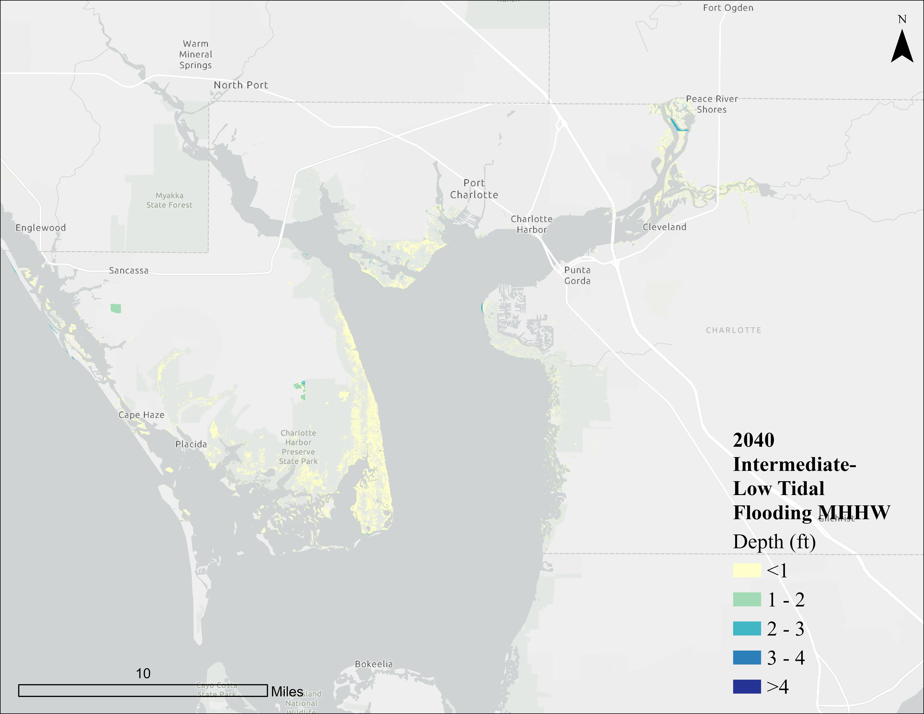
Figure 1: Mean high higher water flood depths - 2040 Intermediate-Low Scenario SLR
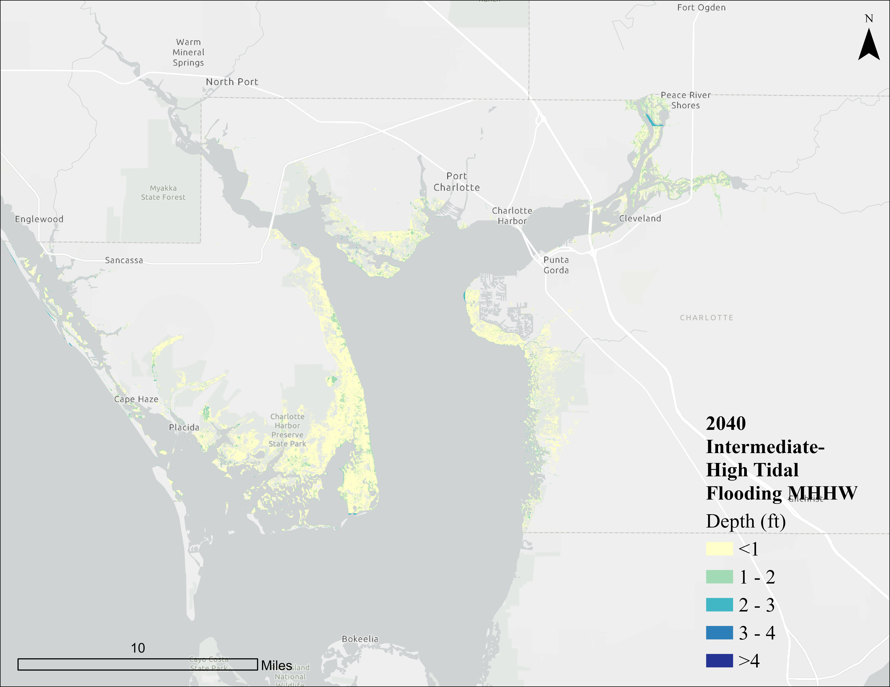
Figure 2: Mean high higher water flood depths - 2040 Intermediate-High Scenario SLR
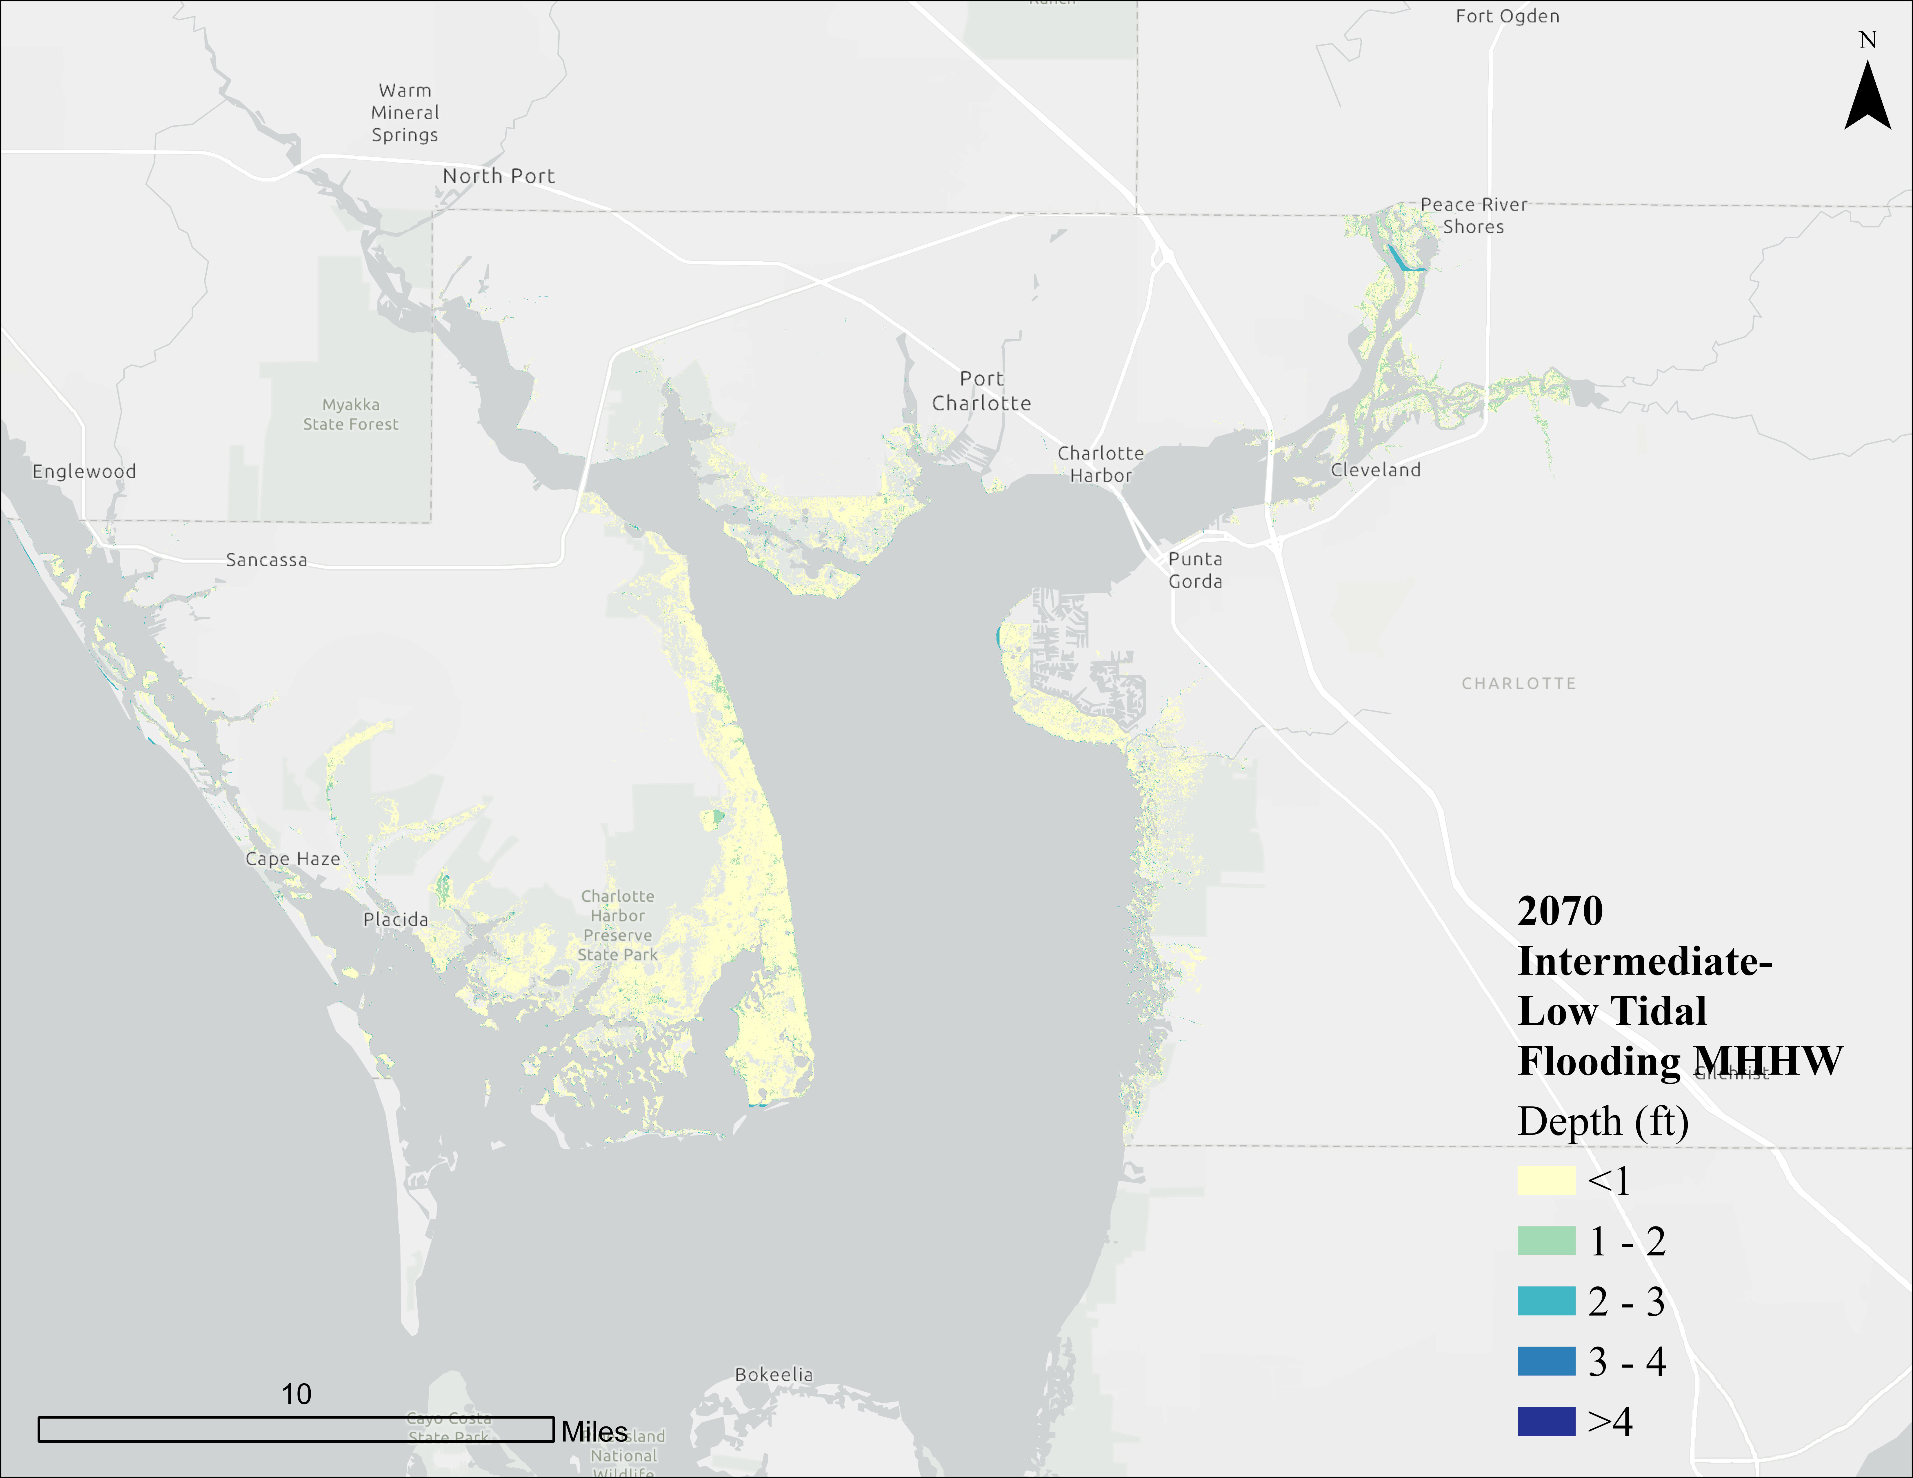
Figure 3: Mean high higher water flood depths - 2070 Intermediate-Low Scenario SLR
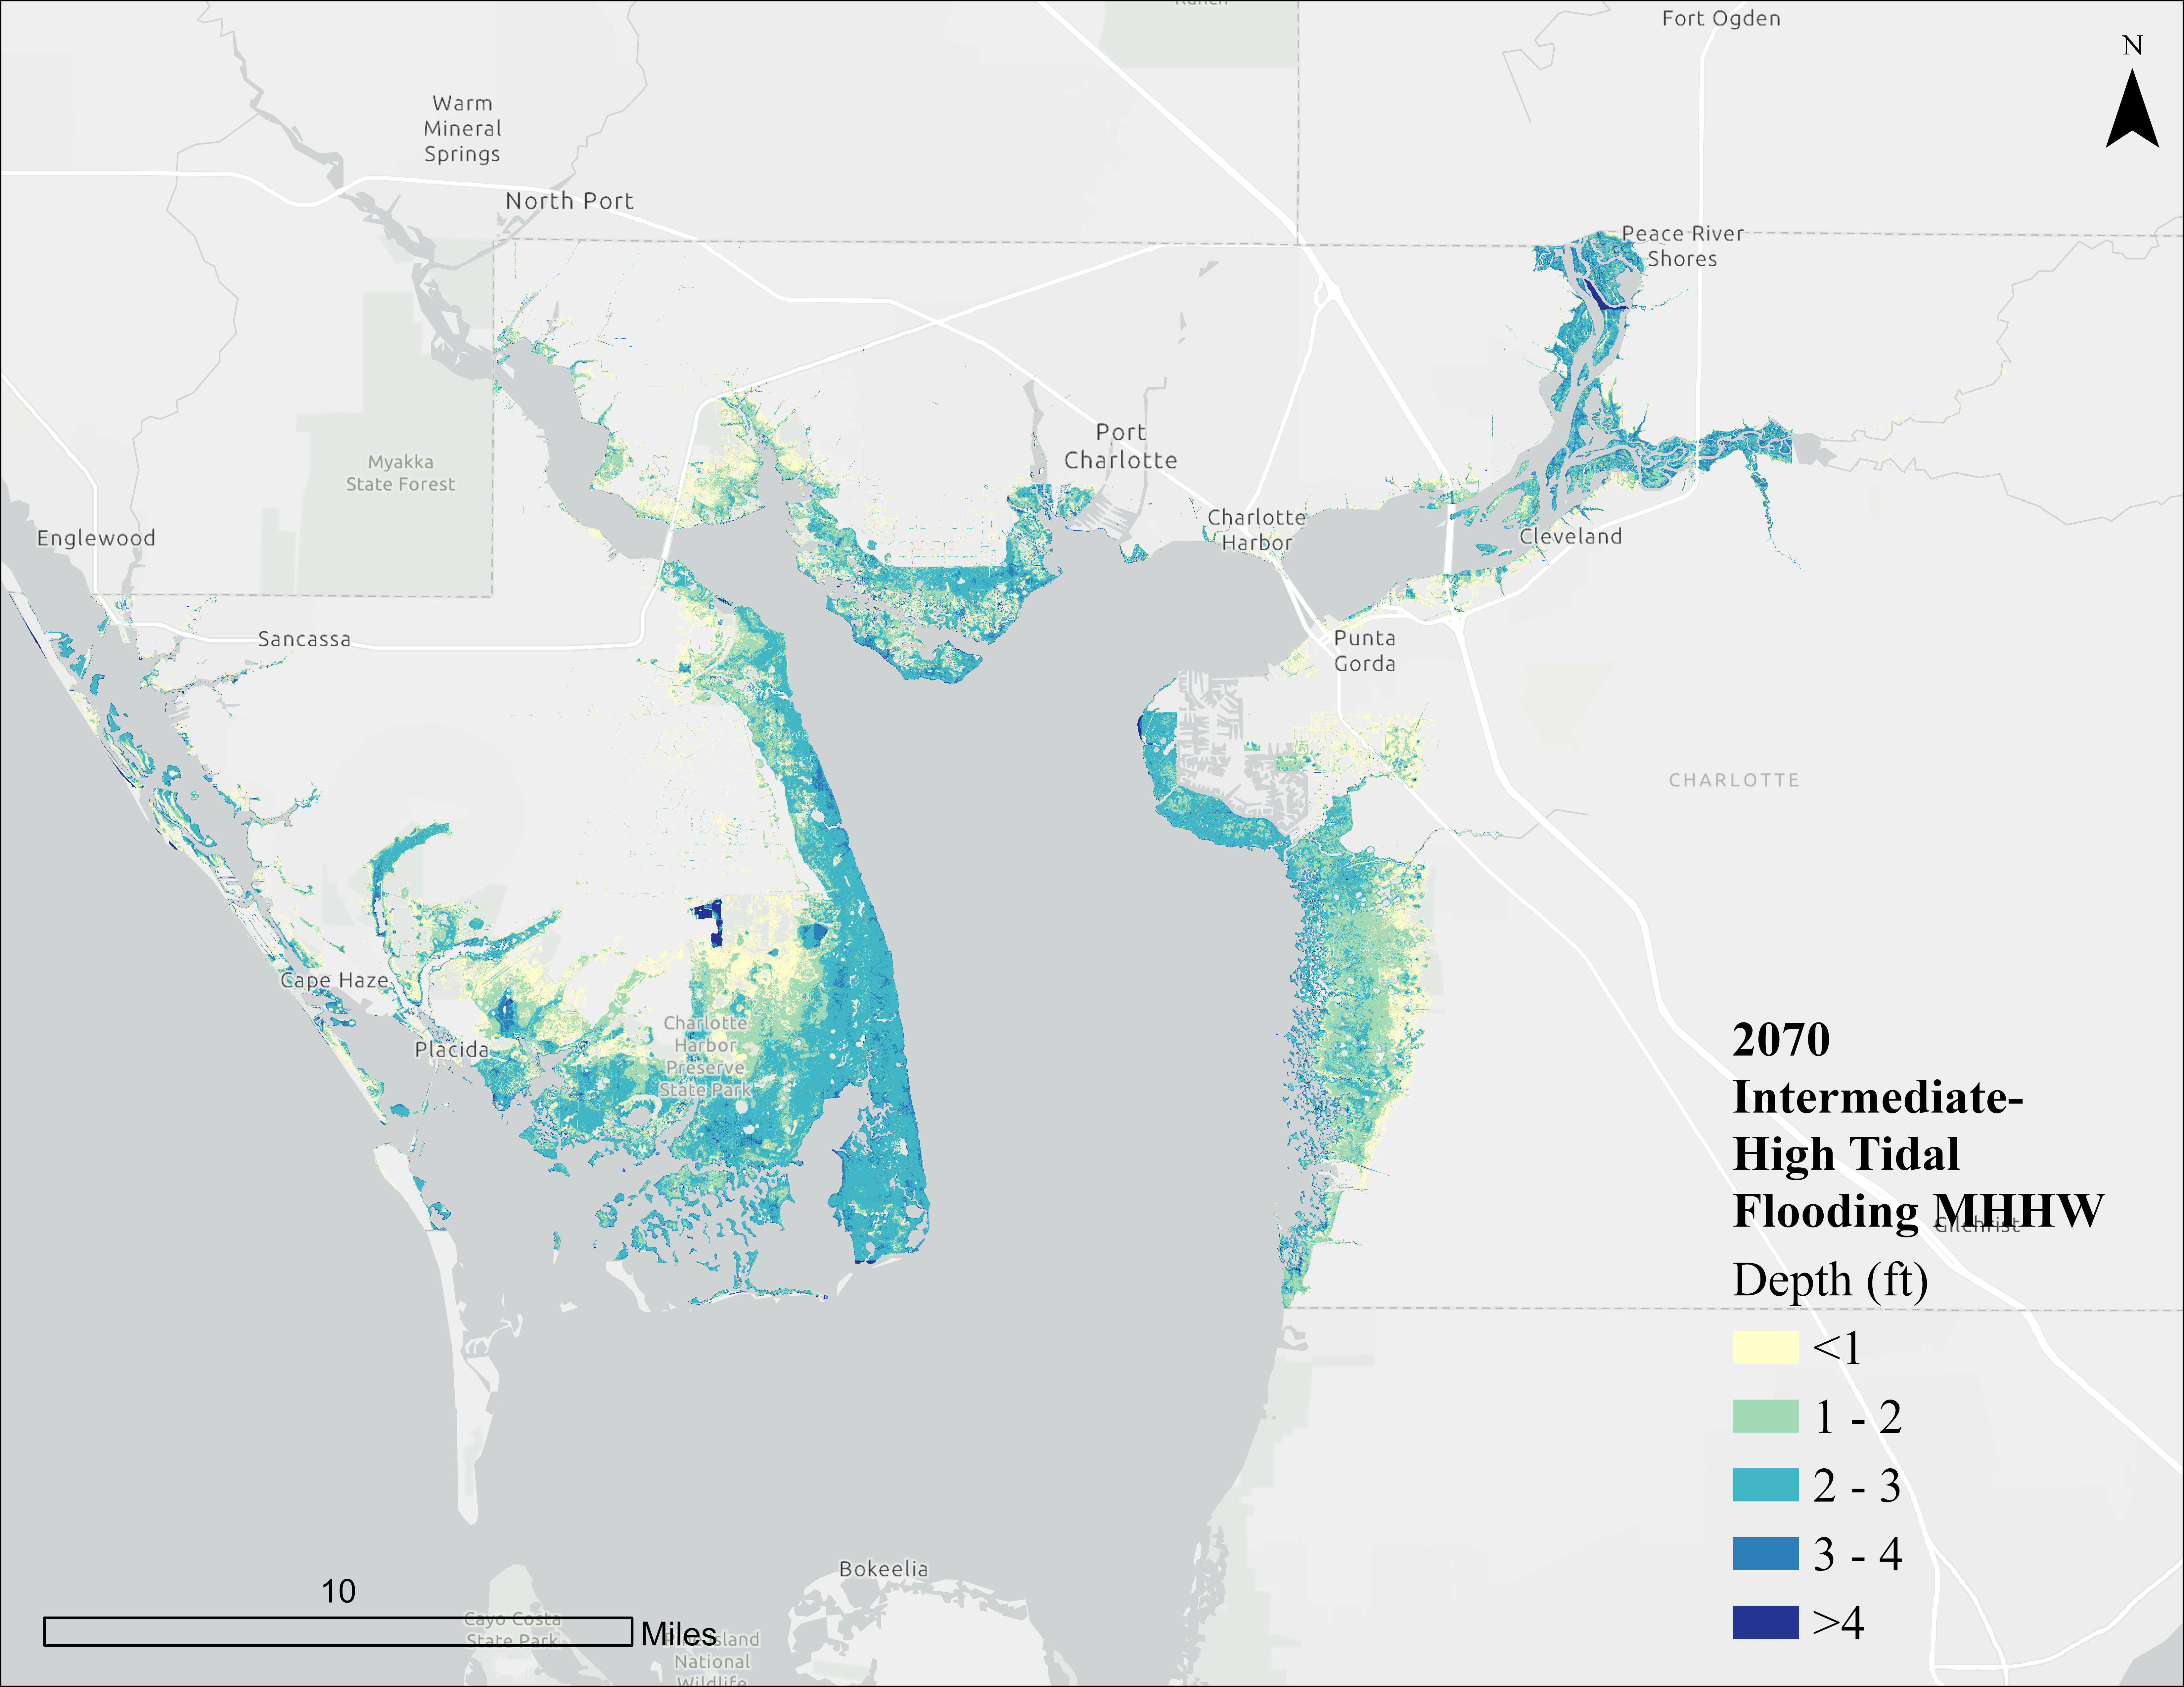
Figure 4: Mean high higher water flood depths - 2070 Intermediate-High Scenario SLR

Storm Surge
Storm surge poses a growing threat to Charlotte County as evidenced by several recent high-impact storm events. In 2023, Hurricane Idalia resulted in a storm surge inundation of 2 to 4 feet, along with heavy rainfall and tropical storm-force winds. The following year, Hurricanes Helene and Milton delivered even more severe impacts. Hurricane Helene, in September 2024, produced a storm surge of 6 to 8 feet in parts of Punta Gorda. Two weeks later, Hurricane Milton struck with another 5 to 8 feet of surge, resulting in significant damage across the county.
To analyze the potential concerns of such events, the University of Florida’s ACUNE model was developed to determine 100-year storm surge conditions for current conditions, and flooding enhanced by NOAA sea level projections. A 1-ft increase in sea level combined with a 100-year storm surge event roughly corresponds to both NOAA’s 2017 projection for the 2040 Intermediate-High and 2070 Intermediate-Low scenarios, and a 3-ft increase in sea level roughly corresponds to the 2070 Intermediate-High scenario, as shown in Table 1.
It should be noted that that is a key gap that exists between the sea level projections used in current storm surge models and the most recent requirements maintained by FDEP. The ACUNE model scenarios are based on NOAA’s 2017 projections, while more recent and updated projections from NOAA’s 2022 Sea Level Rise Technical Report were integrated into FDEP’s requirements and are now available and widely adopted in planning efforts statewide. Moving forward, Charlotte County may benefit from updating storm surge layers using the 2022 SLR scenarios with benchmarks for 2050 and 2080, to be consistent with state requirements and data analysis being conducted in other communities in Florida.
Note that the data used from the existing modeled scenarios provide credible information with which to complete the current VA analysis, develop mitigation actions and policies, and establish priorities and implementation timeframes. The scenarios for which surge was analyzed, present a comprehensive look at future conditions within the county. Importantly, the current ACUNE model outputs have been deemed acceptable by FDEP to meet compliance with the applicable standard at the time of project initiation (2022).
Figures 5 to 9 show storm surge flooding depth (in feet) for Charlotte County with different NOAA scenarios, and for the 100-year analysis framework.
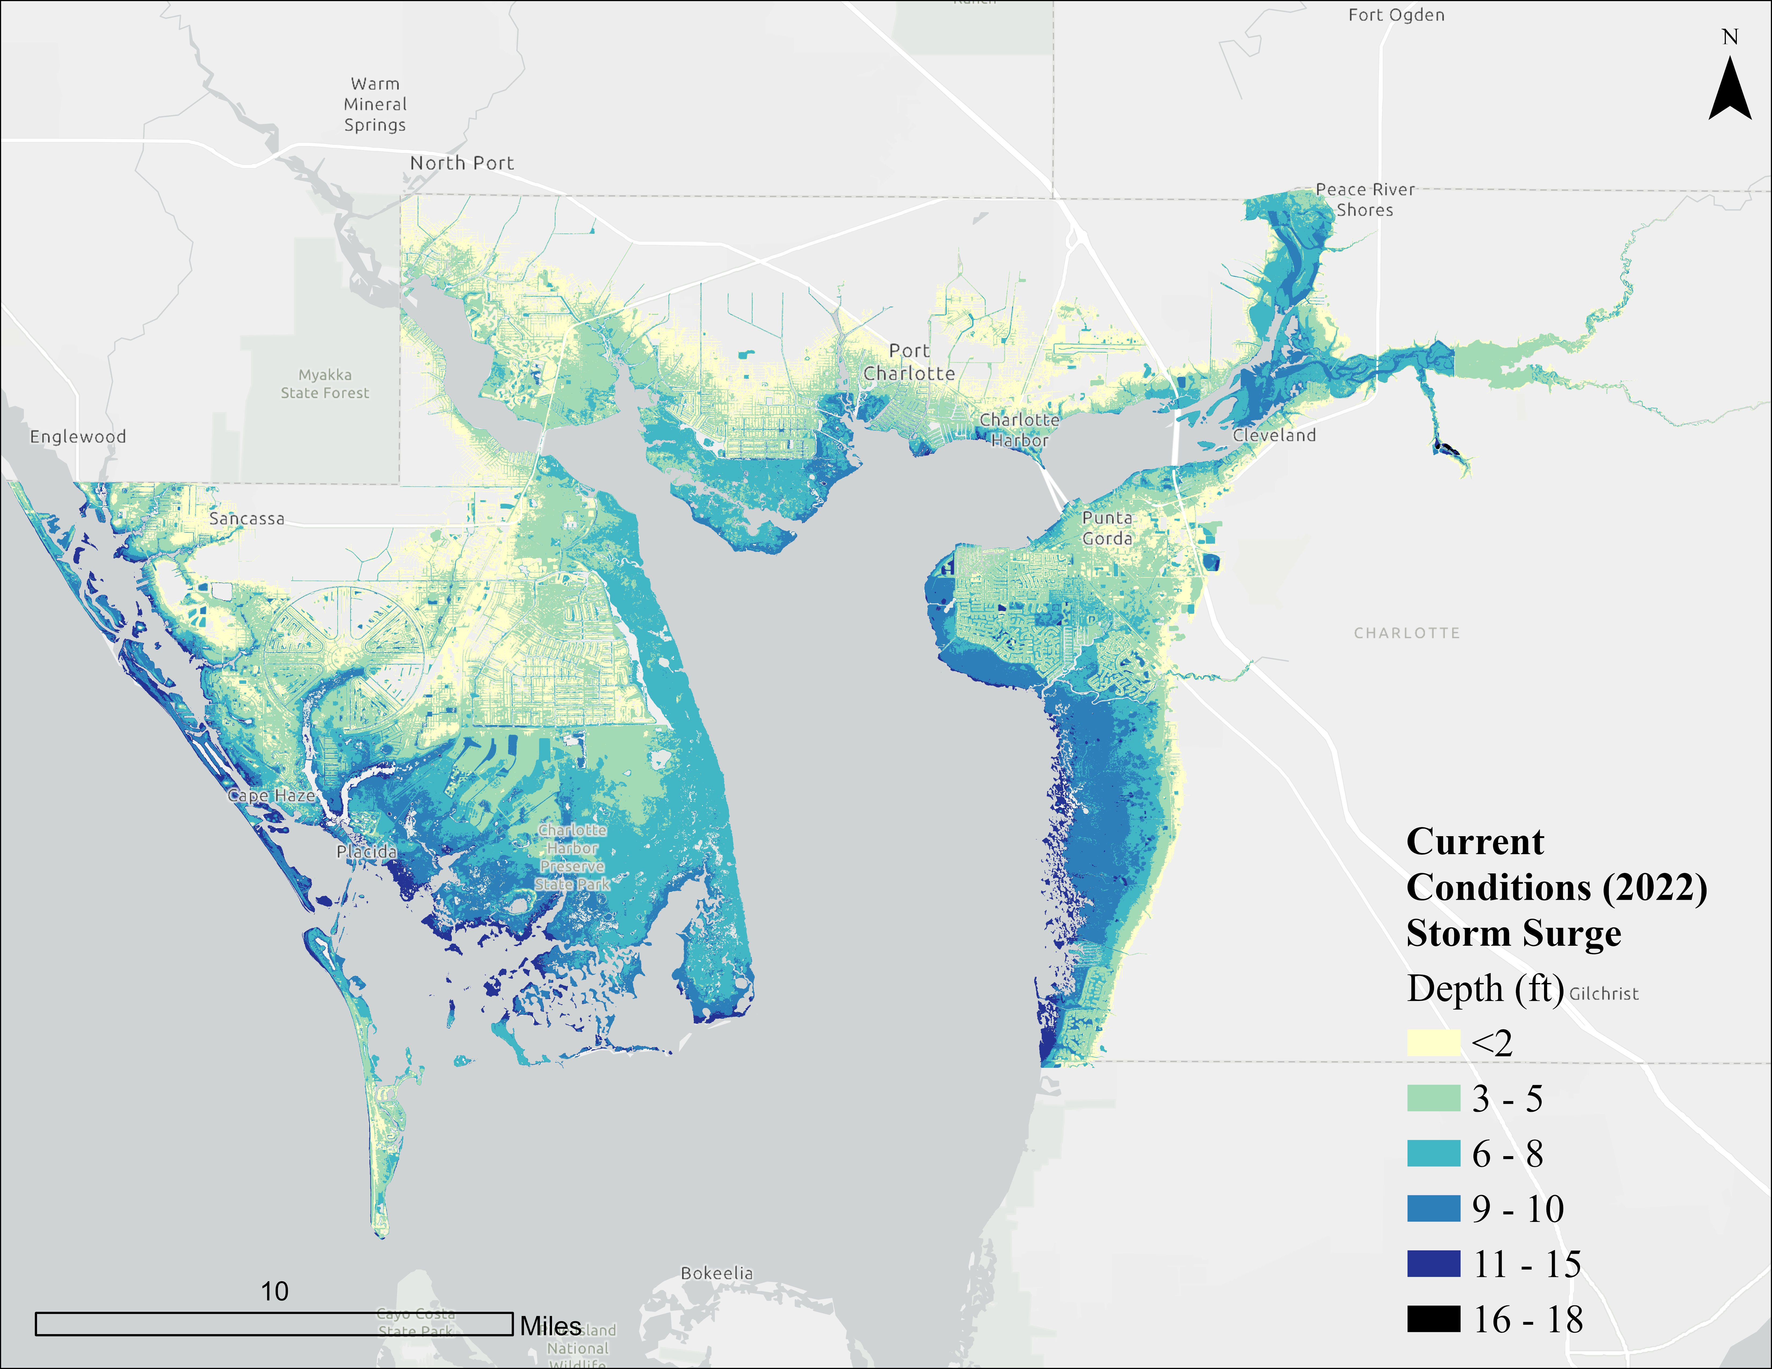
Figure 5: Storm surge flood depths for 100-year storm, Current Conditions (2022)
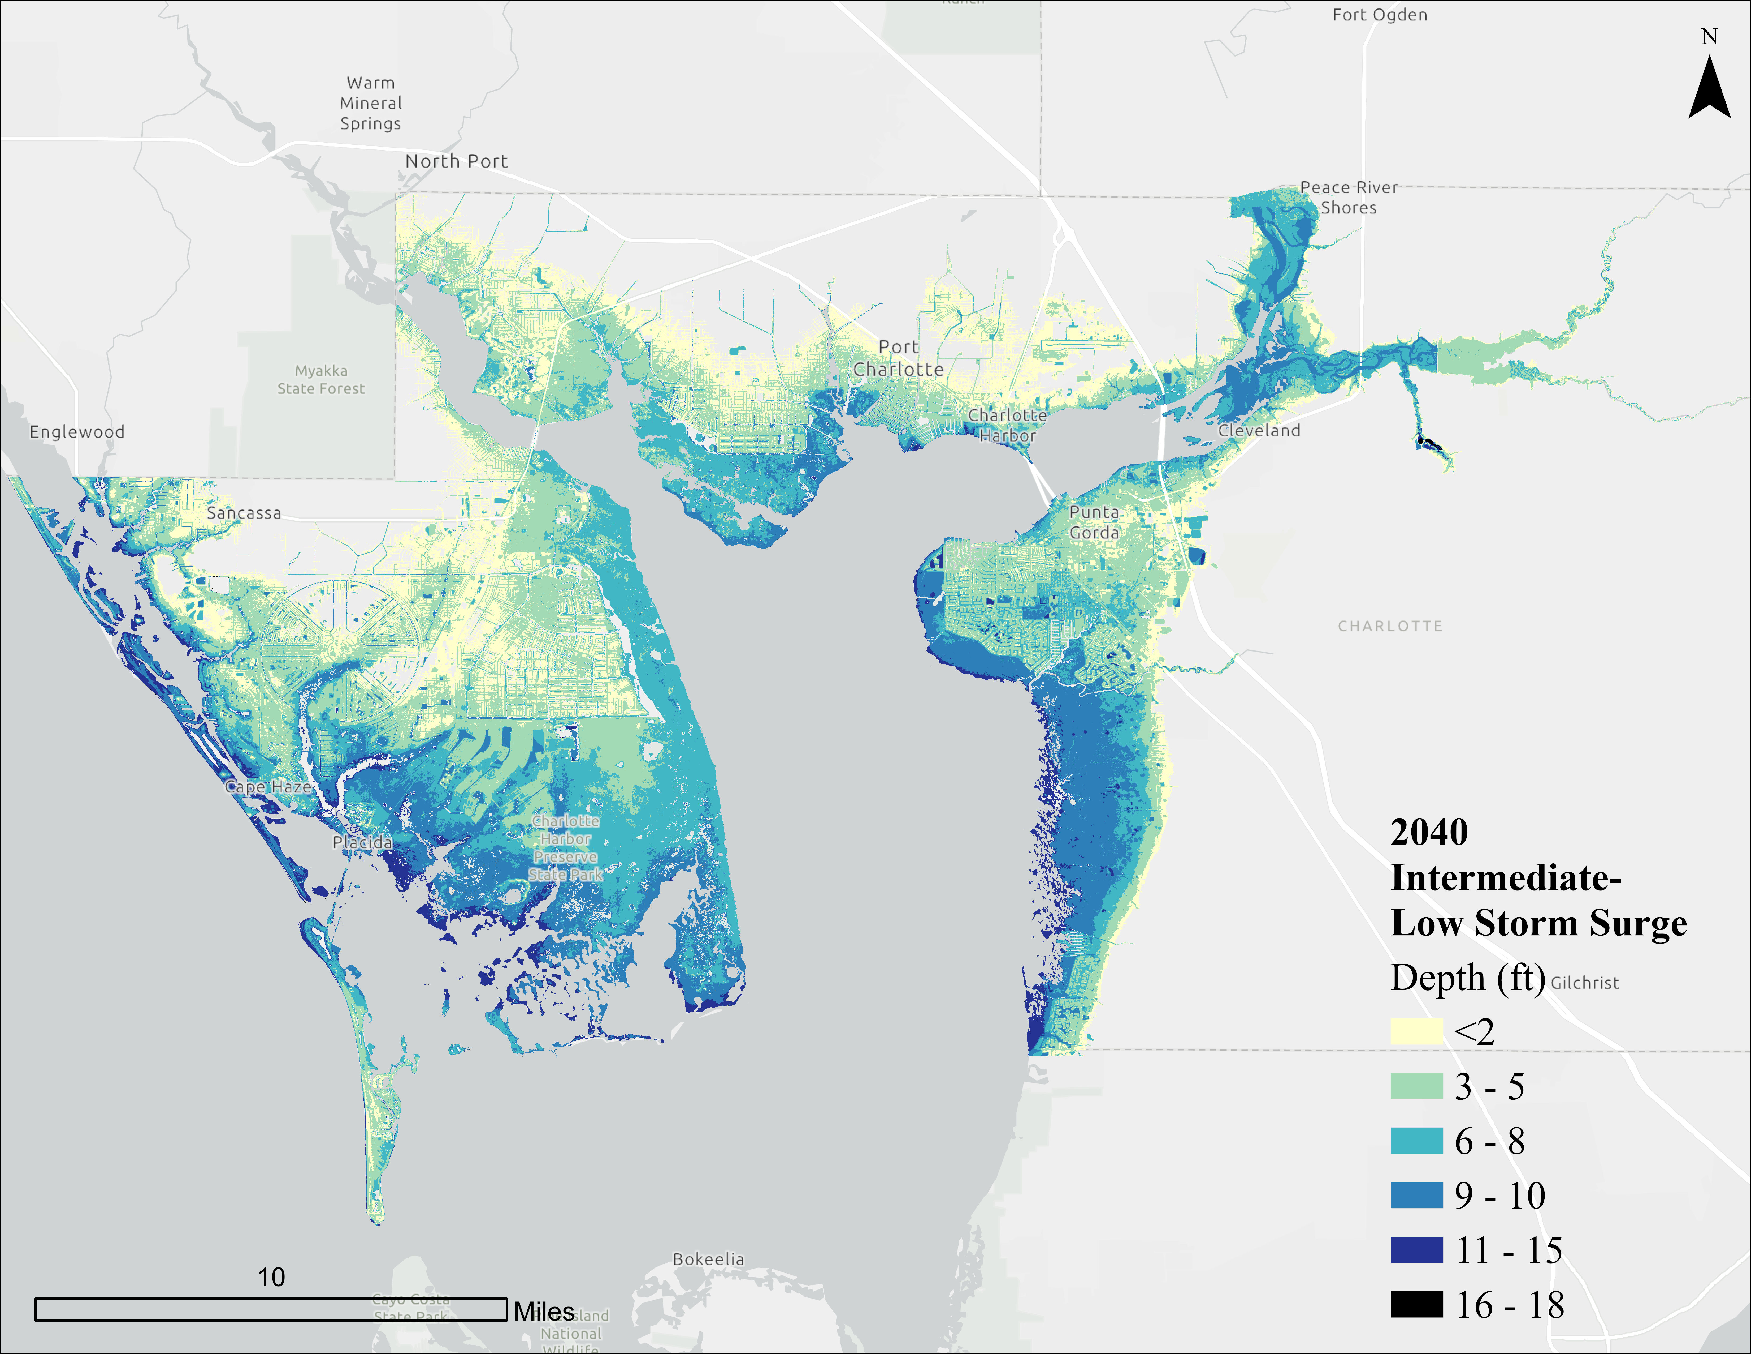
Figure 6: Storm surge flood depths for 100-year storm, 2040 Intermediate-Low Scenario
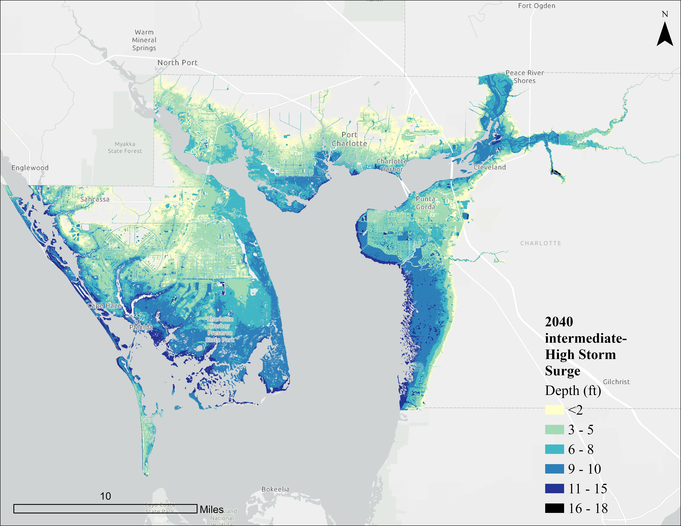
Figure 7: Storm surge flood depths for 100-year storm, 2040 Intermediate-High Scenario
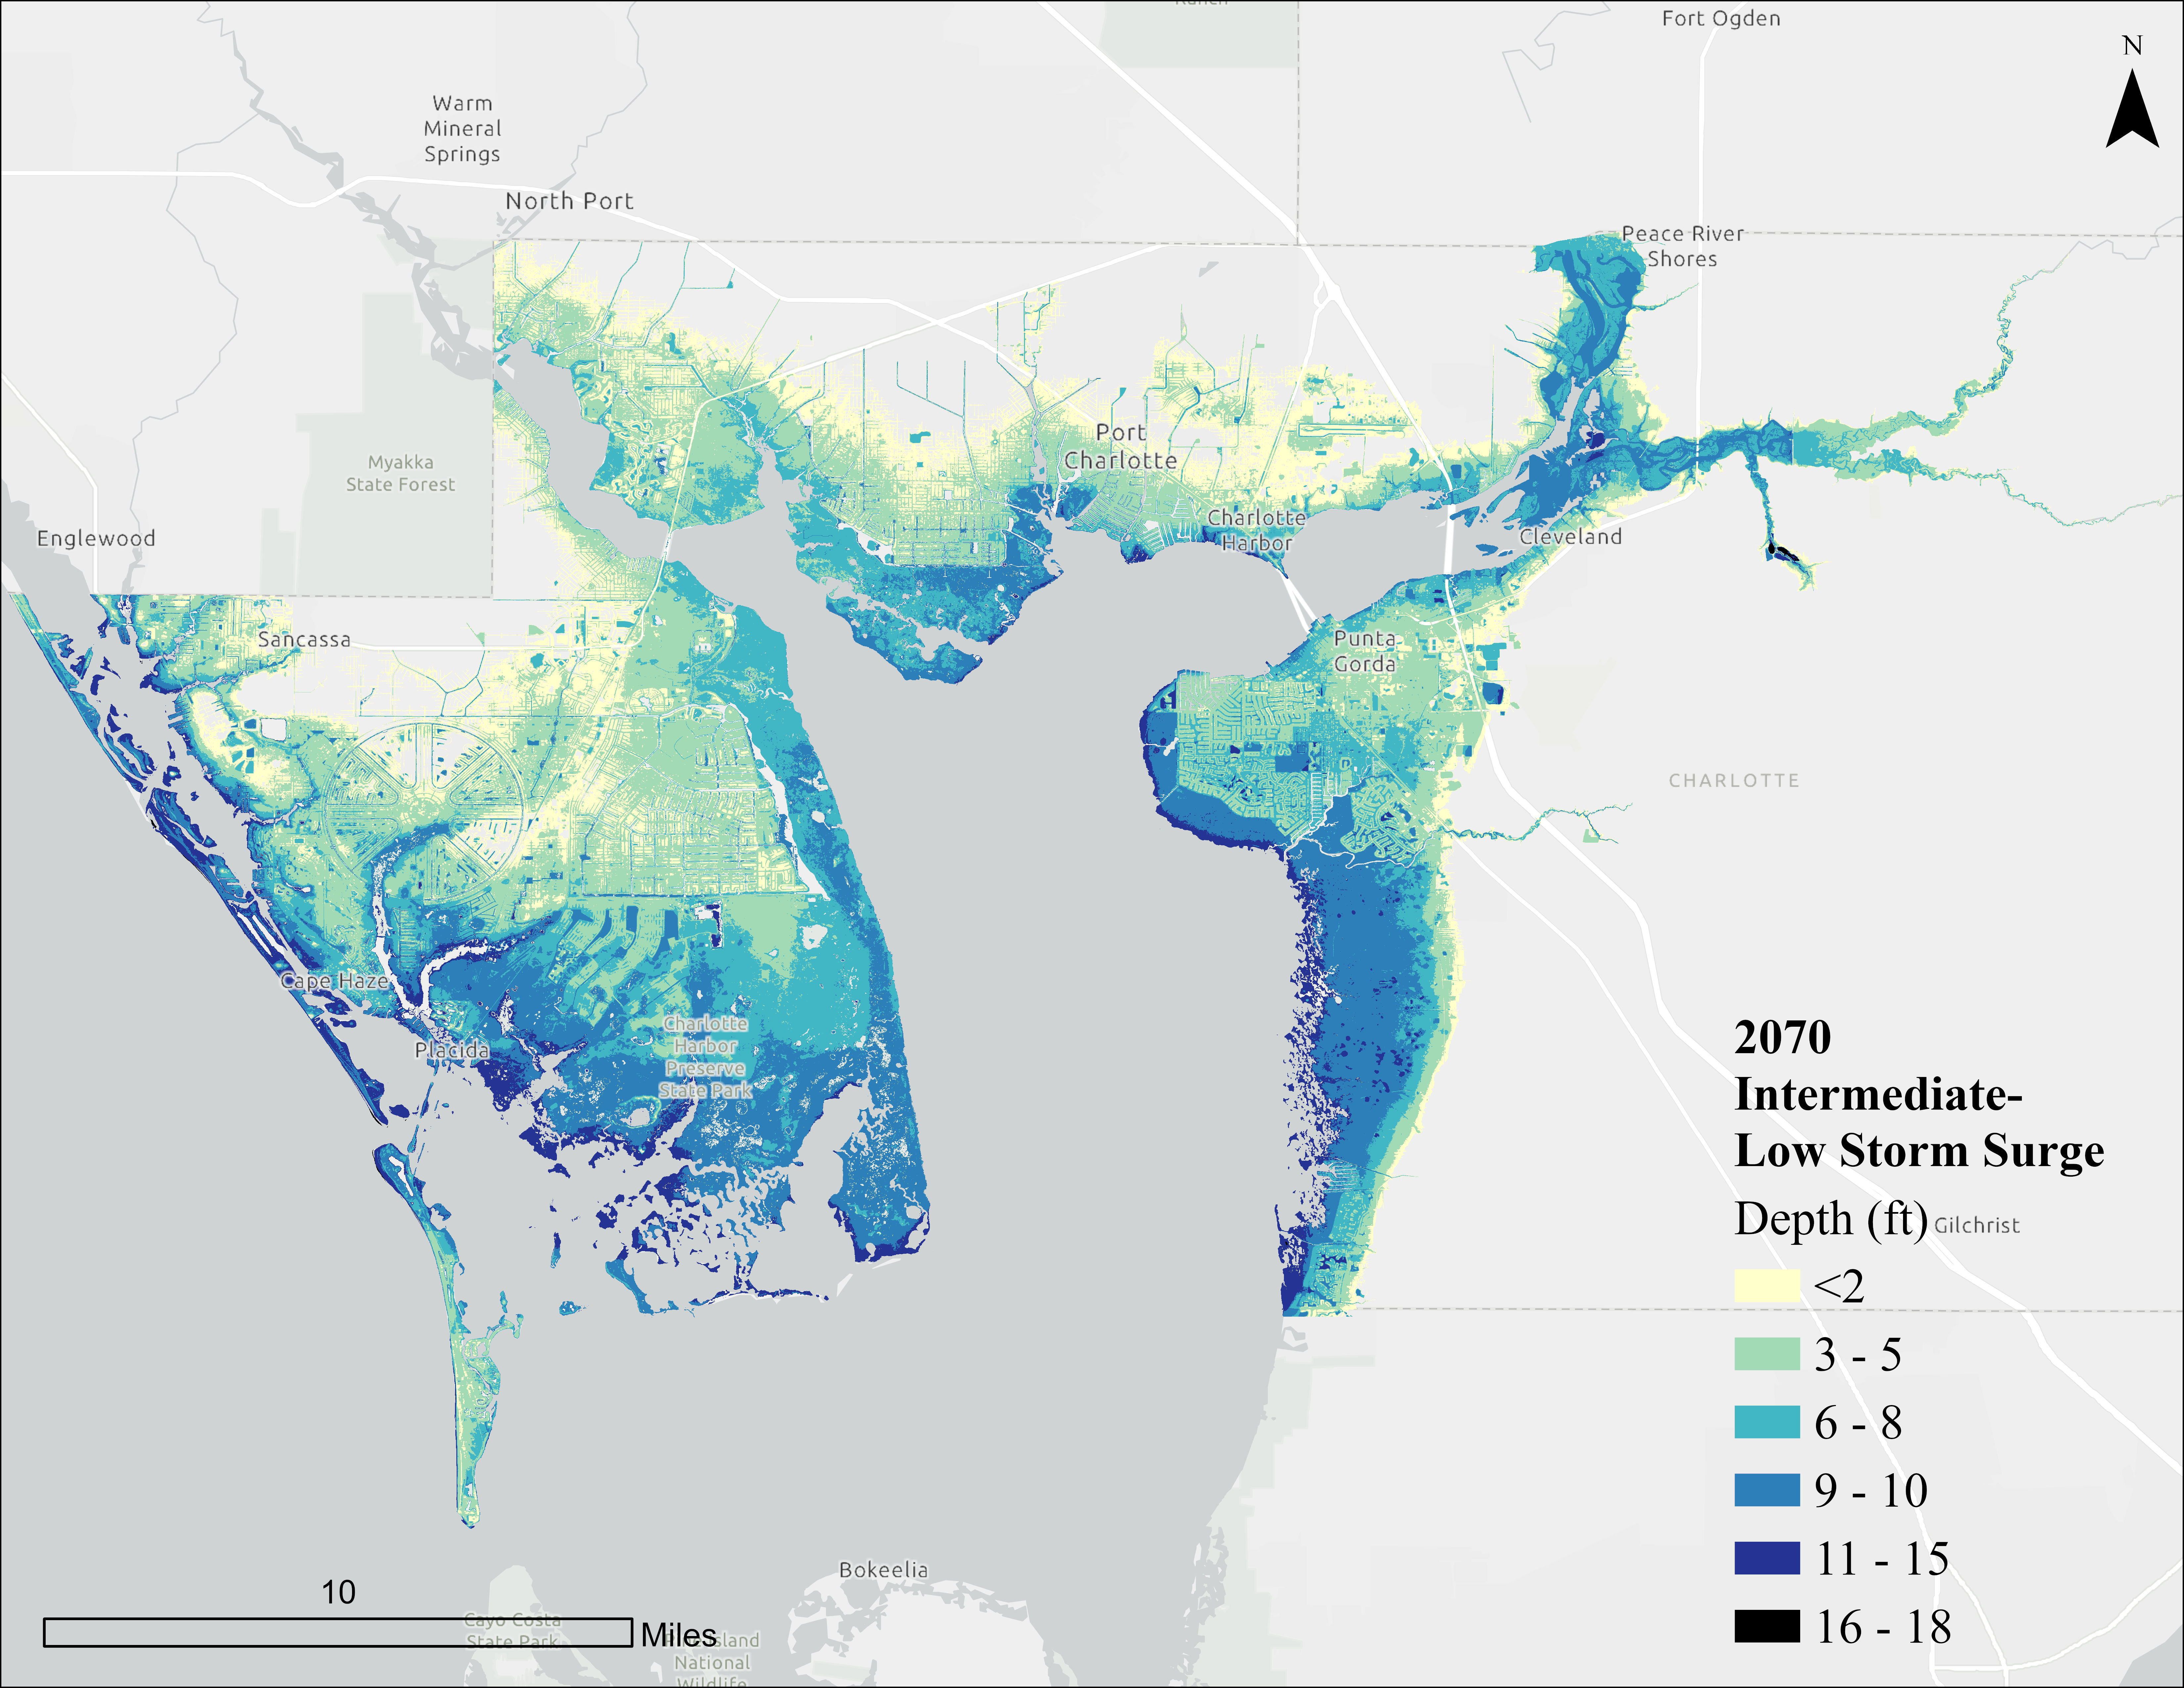
Figure 8: Storm surge flood depths for 100-year storm, 2070 Intermediate-Low Scenario
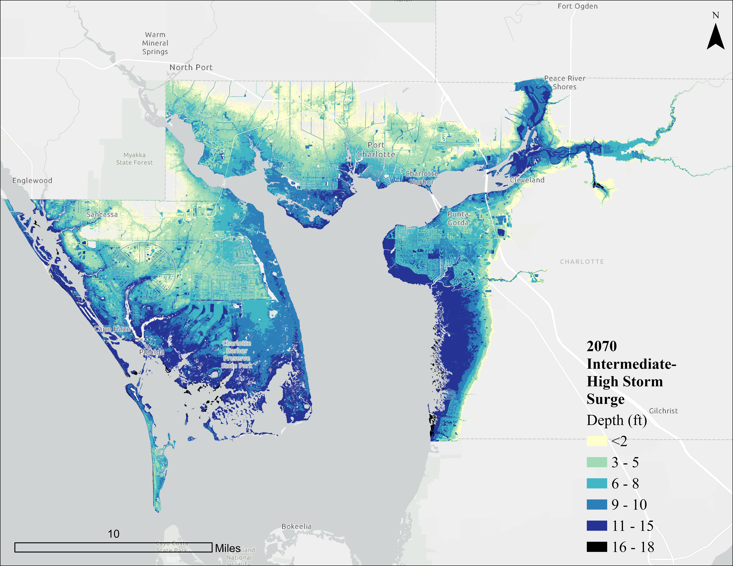
Figure 9: Storm surge flood depths for 100-year storm, 2070 Intermediate-High Scenario

RISING GROUNDWATER
As sea levels rise along coastal regions like Charlotte County, the groundwater table beneath the surface is also expected to rise. When sea levels increase, the "baseline" water level that influences these underground systems also moves higher, pushing groundwater closer to the surface. Higher groundwater conditions will impact underground systems (stormwater, sewer, utility, etc) and should be considered as a part of county policies and actions.
To evaluate this potential impact in Charlotte County, a simplified modeling approach was used, referred to as the “bathtub method.” This method generally assumes that groundwater will rise at the same rate as the nearby sea level. Determining depth to groundwater is accomplished by subtracting projected sea level elevations from existing ground elevation data using a high-resolution DEM – with the difference being the derived and estimate depth to groundwater from the surface in all areas.
For this work, sea levels were identified based on the MHHW levels, which represents typical high tides and is more relevant to long-term groundwater changes. The final depth to groundwater estimates are calculated using this formula:
Projected Groundwater Depth = Ground Elevation – (MHHW + Sea Level Rise)
Figures 10 to 12 show depth-to-groundwater (in feet) for Charlotte County. Feet measures were developed as criteria as they link to vulnerability analysis measures for some features (like roadways).
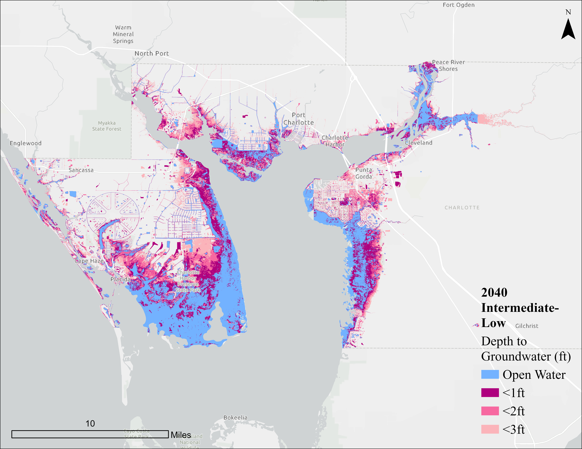
Figure 10: Depth to groundwater in feet for mean higher high water, 2040 Intermediate-Low Scenario
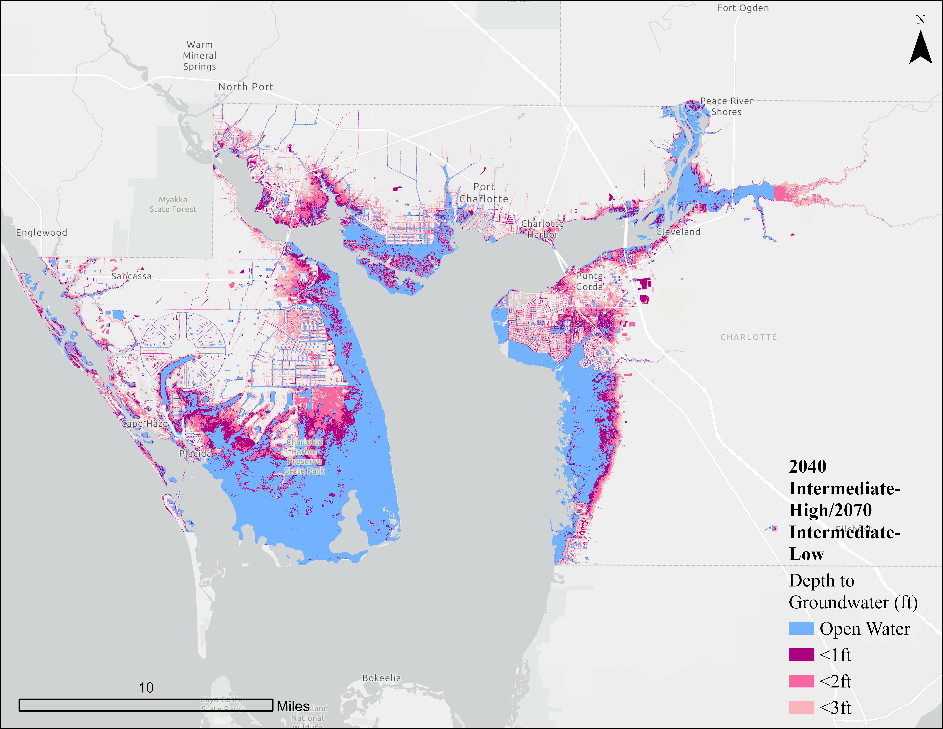
Figure 11 Depth to groundwater in feet for mean higher high water 2040 intermediate-high or 2070 intermediate-low scenario
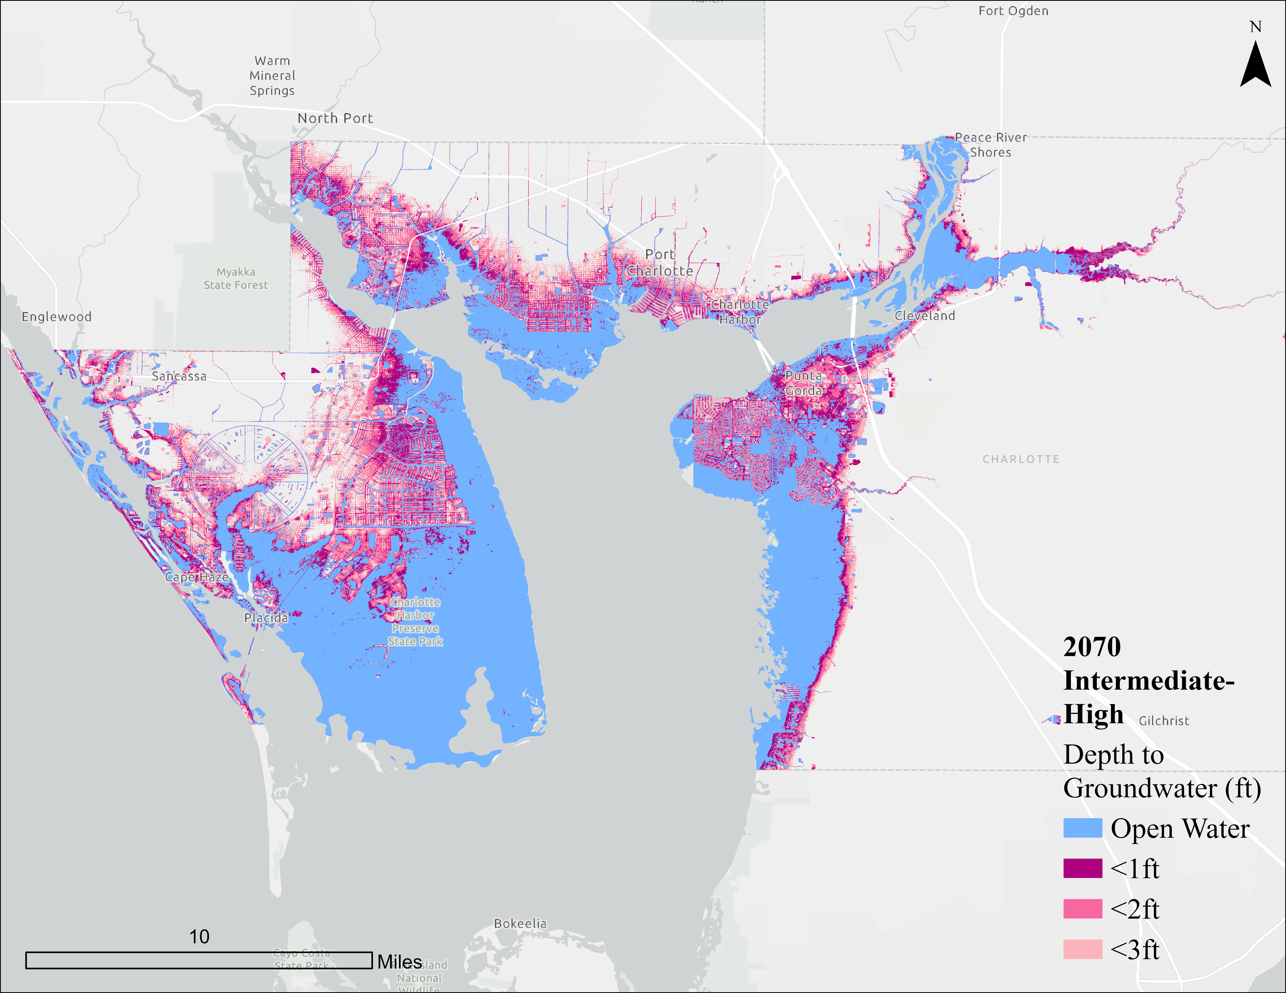
Figure 12: Depth to groundwater in feet for mean higher high water, 2070 Intermediate-High Scenario

Critical/regionally significant assets inventory
This section describes the asset inventory organization, data sources, and assets considered by the vulnerability assessment process. A critical part of the vulnerability assessment is obtaining, identifying, and organizing the critical and regionally-significant asset inventory. Categorizing assets helps to organize the findings of the vulnerability assessment based on asset function while also meeting FDEP grant requirements. The data provided to WSP was organized into four asset classes shown below and as defined in paragraphs 380.093(2)(a)1-4, F.S.
- Transportation assets and evacuation routes: Airports, bridges, bus terminals, ports, major roadways, marinas, rail facilities, and railroad bridges.
- Critical infrastructure: Wastewater treatment facilities and lift stations, stormwater treatment facilities and pump stations, drinking water facilities, solid and hazardous waste facilities, military installations, communications facilities, and disaster debris management sites.
- Critical community and emergency facilities: Schools, colleges, universities, community centers, correctional facilities, disaster recovery centers, emergency medical service facilities, emergency operation centers, fire stations, health care facilities, hospitals, law enforcement facilities, local government facilities, logistical staging areas, affordable public, housing, risk shelter inventory, and state government facilities.
- Natural, cultural, and historic resources: Conservation lands and parks, shorelines, surface waters and wetlands, historic and cultural assets.

Available Data Sources
The analysis utilized a combination of publicly-available and locally-provided datasets. Below is a list of the datasets used, along with a brief description of the attributes of each:
- Charlotte County Critical Facilities
  - Locally provided critical facilities including water treatment facilities, wastewater treatment facilities, fire stations, maintenance facilities, recreational facilities, and other asset types were provided with building footprints. These were the starting datasets for the critical asset inventory. Major roadways, evacuation routes, and bridges were also locally provided.
- Florida Statewide Resilience Dataset Statewide Critical Assets
  - Served as a secondary dataset for the analysis. It provided a comprehensive point dataset covering all asset categories required by FDEP.
- ACUNE SWFL GeoTool Asset datasets
  - Point datasets included public schools, fire stations, hospitals, and police stations, linear features included major roads, and evacuation routes.
- Florida Department of Transportation (FDOT) Annual Average Daily Traffic (AADT)
  - Spatially joined AADT to the major roads, dataset provided by Charlotte County.
- Microsoft Building Footprints
  - Spatially joined point datasets to building footprints to support the exposure analysis.
- Tax Parcels
  - Spatially joined building footprints to tax parcels to support the exposure analysis.
- Elevation Certificate (EC)
  - ECs were locally provided by Charlotte County to help determine an asset’s critical elevation by providing precise measurements of the property’s lowest floor elevation that could then be assessed relative to expected flood levels.
- U.S. Army Corps of Engineers (USACE) National Structures Inventory (NSI)
  - Point dataset used to estimate first-floor elevations to assess critical elevation thresholds. Where ECs were not available, NSI first-floor elevations were used to assume critical elevation.

Asset Inventory
Table 2 highlights the asset inventory used for the vulnerability assessment, which included 386 buildings across 24 asset types, totaling more than 7.1 million square feet of built area. A significant portion of these assets are schools, which make up 30% of all buildings and account for 43% of the total built area, thus highlighting their importance in both daily operations and can support emergency response planning. Other prominent facility types include health care facilities, hospitals, and correctional facilities, each of which have large physical footprints and play critical roles in public safety and resilience. Additional key assets include local government facilities, fire stations, airports, and community centers, which support essential services, governance functions, and disaster response.
To complement the facility data, the inventory also includes 365 network infrastructure lift station points. These networked assets are widely distributed and critical for maintaining utility services. While their individual footprint is small (a related measure in FDEP analysis), their collective performance is essential for public health and environmental protection, particularly during and after hazard events.
Charlotte County contains essential transportation infrastructure that supports daily travel and emergency operations. The county includes 25 miles of railroad and approximately 491 miles of roadway, categorized by functional class as shown in Table 3. Of this network, over 260 miles serve as designated evacuation routes, primarily along interstates and arterial roads, which are critical during hurricane events and other emergencies.
The county’s roadway system is supported by 104 bridges, 48 culverts, and 9 historic bridges (see Table 4), which provide critical crossings over water bodies and low-lying areas. These structures represent potential vulnerability points when damaged and are vital for maintaining access to key facilities before, during, and after hazard events.
Charlotte County is also rich in natural, cultural, and recreational resources, containing 31,059 acres of parks, 20,402 acres of conservation lands, and an extensive 1,012,652 acres of wetlands, as shown in Table 5. Additionally, the county features 337 miles of shoreline, making coastal system resilience a priority in planning efforts. These resources not only contribute to environmental health and quality of life in the county, but also require special consideration relating to climate-related hazards where changing conditions may threaten the existence of some of these areas.
Table 2: Critical assets within the study area, number of facilities, built area, and their proportional representation
Asset Type | Total Count of Buildings | Sum of Built Area (sq ft) | % of Total Count of Buildings | % of Total Sum of Built Area
Affordable Public Housing | 7 | 132,682 | 2% | 2%
Airports | 12 | 301,951 | 3% | 4%
Colleges and Universities | 9 | 109,143 | 2% | 2%
Communications Facilities | 6 | 130,131 | 2% | 2%
Community Centers | 13 | 223,152 | 3% | 3%
Correctional Facilities | 29 | 532,186 | 8% | 7%
Disaster Recovery Centers | 2 | 138,314 | 1% | 2%
Emergency Medical Service Facilities | 2 | 21,624 | 1% | 0.3%
Emergency Operation Centers | 1 | 20,581 | 0% | 0.3%
Fire Stations | 25 | 147,855 | 6% | 2%
Health Care Facilities | 22 | 778,749 | 6% | 11%
Historical and Cultural Assets | 4 | 21,904 | 1% | 0.3%
Hospitals | 8 | 468,270 | 2% | 7%
Law Enforcement Facilities | 6 | 109,445 | 2% | 2%
Lift Stations | 2 | 1,579 | 1% | 0.02%
Local Government Facilities | 22 | 362,764 | 6% | 5%
Logistical Staging Areas | 2 | 32,644 | 1% | 0.5%
Marinas | 1 | 16,165 | 0% | 0.2%
Parks | 11 | 162,307 | 3% | 2%
Pump Stations | 18 | 18,694 | 5% | 0.3%
Risk Shelter Inventory | 6 | 142,135 | 2% | 2%
Schools | 114 | 3,057,219 | 30% | 43%
Solid and Hazardous Waste Facilities | 9 | 47,845 | 2% | 0.7%
Wastewater Treatment Facilities | 55 | 191,646 | 14% | 3%
Total | 386 | 7,168,985 | 100% | 100%

Table 3: Roadway linear mileage by functional class and evacuation route
Functional Class | Total Mileage | Evacuation Route Mileage
Interstate | 52 | 44
Principal Arterial | 76 | 69
Minor Arterial | 161 | 113
Major Collector | 200 | 34
Minor Collector | 2 | -

Table 4: Transportation infrastructure asset inventory
Structure | Number
Bridges | 104
Culverts | 48
Historic Bridges | 9

Table 5: Natural, cultural, and historical resources, total acres of land
Land Use Type | Total Acres
Parks | 31,059
Conservation Lands | 20,402
Wetlands | 1,012,652

Data Gaps
While the assessment methodology utilizes the best available data to assess Charlotte County’s vulnerability to climate-related hazards, there are several key data gaps that might limit the completeness or precision of the analysis. Addressing these gaps will enhance the County’s ability to conduct future assessments, refine adaptation strategies, and pursue funding opportunities through programs such as FDEP’s Resilient Florida Program.

Precipitation-induced Flooding Data
Stand-alone rainfall-based flooding was not included in the current analysis due to the lack of available data. Although not a mandatory requirement for coastal communities under s. 380.093, F.S., the inclusion of precipitation-based flood modeling (e.g., 100-year and 500-year rainfall events) would provide a more complete understanding of compound flooding risks. Future assessments should consider collaboration with regional water management districts or NOAA’s Atlas 14 datasets to fill this gap.

Sea Level Scenarios
The current flood scenarios use NOAA’s 2017 Sea level projections. Updated projections from NOAA’s 2022 Sea Level Technical Report offer more recent estimates and are increasingly used in resilience planning given the tie in to Florida state codes. Incorporating these newer projections in future modeling for 2050 and 2080 benchmarks would improve alignment with current best practices in the state and align analysis/results with other communities.

Asset Inventory
All required asset types that exist within Charlotte County are present in the asset database. Several asset types listed in FDEP guidance do not exist within the county and were therefore excluded from the vulnerability assessment, including:
- Stormwater treatment facilities
- Drinking water facilities
- Military installations
- Bus terminals
- Ports
- Rail facilities
- Railroad bridges
The best available datasets were utilized to estimate critical elevations, which served as a key metric for assessing asset vulnerability. The DEM was used in most/all cases to determine land elevations at critical assets. Elevation certificates, provided locally by Charlotte County, offered additional detailed measurements of a property's lowest floor relative to expected flood levels and were used to determine an asset’s critical elevation where available. While these sources provided a valuable foundation, they may not have fully captured actual asset conditions to a level that would enable a more detailed technical analysis. Data such as information on asset age, deterioration, or condition are lacking from the analysis, and could provide benefit to future assessments. Addressing these gaps in future assessments through field surveys or integration with local property appraiser data would improve the accuracy and reliability of vulnerability evaluations.

https://storymaps.arcgis.com/stories/aad4c97c78234b5fae02ef3b90176ead
https://sls.geoplan.ufl.edu/use/
NOAA. 2017. Global and Regional Sea Level Rise Scenarios for the United States, NOAA Technical Report NOS CO-OPS 083. Accessed at https://tidesandcurrents.noaa.gov/publications/techrpt83_Global_and_Regional_SLR_Scenarios_for_the_US_final.pdf
https://coast.noaa.gov/states/stories
https://coast.noaa.gov/slr/#/layer/slr 8 Sheehan, L. and S. Crooks. 2016. Tampa Bay Blue Carbon Assessment: Summary of Findings, TBEP Technical Report #07-16L. Sheehan, L. and S. Crooks. 2016. Tampa Bay Blue Carbon Assessment: Summary of Findings, TBEP Technical Report #07-16L St. Petersburg, FL.www.tbeptech.org/ 9 CHNEP (Coastal and Heartland National Estuary Partnership). 2019. Habitat Restoration Needs Plan. Environmental Science Associates. https://www.chnep.org/resources
https://sealevel.globalchange.gov/resources/2022-sea-level-rise-technical-report/
Florida Division of Emergency Management. 2023. Florida Statewide Resilience Dataset: Statewide Critical Assets. Available from https://floridadep.gov/sites/default/files/DEP%20Resilience%20Statewide%20Final%20Critical%20Assets%20Spatial%20Data%20Report-504.pdf
The sum does not equal 100% due to rounding of numbers.

